SUITABILITY OF CEMENT KILN DUST FOR RECONSTRUCTION OF BITUMINOUS ROADS

by

Jeremy S. Baugh

30 December 2007

Acknowledgement
Financial support for this project was provided by the Portland Cement Association’s Education Foundation. Thanks to Peter Bosscher and Xiadong “Buff” Wang for their assistance in the lab. Thanks also to Auckpath “Ake” Sawangsuriya, Maria Rosa, Justin Warner, and Felipe Carmago for their input and help during testing. Thanks also to Tuncer Edil for advising me.

Table of Contents

Acknowledgement i

Table of Contents ii

List of Figures iv

List of Tables vi

1 Introduction 1

2 Background 3

2.1 What is CKD? 3
2.2 What are Recycled Pavement Materials? 3
2.3 Previous Cement Kiln Dust Stabilization Research 3
2.3.1 Treatment of Fine-Grained Soils 3
2.3.2 Treatment of Sands and Aggregate 7
2.3.3 Treatment of Recycled Pavement 10
2.4 Summary of Prior Stabilization Research 10
2.4.1 Compaction 10
2.4.2 Atterberg Limits and Swell Potential 11
2.4.3 Strength 12
2.4.4 Resilient Modulus 13
2.4.5 Durability 13
2.5 Environmental Concerns 13

3 Materials 15

3.1 Pavement Materials 15
3.1.1 Base Material Sources 15
3.1.2 Base Material Properties 15
3.2 Cement Kiln Dust 16

4 Methods 21

4.1 Specimen Preparation 21
4.2 California Bearing Ratio 23
4.3 Resilient Modulus 23
4.3.1 Laboratory Procedure 23
4.3.2 Resilient Modulus Model 25
4.3.3 Data Processing 26
4.4 Unconfined Compression 27
4.5 Freeze-Thaw Durability 27
4.6 Leaching Potential 28

5 Compaction Characteristics 33

6 California Bearing Ratio 37

7 Resilient Modulus 43
7.1 Untreated Aggregate 43
7.2 Aggregate-Cement Kiln Dust Mixtures 43
7.3 Plastic Deformation 46
7.4 Resilient Modulus Data Summary 46

8 Unconfined Compressive Strength 57

9 Freeze-Thaw Durability 61
9.1 Resilient Modulus 61
9.2 Plastic Deformation 61
9.3 Unconfined Compressive Strength 61
9.4 Freeze-Thaw Synthesis 62

10 Leaching Characteristics 72

11 Summary and Conclusions 74

12 References 76

Appendix A 79

Appendix B 81

List of Figures

Figure 2.1. Diagram of rotary cement kiln (image in public domain). 14

Figure 3.1. Particle size distributions for recycled pavement materials and road surface gravel as tested. 18

Figure 3.2. Standard Proctor compaction curves for untreated materials. 19

Figure 4.1. PVC 6” compaction mold reinforced with stainless steel pipe clamps. 29

Figure 4.2. Resilient modulus testing apparatus. 30

Figure 5.1. Compaction curves for CKD-treated base materials. 34

Figure 5.2. Standard Proctor Maximum dry unit weight and optimum soil moisture content with CKD content for (A) RAP, (B) RPM, and (C) RSG. CKD content is by dry weight of aggregate. 36

Figure 6.1. Average CBR of stabilized RAP, RPM, and RSG with CKD content. CBR reported for 0.1” penetration. Each point is the average of two replicate tests. 40

Figure 6.2. Normalized increase in CBR of stabilized base materials (RAP, RPM, and RSG) with CKD content. Each point is the average of two replicate tests. 41

Figure 7.1. Resilient moduli with CKD content and curing time for treated (A) RAP, (B) RPM, and (C) RSG. Resilient moduli reported for bulk stress (θ) of 208 kPa and octahedral shear stress (τ_{oct}) of 48.6 kPa. 52

Figure 7.2. Box plots of resilient moduli distributions of stabilized (A) RAP, (B) RPM, and (C) RSG at curing lengths of 7, 28, and 56 days. Resilient moduli reported for bulk stress (θ) of 208 kPa and octahedral shear stress (τ_{oct}) of 48.6 kPa. 54

Figure 7.3. Normalized increase in resilient moduli for stabilized base materials. Resilient moduli reported for bulk stress (θ) of 208 kPa and octahedral shear stress (τ_{oct}) of 48.6 kPa. 55

Figure 7.4. Total plastic strain of treated material during resilient modulus test for treated (A) RAP, (B) RPM, and (C) RSG. 56

Figure 8.1. Unconfined compressive strength with CKD content and curing time for treated (A) RAP, (B) RPM, and (C) RSG. 59

Figure 8.2. Young’s modulus with CKD content and curing time for treated (A) RAP, (B) RPM, and (C) RSG. 60

Figure 9.1. Resilient moduli with freeze-thaw cycles for treated (A) RAP, (B) RPM and (C) RSG. Resilient moduli reported for bulk stress (θ) of 208 kPa and octahedral shear stress (τ_{oct}) of 48.6 kPa. 68

Figure 9.2. Total plastic strain during resilient modulus test with freeze-thaw cycles for treated (A) RAP, (B) RPM, and (C) RSG. 69

Figure 9.3. Normalized average unconfined compressive strength (q_{u}) with freeze-thaw cycles for treated (A) RAP, (B) RPM, and (C) RSG. 70

Figure 9.4. Normalized average Young’s modulus (E) with freeze-thaw cycles for treated (A) RAP, (B) RPM, and (C) RSG. 71

List of Tables

Table 3.1. Properties of recycled pavement materials and road surface gravel. 17

Table 3.2. Chemical composition of Davenport and other CKDs. 20

Table 4.1. Loading protocol for NCHRP 1-28A Procedure 1b. 31

Table 4.2. Loading protocol for NCHRP 1-28A Procedure 2. 32

Table 5.1. Standard Proctor maximum dry unit weight and optimum moisture content with CKD content. 35

Table 6.1. Summary of CBR Data. 39

Table 6.2. Typical CBR for unbound materials (Hunt 1986). 42

Table 7.1. Summary of resilient moduli of untreated materials. 48

Table 7.2. Resilient modulus and unconfined compressive strength data for RAP. 49

Table 7.3. Resilient modulus and unconfined compressive strength data for RPM. 50

Table 7.4. Resilient modulus and unconfined compressive strength data for RSG. 51

Table 7.5. Trends in resilient modulus with CKD content. 53

Table 9.1. Resilient modulus and unconfined compressive strength data for RAP with freeze-thaw cycles. 64

Table 9.2. Resilient modulus and unconfined compressive strength data for RPM with freeze-thaw cycles. 65

Table 9.3. Resilient modulus and unconfined compressive strength data for RSG with freeze-thaw cycles. 66

Table 9.4. Change in average summary modulus after 10 freeze-thaw cycles. 67

Table 9.5. Change in average plastic strain after 10 freeze-thaw cycles. 67

Table 10.1. Summary of concentrations from water leach test. 73

Table A.1. PVC compaction mold volumes. 80

Table B.2. Calibration factors for resilient modulus testing equipment. 82

Introduction

Most of the highways in the United States were built in 1950s and 1960s and have deteriorated significantly to date. More than 96% of the current highways and most surface streets are paved with asphalt. Asphaltic pavement that is removed during road reconstruction or rehabilitation is often landfilled with significant costs and environmental issues. Quarrying virgin aggregate for road reconstruction also results in environmental problems and energy consumption. There is an increased trend to recycle existing asphalt pavement in situ as base course for the new pavement surface. However, the load carrying capacity of such a base course is of concern due to the inclusion of asphalt and possibly fine-grained materials. Reuse of existing material in place would reduce material, transportation, and disposal costs and save energy.
Much CKD is reintroduced to the Portland cement manufacturing process as kiln feed, but amounts are limited by alkalinity requirements for Portland cement and kiln operation issues. Too much CKD can clog parts of the system. Other options for reuse include soil stabilization, soil amendment for agriculture, and wastewater treatment (Bhatty 1995).
Todres et al. (1992) reported that more than 3,500,000 Mg of CKD unsuitable for recycling in the cement industry was landfilled every year. According to Portland Cement Association (PCA) surveys (Hawkins et al. 2003) the amount of clinker produced each year increased 55% from 1990 to 2000. Over the same period the amount of CKD landfilled per unit of clinker produced decreased 46%. The net result is a 16% reduction in the amount of CKD landfilled each year among the surveyed cement plants. Still, much CKD is produced that is not reused. The amount of CKD produced at plants varies widely. About 25% of plants produce no net CKD, while the top 10% of net CKD producers account for 50% of sold or disposed CKD (EPA 1993).
Cement kiln dust stabilization for rehabilitation of roads would provide another option to DOTs and municipalities depending on location and availability of suitable material.

Background

What is CKD?
Cement kiln dust is a byproduct of the production of Portland cement found in the exhaust gasses released by cement kilns (Figure 2.1) and collected by fabric filters or electrostatic precipitators. Kiln dust contains the same constituents as Portland cement: lime, silica, and metal oxides. The chemical and physical makeup of CKD varies widely depending on raw materials and the manufacturing process: kiln type, fuel, dust collection method, etc.

What are Recycled Pavement Materials?
Recycled pavement materials (RPM) include pulverized asphalt or concrete surfacing that may be mixed with existing base and subgrade materials. Road surface gravel (RSG) may also be recycled in-place. Both materials can be used as a base material for new paving projects.

Previous Cement Kiln Dust Stabilization Research

Treatment of Fine-Grained Soils
Bhatty et al. (1996) explains that stabilization of clayey soils is achieved by the mechanism of ion-exchange. Clayey soils are plastic, not volumetrically stable, and sensitive to moisture content as it relates to stiffness and strength. Ion-exchange stabilization involves the exchange of calcium for sodium on the cleavage surfaces of clay particles. The structure becomes flocculated and agglomerated, creating a more granular material that is less sensitive to moisture content change with respect to volume and strength change. Cementation of particles also contributes to stabilization (American Coal Ash Association 2003).
McCoy and Kriner (1971) investigated the effects of treatment by different CKDs on the properties of clays. Cement kiln dusts with higher free lime content and lower loss-on-ignition (LOI) produced higher unconfined compressive strengths. Other variability in strength and Atterberg limits may be explained by differences in fineness and alkali content.
Baghdadi (1990) investigated the effects of CKD treatment on bentonite and kaolinite. Bentonite and 50%-50% bentonite-kaolinite mixture were treated with CKD and cured for 7 days before Atterberg tests. Both materials exhibited a decrease in plasticity index (PI) with increasing CKD content mostly due to a reduction in the liquid limit (LL). Cement Kiln dust was not as effective at PI reduction as hydrated lime at the same content for contents <8% by total dry weight. Standard Proctor compaction tests were performed on CKD-kaolinite mixtures. Maximum dry unit weight (MDUW) increased and optimum moisture content (OMC) decreased with increased CKD content. Compressive strength increased with CKD content and curing time. Cement kiln dust was also effective in conjunction with cement or lime at increasing the strength of kaolinite.
Zaman et al. (1992) investigated the effects of CKD treatment on the properties of a fat clay (Unified Soil Classification System (USCS) class CH) with a LL of 98 and a PI of 64. Generally, the LL and PI decreased with increasing CKD content and curing time to a minimum PI of 12 with 40% CKD by total dry weight and 56 days of curing. Swell, unconfined compressive strength, and California bearing ratio (CBR) were measured on blends of 0, 5, 10, 15, 20, and 25% CKD. Specimens were compacted near MDUW and OMC determined by standard Proctor effort. Maximum dry unit weight decreased and OMC increased with increased increased CKD treatment. Swell decreased from 9.1% for untreated clay to 0% for clay treated with 25% CKD. Unconfined compressive strength increased consistently with CKD content and curing time. California bearing ratio (CBR) increased from 4 for untreated clay to 17 for clay treated with 25% CKD.
Miller and Zaman (2000) compared effects of treating weathered shale (AASHTO class A-7-6) with 15% CKD to treatment with 4% granular quicklime by dry weight of soil. Three CKDs were tested. Specimens were compacted to 100% MDUW at 4% wet of the optimum water content determined by standard Proctor effort. Lime specimens were hydrated for 48 hours prior to compaction while CKD specimens were compacted immediately after mixing. The cement kiln dust with the highest CaO content (52.8%) and lowest LOI (17.5%) demonstrated the most gain in unconfined compressive strength over untreated soil. All three CKDs performed as well or better than the quicklime. Specimens treated with the best performing CKD were subjected to freeze-thaw and wet-dry cycles Freeze-thaw cycles involved 24 hours at -23 °C and 24 hours at 23 °C and 95% humidity. After 12 cycles the unconfined compressive strength (UCS) was slightly higher than with no cycles. This strength gain is attributed to sample drying. Wet-dry cycles involved 5 hours immersed in water and dried for 24 hours at 71 °C. Specimens were tested in the dry state and demonstrated a slight UCS gain over non-cycled specimens.
Miller and Azad (2000) investigated the effect of CKD treatment on three fine-grained soils (USCS class CH, CL, and ML). Specimens were compacted at OMC and with standard Proctor effort at CKD contents of 0 to 26% by total dry weight. Maximum dry unit weight decreased and OMC increased with increasing CKD content. Specimens cured for 7, 14, and 28 days. Half the specimens then underwent unconfined compression testing. The other half were soaked for 48 hours before testing. Increased CKD treatment and curing time resulted in increased unconfined compressive strength. Soaking of treated specimens resulted in an unconfined compressive strength of 50 to 100% of the un-soaked strength but in most cases was between 75 and 95% of the un-soaked strength. Untreated specimens disintegrated during soaking. Liquid limit decreased for higher plasticity soils and increased for lower plasticity soils with increased CKD treatment. An inverse relationship was observed between the PI of the untreated soil and relative UCS increase with CKD treatment.
Legere and Tremblay (2003) investigated the effects of treating clayey silt (USCS class CL-ML and AASHTO class A-4) with 3 and 6% CKD by dry weight of soil at moisture contents of 17 and 20% compacted with standard Proctor effort and cured for 7, 28 and 100 days before unconfined compression testing. Most strength gain was obtained by 7 days. Specimens treated with 3% CKD showed negligible strength gain over untreated soil, but significant strength was gained with 6% CKD. Specimens compacted at a moisture content of 17% were stronger than those compacted at 20%.
Parsons and Kneebone (2004) investigated the effects of treating fine-grained soils (USCS class ML, CL, and CH) for subgrade improvement. The soils were treated with 5 to 7% CKD by dry weight of soil, compacted at OMC and MDUW at standard effort, and cured for 28 days. Unconfined compressive strength increased 100 to 200% compared to untreated soil. After 28 days of curing the specimens were leached with distilled water under a confining stress of 68.9 kPa for 28 days before unconfined compression testing. Most soil-CKD blends demonstrated a strength loss but some did gain strength over the leaching period. Plastictiy limits increased and PIs decreased with CKD content.
Sreekrishnavilasam et al. (2007) investigated the effects of treating three soils (all USCS class CL and AASHTO class A-6) with two CKDs. The low plasticity soils demonstrated an increase in LL, PL, and PI with increased CKD treatment up to 15% by dry weight of soil while no change in the Atterberg limits with time was observed. The cement kiln dust with higher free lime content caused a more significant increase in PL. Optimum moisture content increased and MDUW decreased with increased CKD treatment, but the magnitude of the compaction curve shift was soil and CKD dependent. Two of the soils were used to test unconfined compressive strength. Unconfined strength gain was also soil dependent as one had a strength gain of 65% and another of 185% over untreated soil when treated with 15% of the same CKD and 14 days of curing. Both were compacted at OMC.

Treatment of Sands and Aggregate
Bhatty et al. (1996) explains that stabilization of sandy soils is achieved by the mechanism of pozzolanic reactions. Sandy soil is volumetrically stable and strength is not sensitive to moisture content. Pozzolanic stabilization increases the unconfined compressive strength (UCS) and bearing capacity of granular soil by cementing particles together through the reaction of silica and hydrated lime to form calcium silicate hydrite. Reactivity is aided by available alkali in solution.
Baghdadi and Rahman (1990) investigated the strength characteristics of dune sand (USCS class SP) treated with CKD. Specimens with CKD contents of 0, 25, 50, 75, and 100% by total dry weight compacted to MDUW at OMC determined by standard Proctor effort were tested. Maximum dry unit weight decreased and OMC increased with CKD content above 25%. Unconfined compression specimens were sealed in wax and cured for 1, 7, and 28 days at before testing. Unconfined compressive strength increased with CKD content up to 75% and with cure time. California bearing ratio specimens were cured in water for 96 hours. California bearing ratio increased from 30 for untreated sand to a maximum of 265 at 75% CKD.
Baghdadi et al. (1995) evaluated the strength characteristics of dune sand (USCS class SP and AASHTO class A-3) treated with CKD. Specimens with CKD contents of 10, 20, 50, 75, and 100% by total dry weight were cured at temperatures of 10, 25, and 40 °C for durations of 7, 28, and 90 days before unconfined compression testing. Specimens were compacted to 100% of the maximum dry unit weight at the OMC determined by standard Proctor effort. Maximum dry unit weight peaked at 50% CKD while OMC increased with CKD content except at contents below 20%. Strength increased with the CKD content. There was more strength gain in early time at higher temperatures, but the specimens cured at 45 °C were not as strong as those cured at 25 °C after 90 days. Samples of 50 and 100% CKD also underwent unconfined compression testing after a 7 day cure and 24 hour soak. The strength of soaked samples cured at 25 °C was 86% and 83% of the un-soaked strength for the 50% and 100% CKD samples respectively. The strength loss was higher for samples cured at 10 °C and less for 40 °C cured samples. The soaked CBR of the untreated sand increased from 29 to 206 and 317 at CKD contents of 30 and 50% respectively after 7 days of curing.
Freer-Hewish et al. (1999) evaluated the strength characteristics of two sands (both AASHTO class A-3) treated with CKD. Cement kiln dust contents of 10, 20, 40, 60, 80, and 100% by total dry weight were tested after curing for 7, 14, 28, and 84 days. Specimens were compacted to 100% of MDUW at OMC as determined with a Dietert apparatus. Maximum dry unit weight peaked between 30 and 40% CKD while OMC increased with CKD content. All unconfined compression tests were performed after being soaked for 24 hours and were compared to a 10%-90% Portland cement-sand mixture. After 28 days, sand treated with CKD contents above 40% was stronger than the Portland cement mixture. At 84 days the 20% CKD mixture was projected to be stronger than the Portland cement mixture due to the rate of strength gain. Treatment with 10% CKD was not effective. Unconfined compressive strengths of the 20% CKD mixtures were between 1 and 2 MPa after 28 days of curing whereas 40% CKD mixtures were between 4 and 5 MPa. The addition of calcium chloride and sodium metasilicate to CKD-sand mixtures was also found to increase strength over mixtures without the additional treatment.
Zaman et al. (1999) investigated the resilient modulus and unconfined compressive strength of crushed limestone stabilized with CKD and the durability of mixes subjected to freeze-thaw and wet-dry cycles. With 15% CKD by dry weight of the aggregate the resilient modulus increased by a maximum of 73% Freeze-thaw and wet-dry cycles were detrimental to resilient modulus. One freeze-thaw cycle consisted of 24 hours at -15 °C and 24 hours at 21.6 °C and >95% relative humidity. One wet-dry cycle consisted of 24 hours at 71 °C and 24 hours immersed in water at room temperature. Freeze-thaw caused a 67.5% reduction in modulus after 8 cycles. Wet-dry caused a 61.9% reduction in modulus after 12 cycles. After durability tests the modulus was at or below that of the untreated aggregate. Unconfined compressive strength decreased over 4 cycles of wet-dry and freeze-thaw after which there was no more decrease. An increase in compressive strength was observed over 8 to 12 wet-dry cycles.
Miller and Zaman (2000) performed the same analysis described in Section 1.5.1 on a poorly-graded fine sand (AASHTO class A-3) and observed the same results: The CKD with the highest CaO content and lowest LOI provided the most strength gain.
Khoury and Zaman (2007) investigated the effects of freeze-thaw cycles on three aggregates, two limestones and a sandstone, stabilized with 15% CKD by dry weight of aggregate. Specimens were cured at 90% relative humidity for 28 days before freeze-thaw cycling. One freeze thaw cycle consisted of 24 hours at -25 °C and 24 hours at 21.1 °C and 98% relative humidity. Specimens were tested after 0, 8, 16, and 30 cycles. The specimens of one limestone aggregate did not survive to 30 cycles while the other two aggregates demonstrated a loss in resilient modulus of 85-90% compared to specimens tested with no freeze-thaw cycles.

Treatment of Recycled Pavement
Taha (2003) investigated the effect of CKD treatment on recycled asphalt pavement (RAP)-virgin aggregate mixtures. The recycled asphalt pavement (USCS class GW and AASHTO A-1-a) and the aggregate (USCS class SW) contained little-to-no fines and were non-plastic. Unconfined compressive strength was tested on specimens consisting of 0, 3, 5, 7, 10, 15, and 20% CKD by dry weight of the aggregate to stabilize RAP-virgin aggregate blends of 100%-0%, 90%-10%, 80%-20%, and 0%-100% with curing lengths of 3, 7, and 28 days. Compaction tests were performed at modified Proctor effort. In general, maximum dry unit weight increased with CKD content and virgin aggregate addition. Optimum moisture content increased with CKD content up to 7% and decreased above 10%. Optimum moisture content also increased with addition of virgin aggregate. Significant strength gain occurred between 7 and 28 days. Strength increased with virgin aggregate addition. In most cases 15% CKD displayed the highest strength or there was not significant gain at 20% CKD.

Summary of Prior Stabilization Research

Compaction
Maximum dry unit weight and optimum moisture content are altered with CKD treatment due to the ability of CKD to absorb water and alter soil structure through pozzolanic and cation exchange reactions (Bhatty et al. 1995). The effect on MDUW and OMC is not consistent throughout the previous studies. In most cases MDUW decreased and OMC increased with increased CKD treatment (Zaman et al. 1992; Miller and Azad 2000; Sreekrishnavilasam 2007), but the reverse trend was observed by Baghdadi (1990).
Maximum dry unit weight of granular soils tends to increase at lower CKD contents and decrease at higher contents (Baghdadi and Rahman 1990; Baghdadi et al. 1995; Freer-Hewish et al. 1999). Taha (2003) observed an increase in MDUW with CKD content but is consistent with the mentioned trend as the maximum CKD content was 20% by weight of aggregate. The increase in MDUW is attributed to pore-space filling as these materials contain few fines. The effect on OMC of granular soils is less clear. Freer-Hewish et al. (1999) observed that OMC continuously increased with CKD content, while Baghdadi and Rahman (1990) and Baghdadi et al. (1995) observed that OMC decreased at low CKD contents and increased at high CKD contents. Taha (2003) observed no trend.
Increasing delay between pozzolanic treatment and compaction results in a reduction in maximum dry density because of the tricalcium aluminate reaction (FHWA 2003). Unfortunately, many studies do not describe the mixing and compaction procedure adequately to clarify this point.

Atterberg Limits and Swell Potential
Changes in structure of fine-grained soils result in a change in Atterberg limits and swell potential. The Atterberg limits of CKD treated soils are influenced by CEC and the available lime in the CKD (Bhatty et al. 1995). The effect of treatment, though, is not consistent through previous studies. Liquid limit tends to increase in low plasticity clays and decrease in higher plasticity (PI > 25 to 30%) clays with increasing CKD content (Zaman et al. 1992; Miller and Azad 2000; Sreekrishnavilasam 2007). Plastic limit tends to increase with CKD content (Zaman et al. 1992; Miller and Azad 2000; Parsons and Kneebone 2004; Sreekrishnavilasam 2007). The net result is a reduction in the PI of higher plasticity clays, while the PI of low plasticity clays may increase or decrease. Exceptions to this trend are shown by McCoy and Kriner (1971) with treatment of clay with 5% CKD with low lime and low alkali and Miller and Zaman (2000) with treatment of weathered shale with CKD. McCoy and Kriner (1971) saw an increase in shrinkage limit (SL) with CKD content.
Swell of fine-grained soils is generally reduced with CKD treatment (Zaman et al. 1992; Parsons and Kneebone 2004; Sreekrishnavilasam 2007). Parsons and Kneebone (2004) did observe one clay swell increased from 2.5% to 7.1% with 6% CKD content. This clay was determined to be sulfate bearing, which can result in expansive mineral formation through reactions with tricalcium aluminate (Kosmatka et al. 2002). Baghdadi and Rahman (1990) observed a swell of 0.02% for dune sand treated with CKD.

Strength
Clays demonstrate increasing unconfined compressive strength and CBR with increasing CKD content. Higher CaO content and lower LOI of CKD seem to generate more strength gain although free lime may be the more important factor (Sreekrishnavilasam 2007). Interestingly, Oklahoma DOT requires a relatively high maximum LOI for CKD of 30% used in soil stabilization (OklaDOT 2002). Soaking reduces UCS (Miller and Azad 2000). Zaman et al. (1992) demonstrated that the CBR of fine-grained soil is improved with CKD treatment.
Granular soils also gain unconfined compressive strength with CKD content. While some sand-CKD mixtures continuously gain strength up to very high CKD contents (75 to 100% by total dry weight) (Baghdadi and Rahman 1990; Baghdadi et al. 1995; Freer-Hewish 1999), other granular materials peak or plateau at the relatively low CKD content of 15% by weight of the aggregate (Taha 2003). Soaking reduces UCS (Baghdadi et al. 1995). Baghdadi and Rahman (1990) and Baghdadi et al. (1995) demonstrated that CBR is improved with CKD treatment.

Resilient Modulus
Little work has been done on the effects of CKD treatment on resilient modulus. Zaman et al. (1999) observed a maximum increase in resilient modulus of crushed limestone aggregate of 73% with a CKD content of 15%.

Durability
Miller and Zaman (2000) observed an increase in UCS CKD-treated sand with 12 cycles of freeze-thaw and wet-dry. A similar increase was observed for CKD-treated shale with 12 wet-dry cycles, but CKD-treated shale did not survive freze-thaw cycling. The freeze-thaw and wet-dry cycled specimens were tested in a drier state than un-cycled specimens, so the comparison may not be valid. Zaman et al. (1999) found that UCS decreased over 4 cycles of freeze-thaw or wet-dry, but that UCS increased after 8 cycles of wet-dry. Resilient modulus is adversely affected by wet-dry and freeze-thaw cycles for CKD treated aggregate (Zaman et al. 1999; Khoury and Zaman 2007).

Environmental Concerns
Cement kiln dust is currently classified as a “special waste” by the United States Environmental Agency (EPA) and is temporarily exempted from the Resource Conservation and Recovery Act (RCRA) Subtitle C (hazardous waste). Proposed rules under RCRA Subtitle D (solid, non-hazardous waste) are currently being considered for CKD management. Cement kiln dust not only contains metals, but also organics such as dioxins and has been found to be RCRA corrosive.

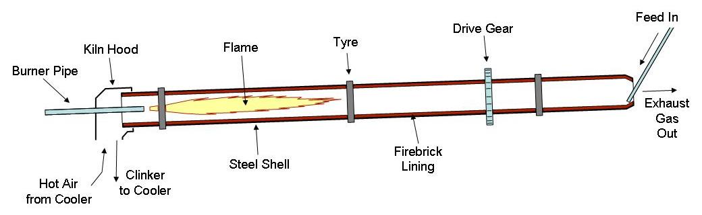
Figure 2.1. Diagram of rotary cement kiln (image in public domain).

Materials

Pavement Materials

Base Material Sources
Two recycled pavement materials and a road surface gravel were used as the base material treated with cement kiln dust in this study. Recycled pavement material (RPM) was provided by WK Construction Company, Inc. The RPM was taken during the annual summer repaving project in the City of Madison, Wisconsin from the vicinity of Muir Field Road and Cornwood Road in 2006. The material consists of pulverized asphalt blended with crushed limestone base. Recycled asphalt pavement (RAP) was obtained from Payne and Dolan, Inc. in Verona, Wisconsin. This material is pulverized asphalt pavement with no base material included. Road surface gravel (RSG) was blended from three materials: gravel from Yahara Materials, washed limestone fines from Rosenbaum Crushing and Excavating, and pit run from Wimme Sand and Gravel. The materials were air dried, sieved past the 19 mm (3/4 “) sieve, and mixed at a ratio of 1:0.2:0.3 Wimme:Rosenbaum:Yahara by weight to yield a material typical of RSG gradation. The constructed RSG meets the gradation requirements of Grading E and F surface courses described in AASHTO M 147.

Base Material Properties
Physical properties, compaction characteristics, and classifications of the tested pavement materials are presented in Table 3.1. Particle size distributions for the pavement materials as tested are presented in Figure 3.2. All aggregates used in testing were scalped above 19 mm (3/4 in) to avoid having to make 152 mm (6 in) diameter by 305 mm (12 in) tall resilient modulus specimens as limited aggregate was available. About 11% of the RPM and 1.5% of the RAP was scalped. Since the RSG was generated by blending no scalping was necessary. Compaction curves were performed at standard effort in accordance with ASTM D 698 Method C. Asphalt content was determined in accordance with ASTM D 6307. The compaction curves for the base materials, as well as Grade 2 gravel, are given in Figure 3.3. The compaction curves are very similar showing that these materials are not sensitive to moisture content and are comparable to typical aggregate curves. Road surface gravel had the highest maximum dry unit weight (MDUW) while RAP had the lowest. Maximum dry unit weight is a function of particle size distribution with more well graded distributions packing more densely. Recycled pavement material has a coefficient of uniformity of 88 compared to 24 for RAP and RSG. Recycled asphalt pavement also contains less fines than RPM and RSG. Recycled asphalt pavement and RPM contain asphalt which has a lower specific gravity than aggregate.

Cement Kiln Dust
Cement kiln dust was obtained from the Lafarge Davenport Cement Plant in Buffalo, Iowa. The Davenport plant is a dry process plant with a four-stage preheating system and a 60 m (197 ft) long kiln that heats material to 1480 °C (2700 °F). In addition to local limestone, raw materials used at the Davenport plant include coal fly ash and alum process residue, a by-product of the paper industry. Coal and coke are supplemented with waste oils as kiln burner fuel. Chemical analysis of the CKD, provided by the manufacturer, is presented in Table 3.2 along with chemical compositions found in the literature. The chemical compositions of CKD vary widely. The chemical composition of Davenport CKD is within the bounds found in the literature.

Table 3.1. Properties of recycled pavement materials and road surface gravel.
Material | Gravel Size Fraction¹ | Sand Size Fraction² | Fines Fraction³ | C_{u}⁴ | C_{c}⁵ | γ_{d max}⁶ | w_{opt}⁷ | Asphalt  Content | Classification
Material | (%) | (%) | (%) | C_{u}⁴ | C_{c}⁵ | (kN/m³) | (%) | (%) | USCS | AASHTO
RAP | 39.2 | 55.2 | 5.6 | 24 | 1.0 | 19.59 | 9.6 | 6.5 | SW-SM | A-1-a
RPM | 40.6 | 47.8 | 11.6 | 88 | 2.8 | 20.81 | 8.8 | 4.5 | SW-SM | A-1-a
RSG | 25.5 | 60.9 | 13.6 | 24 | 1.8 | 21.47 | 6.6 | - | SM | A-1-b
¹ 4.75 to 19 mm; ² 0.075 to 4.75 mm; ³ < 0.075 mm; ⁴coefficient of uniformity; ⁵coefficient of curvature; ⁶ maximum dry unit weight; ⁷optimum moisture content, γ_{d max} and w_{opt} detemined with ASTM D 698, asphalt content determined with ASTM D 6307, effective grain size, D₁₀ for RPM and RSG determined by extrapolation, material properties reported are as tested.

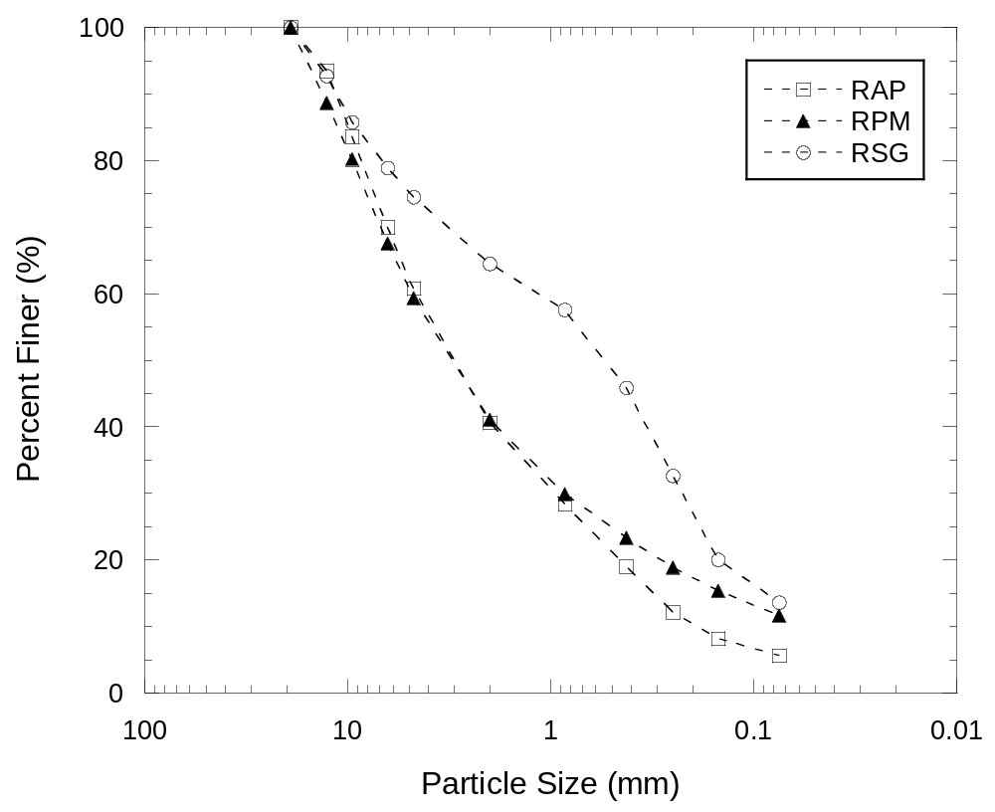
Figure 3.2. Particle size distributions for recycled pavement materials and road surface gravel as tested.

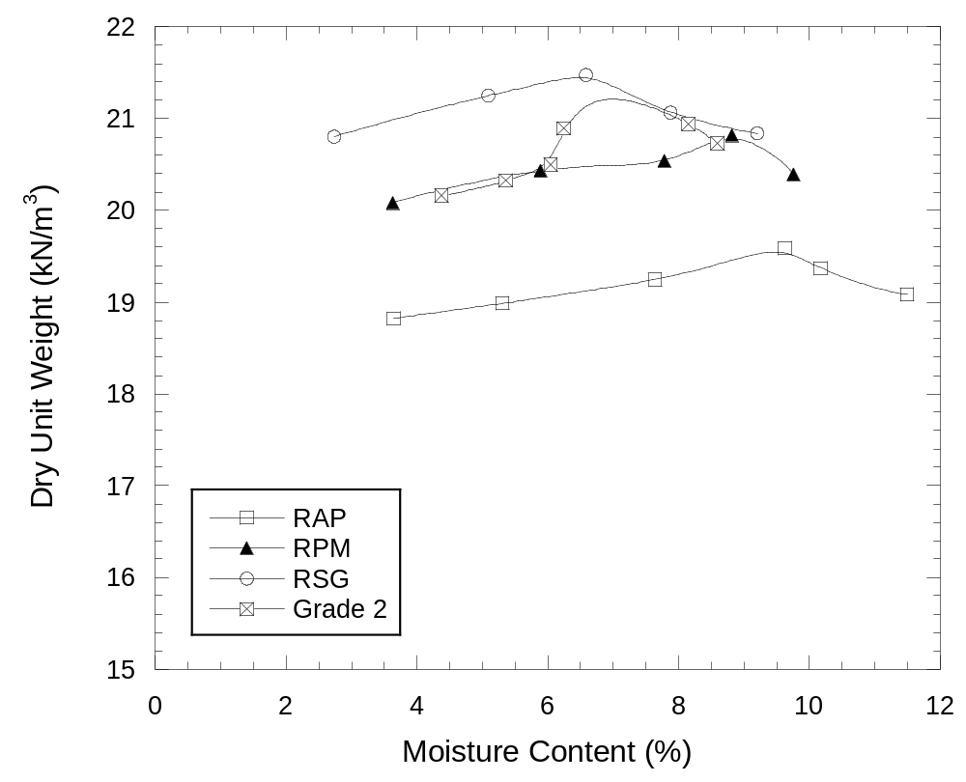
Figure 3.3. Standard Proctor compaction curves for untreated materials.

Table 3.2. Chemical composition of Davenport and other CKDs.
Component | Davenport CKD | 63 Fresh CKDs
Component | Davenport CKD | Mean | S.D. | COV (%) | Max. | Min.
CaO | 54.43 | 43.99 | 8.01 | 18 | 61.28 | 19.40
SiO₂ | 14.69 | 15.05 | 4.74 | 31 | 34.30 | 2.16
Al₂O₃ | 3.66 | 4.43 | 1.82 | 41 | 10.50 | 1.09
Fe₂O₃ | 2.24 | 2.23 | 1.04 | 47 | 6.00 | 0.24
MgO | 2.28 | 1.64 | 0.68 | 41 | 3.50 | 0.54
SO₃ | 10.50 | 6.02 | 3.93 | 65 | 17.40 | 0.02
Na₂O | 0.25 | 0.69 | 1.02 | 147 | 6.25 | 0.00
K₂O | 5.05 | 4.00 | 3.01 | 75 | 15.30 | 0.11
TiO₂ | 0.32 | - | - | - | - | -
P₂O₅ | 0.10 | - | - | - | - | -
Mn₂O₃ | 0.46 | - | - | - | - | -
SrO | 0.04 | - | - | - | - | -
Cl | 2.93 | - | - | - | - | -
LOI¹ | 9.41 | 21.57 | 8.50 | 39 | 42.39 | 4.20
Free CaO | - | 6.75 | 7.83 | 116 | 27.18 | 0.00
Total alkali² | 3.57 | 3.32 | 2.44 | 74 | 11.42 | 0.14
TRO³ | 42.00 | 21.49 | 12.97 | 60 | 56.08 | 1.86
HM⁴ | 2.64 | 2.33 | 1.61 | 69 | 13.91 | 0.53
Davenport CKD data provided by manufacturer. Statistics reproduced from Sreekrishnavilasam et al. (2006). Components listed as % by mass of CKD. ¹LOI = loss on ignition; ²Total alkali = Na₂O + 0.658K₂O; ³TRO = total reactive oxide = CaO + MgO - LOI - (K₂O + Na₂O); ⁴HM = hydration modulus = CaO/(SiO₂ + Al₂O₃ +Fe₂O₃).

Methods

Specimen Preparation
Untreated aggregate specimens were prepared as follows: (1) the water content of the aggregate was measured, (2) water was added to the un-dried aggregate to meet the optimum moisture content, (3) the mixture was tempered in a plastic bag for at least 16 hours before (4) compaction to 95% of maximum dry density as obtained from the standard Proctor compaction test. California bearing ratio (CBR) specimens were compacted in three lifts of equal mass and thickness. Resilient modulus specimens were compacted in six lifts of equal mass and thickness in a split mold 102 mm in diameter and 203 mm in height. Testing was performed soon after compaction.
Cement kiln dust treated specimens were prepared as follows: (1) the water content of the aggregate was measured (about 0.7% for RSG and between 3 and 4% for RAP and RPM), (2) CKD was added to the aggregate at its existing water content without drying to obtain the required CKD to dry aggregate ratio, (3) the CKD was blended with the aggregate until the mixture had a uniform color, (4) an amount of water was measured such that the mixture would be at the required water content after an hour of sitting in a open pan, (5) water was added to the mixture with a spray bottle and blended until uniform, (6) the mixture was mounded and let sit for 1 hour before compaction, (7) CKD treated specimens were compacted to 95% of maximum dry unit weight in PVC molds measuring 102 mm in diameter by 203 mm tall in six lifts of equal mass and thickness for resilient modulus/unconfined compressive strength (UCS) testing and in 152 mm compaction molds in three lifts of equal mass and thickness for CBR testing. The inside walls of the resilient modulus molds were coated with petroleum jelly to ease extrusion. (8) After compaction, all specimens were wrapped in plastic and cured in the molds at 100% relative humidity and 24 °C, and (9) specimens were unwrapped and resilient modulus/UCS specimens were extruded from the PVC molds prior to testing.
The one-hour waiting period between mixing and compaction is to simulate the delay in the field from when the chemical treatment first contacts the moist soil or water to when compaction occurs (American Coal Ash Association 2003). Extra water (over the amount required to be at the optimum moisture content) was added to the aggregate-CKD mixture. The amount of extra water needed was determined during the compaction tests. The total moisture content before the delay was calculated with the equation:
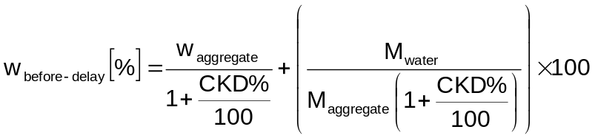 | (4.)
where w_{aggregate} is the existing moisture content of the aggregate, M_{water} is the mass of water added to the aggregate-CKD mixture, M_{aggregate} is the dry mass of the aggregate, and CKD% is the CKD content. The moisture content of the mixture after the delay was measured, and the difference in moisture content calculated by:
 | (4.)
The extra water required to be at the optimum moisture content after the one-hour delay is:
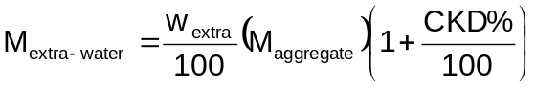 | (4.)

California Bearing Ratio
CBR was performed in accordance with ASTM D 1883. Specimens were tested un-soaked with an overburden of 4.54 kg. Due to a shortage of metal molds, PVC molds (Figure 4.4) were machined from 152 mm internal diameter schedule 40 PVC pipe and reinforced with two stainless steel pipe clamps. These molds were used for CKD treated specimens because of the curing times required and the limited supply of metal molds. Volumes of the molds were measured using the water-filling method described in ASTM D 698. All mold volumes were within the standard and are presented in Appendix A. During CBR testing the PVC mold was locked down to the compaction frame with a metal collar.

Resilient Modulus
NCHRP 1-28A describes three loading procedures. Procedure 1a is meant for unbound granular base and subbase material. Procedures 1b and 2 are meant for unbound granular and cohesive subgrade materials, respectively. Procedure 1a applies higher confining and deviator stresses, more loading sequences, and applies deviator stress for a shorter duration (0.1 s versus 0.2 s) than Procedures 1b and 2. No standard exists for chemically stabilized material. The load sequences for Procedures 1b and 2 are presented in Table 4.3and Table 4.4 respectively.

Laboratory Procedure
Procedure 2 was used for CKD treated specimens. The cohesive procedure was used because resilient modulus testing of chemically stabilized soil at UW-Madison had previously been performed with cohesive procedures, the reasoning being that cementation should result in material with behavior more like cohesive soil than granular. Procedure 1b was used for untreated specimens because the loading scheme is more similar to Procedure 2 than Procedure 1a. The loading protocols for Procedures 1b and 2 are presented in Table 4.3 and Table 4.4 respectively.
After curing and extrusion, treated specimens were soaked for five hours, each in a 5-gallon (approximately 28 cm diameter by 38 cm tall) bucket. The specimens were then allowed to drain for 5 to 10 min before being sealed in plastic bags until testing later on the same day.
Untreated specimens were placed in the testing cell. The specimens contained enough fines that they could stand unconfined while applying the rubber membrane, o-rings, cell wall, and top plate. A small confining pressure (between 7 and 14 kPa) was applied. Water was allowed to flow up through the specimens for five hours and allowed to drain for 5 to 10 min before testing. Untreated specimens were soaked because all treated specimens were soaked to allow comparison with freeze-thaw specimens. Confinement allowed untreated specimens to retain structural integrity during the soaking period in the testing cell.
NCHRP 1-28A requires linear variable displacement transducers (LVDTs) to be mounted inside the pressure cell to the specimen at the quarter points or to the end platens if the specimen is grouted to the platens. External LVDTs were used in this testing program due a workable internal mounting system being unavailable. An internal load cell is also specified in the standard but was unfeasible in the current configuration.
All specimens had a thin non-woven geotextile on each end between the specimen and aluminum platens. A rubber membrane was placed around the specimen and platens and secured with two o-rings around each platen. The acrylic cell wall and top plate were put in place and tightened with washers and nuts via threaded rods running between the bottom and top plates. The plunger was lubricated with WD-40 and inserted through the plate to make contact with the top platen. Vacuum grease was applied to the seam between the plunger and top plate to maintain cell pressure during the test. The triaxial cell was placed in the testing frame (Figure 4.5) and secured with clamps. A 1 in ball bearing was placed on the plunger so the hydraulic piston to provide a point contact between the hydraulic piston and the soil specimen. The loading sequences and data collection were controlled using Version 7 of a custom LabView testing program created by Dr. Peter Bosscher running in LabView 8.2.
Prior to testing the LVDTs, load cell, and pressure controller were calibrated. See Appendix B for these calibrations.

Resilient Modulus Model
NCHRP 1-28A defines resilient modulus (M_{r}) as:
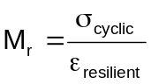 | (4.)
where _{resilient} is the recoverable strain and _{cyclic} is the cyclic stress. Cyclic stress is related to deviator stress by:
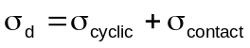 | (4.)
where σ_{contact} is the contact stress that keeps the axial load plunger in contact with the specimen and has a magnitude of 20% of the confining pressure (σ₃) in the NCHRP 1-28A standard.
The model fit to resilient modulus data from NCHRP 1-28A is:
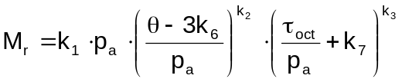 | (4.)
where p_{a} is atmospheric pressure (101.3 kPa),  is bulk stress, _{oct} is octahedral shear stress, and k₁, k₂, k₃, k₆, and k₇ are model fitting parameters. Bulk stress is defined as:
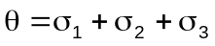 | (4.)
where σ₁ is the major principal stress, ₂ is the intermediate principal stress, and σ₃ is the minor principal stress. In a triaxial cell ₂ = ₃ and so the bulk stress equation becomes:
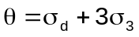 | (4.)
where _{d} = ₁ - ₃ is the deviator stress. Octahedral shear stress is defined as:
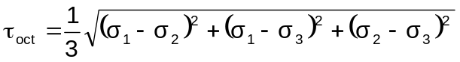 | (4.)
But, because ₂ = ₃, reduces to:
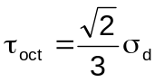 | (4.)

Data Processing
Data from the last 5 cycles of each loading sequence (except for Sequence 0) was used to calculate the resilient modulus for each loading. The model given in (4.) was fit to the data using SOLVER within Microsoft Excel employing a normal least-square-error method. The fitting parameters were then used to calculate resilient modulus under the desired conditions.
Plastic strain was calculated by summing the plastic strains during each loading sequence after the conditioning sequence (Sequence 0).

Unconfined Compression
Unconfined compressive strength tests were conducted in accordance with ASTM D 5102. Unconfined compressive strength tests were performed on specimens subsequent to resilient modulus testing. Load levels used in resilient modulus testing were such that no apparent damage was observed in the specimens. ASTM D 5102 dictates a strain rate between 0.5% and 2%/min, but 0.21%/min was used due to specimen stiffness (Acosta et al. 2002). Untreated recycled pavement materials were not tested for unconfined compressive strength.

Freeze-Thaw Durability
Durability testing of CKD stabilized materials was performed based partly on the test procedures specified in ASTM D 6035. Specimens were made in the same manner as other resilient modulus specimens except that some contained thermocouples. After three layers were compacted a thermocouple was placed in the center of some specimens before compacting the final three layers. Specimens were cured for 7 days. Following extrusion, specimens were soaked for five hours and allowed to drain for 5 to 10 min. Specimens were then wrapped in plastic to prevent moisture content changes and subjected to 5 or 10 cycles of freeze-thaw. Internal temperature was monitored to ensure freezing and thawing. The end of a freezing cycle was defined as an internal specimen temperature less than -15 °C and the end of a thaw cycle more than 15 °C. Temperature was monitored for some of the specimens during all freeze-thaw cycles. Freezing took approximately 9-10 hours while thawing took approximately 5-6 hours. Actual times the specimens were left in the freezer or thawing varied, but one full cycle (freeze and thaw) was about 24 hours. The temperature in the freezer was approximately -19°C while room temperature was approximately 22°C. The freezing point of the specimens was between -1 and -3°C. After 5 or 10 cycles, resilient modulus and unconfined compressive strength were measured. Comparisons were made to specimens that were soaked for 5 hours after 7-day curing but not subjected to freeze-thaw cycles.

Leaching Potential
Leaching potential was tested in accordance with ASTM D 3987 Water Leach Test. Untreated material, CKD, and each material blended with 20% CKD were tested. Treated and untreated materials were prepared as if for resilient modulus or CBR but were not compacted. The pure cement kiln dust was moistened until the material stopped steaming and reacting violently. Treated materials and the CKD were cured in plastic bags in a sealed bucket for 7 days before testing. After the leach test, all water samples were tested for pH, Eh, conductivity, and trace metals. An important note is that ASTM D 3987 is not intended to represent the metals concentrations, but is meant to represent the pH, that would occur in real-world leachate.

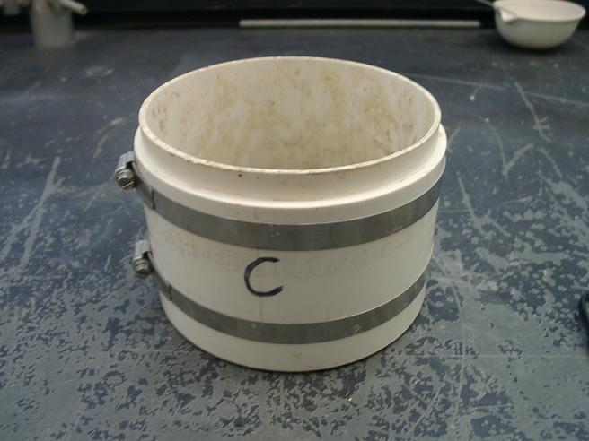

Figure 4.4. PVC 6” compaction mold reinforced with stainless steel pipe clamps.

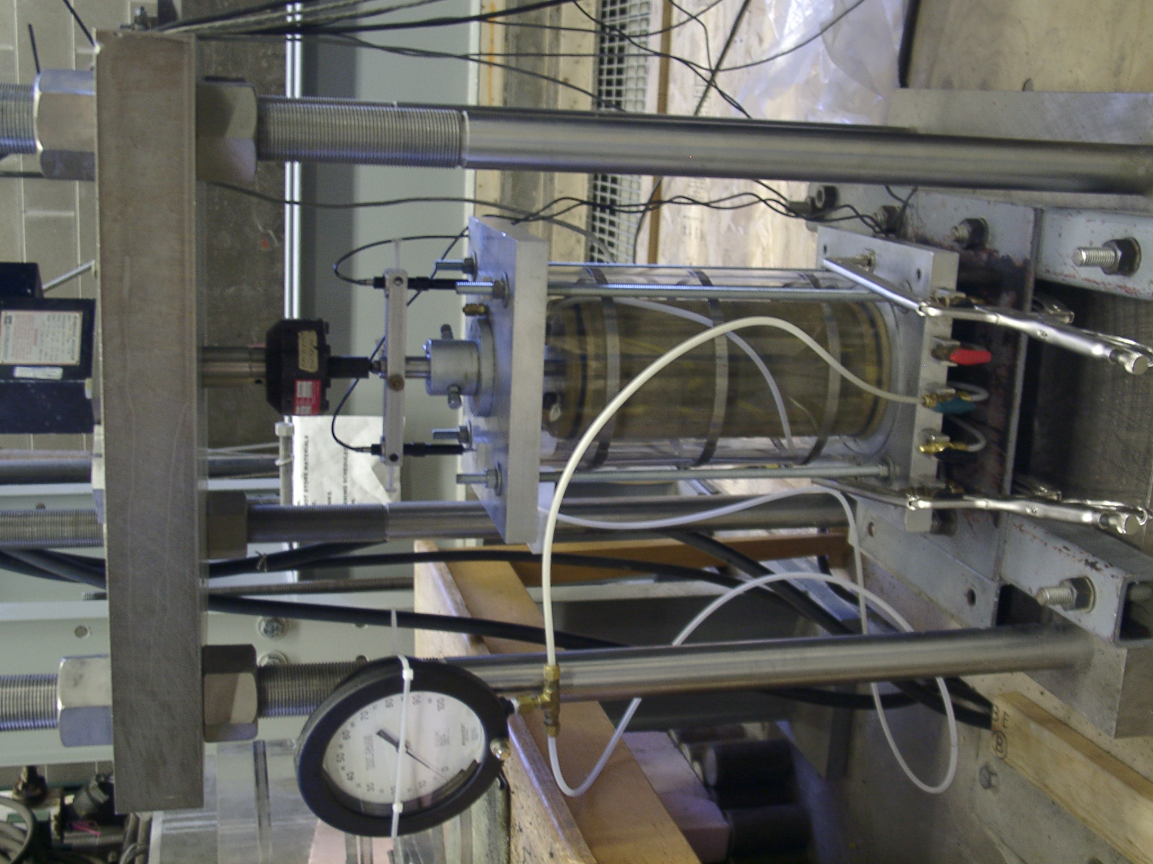
Load cell
LVDT
Cell pressure line
Hydraulic actuator
Figure 4.5. Resilient modulus testing apparatus.
Soil specimen in membrane
Table 4.3. Loading protocol for NCHRP 1-28A Procedure 1b.
Sequence | Confing Pressure | Contact Stress | Cyclic Stress | Maximum Stress | Repetitions
Sequence | (kPa) | (kPa) | (kPa) | (kPa) | Repetitions
0 | 27.6 | 5.5 | 55.2 | 60.7 | 1000
1 | 13.8 | 2.8 | 6.9 | 9.7 | 100
2 | 27.6 | 5.5 | 13.8 | 19.3 | 100
3 | 41.4 | 8.3 | 20.7 | 29.0 | 100
4 | 55.2 | 11.0 | 27.6 | 38.6 | 100
5 | 82.8 | 16.6 | 41.4 | 58.0 | 100
6 | 13.8 | 2.8 | 13.8 | 16.6 | 100
7 | 27.6 | 5.5 | 27.6 | 33.1 | 100
8 | 41.4 | 8.3 | 41.4 | 49.7 | 100
9 | 55.2 | 11.0 | 55.2 | 66.2 | 100
10 | 82.8 | 16.6 | 82.8 | 99.4 | 100
11 | 13.8 | 2.8 | 27.6 | 30.4 | 100
12 | 27.6 | 5.5 | 55.2 | 60.7 | 100
13 | 41.4 | 8.3 | 82.8 | 91.1 | 100
14 | 55.2 | 11.0 | 110.4 | 121.4 | 100
15 | 82.8 | 16.6 | 165.6 | 182.2 | 100
16 | 13.8 | 2.8 | 41.4 | 44.2 | 100
17 | 27.6 | 5.5 | 82.8 | 88.3 | 100
18 | 41.4 | 8.3 | 124.2 | 132.5 | 100
19 | 55.2 | 11.0 | 165.6 | 176.6 | 100
20 | 82.8 | 16.6 | 248.4 | 265.0 | 100

Table 4.4. Loading protocol for NCHRP 1-28A Procedure 2.
Sequence | Confing Pressure | Contact Stress | Cyclic Stress | Maximum Stress | Repetitions
Sequence | (kPa) | (kPa) | (kPa) | (kPa) | Repetitions
0 | 27.6 | 5.5 | 48.3 | 53.8 | 1000
1 | 55.2 | 11.0 | 27.6 | 38.6 | 100
2 | 41.4 | 8.3 | 27.6 | 35.9 | 100
3 | 27.6 | 5.5 | 27.6 | 33.1 | 100
4 | 13.8 | 2.8 | 27.6 | 30.4 | 100
5 | 55.2 | 11.0 | 48.3 | 59.3 | 100
6 | 41.4 | 8.3 | 48.3 | 56.6 | 100
7 | 27.6 | 5.5 | 48.3 | 53.8 | 100
8 | 13.8 | 2.8 | 48.3 | 51.1 | 100
9 | 55.2 | 11.0 | 69.0 | 80.0 | 100
10 | 41.4 | 8.3 | 69.0 | 77.3 | 100
11 | 27.6 | 5.5 | 69.0 | 74.5 | 100
12 | 13.8 | 2.8 | 69.0 | 71.8 | 100
13 | 55.2 | 11.0 | 96.6 | 107.6 | 100
14 | 41.4 | 8.3 | 96.6 | 104.9 | 100
15 | 27.6 | 5.5 | 96.6 | 102.1 | 100
16 | 13.8 | 2.8 | 96.6 | 99.4 | 100

Compaction Characteristics

Figure 5.6 shows the compaction curves of CKD-treated RAP, RPM and RSG. Table 5.5 summarizes the compaction data. Figure 5.7 shows the relationships between optimum moisture content/maximum dry unit weight and CKD content as determined from standard Proctor compaction test. The treated curves for a given material are similar to the untreated curves, but are less sensitive to moisture content. Optimum moisture content (OMC) increased and maximum dry unit weight (MDUW) decreased with increased CKD content. The delay between mixing to compaction allows bonds to form between particles that must be overcome during compaction.
Many previous studies found that the MDUW of granular soils increased with CKD content for low contents. This was not seen in this study due to the delay between mixing and compaction and the particle gradations of the three base materials. All three materials are well graded and contain significant amounts of fines. These properties would limit pore filling and result in the CKD displacing aggregate.
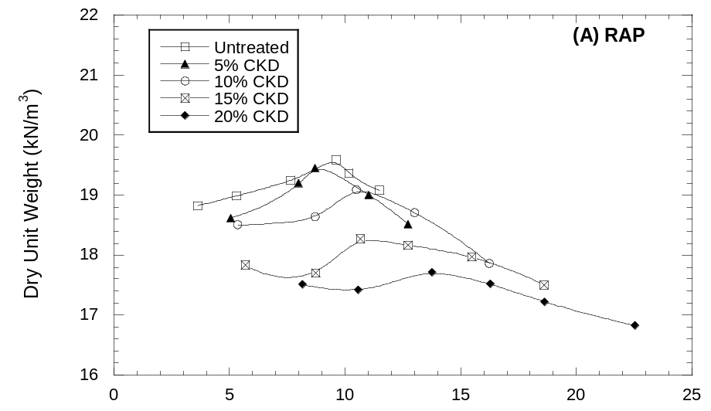
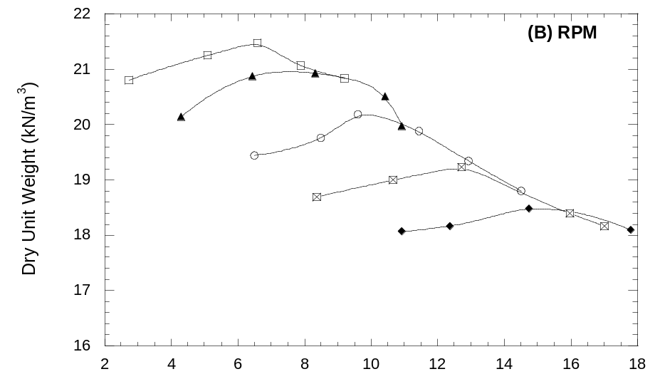
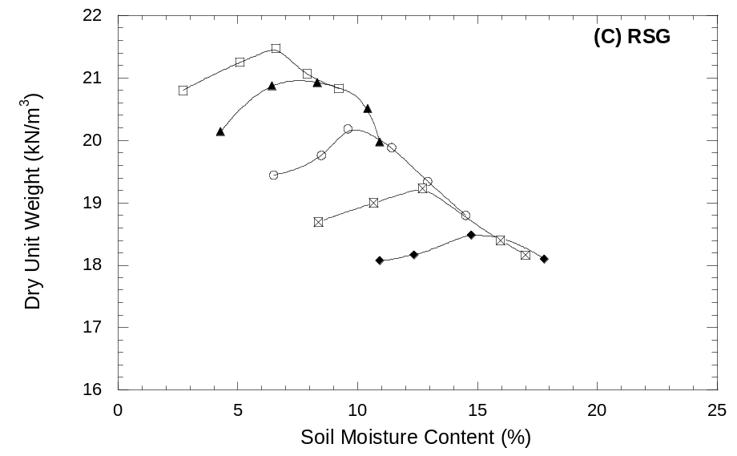
Figure 5.6. Compaction curves for CKD-treated base materials.

Table 5.5. Standard Proctor maximum dry unit weight and optimum moisture content with CKD content.
CKD Content | RAP |  | RPM |  | RSG
CKD Content | OMC | MDUW | OMC | MDUW | OMC | MDUW
(%) | (%) | (kN/m³) | (%) | (kN/m³) | (%) | (kN/m³)
0 | 9.6 | 19.59 | 8.8 | 21.81 | 6.6 | 21.47
5 | 8.7 | 19.45 | 10.0 | 20.15 | 7.5 | 21.00
10 | 10.3 | 19.10 | 11.8 | 19.14 | 9.6 | 20.18
15 | 11.0 | 18.32 | 13.9 | 18.66 | 12.2 | 19.26
20 | 13.8 | 17.71 | 14.8 | 17.96 | 14.8 | 18.48
OMC = optimum moisture content, MDUW = maximum dry unit weight, OMC reported is soil moisture content.

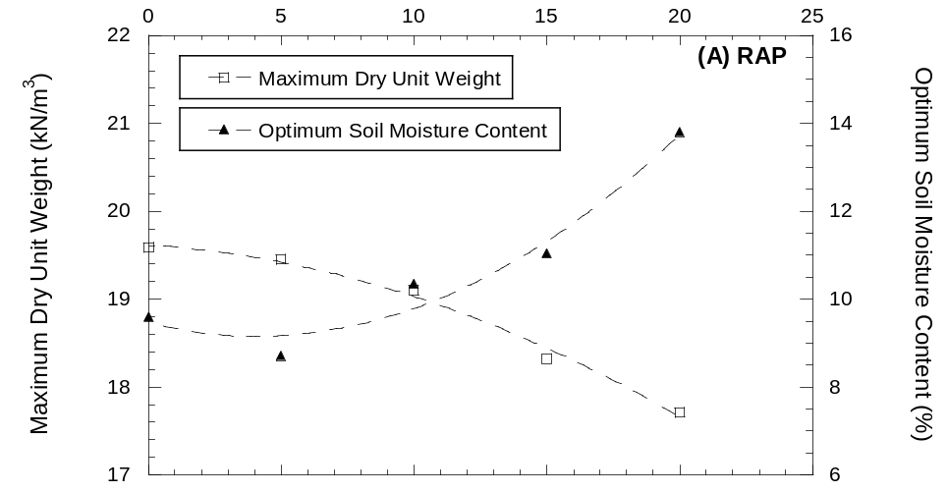
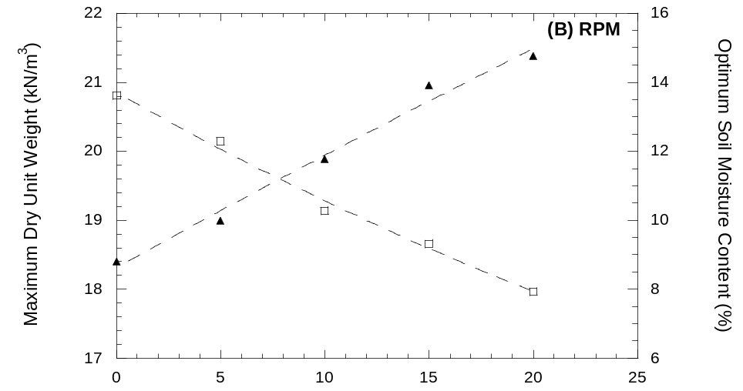
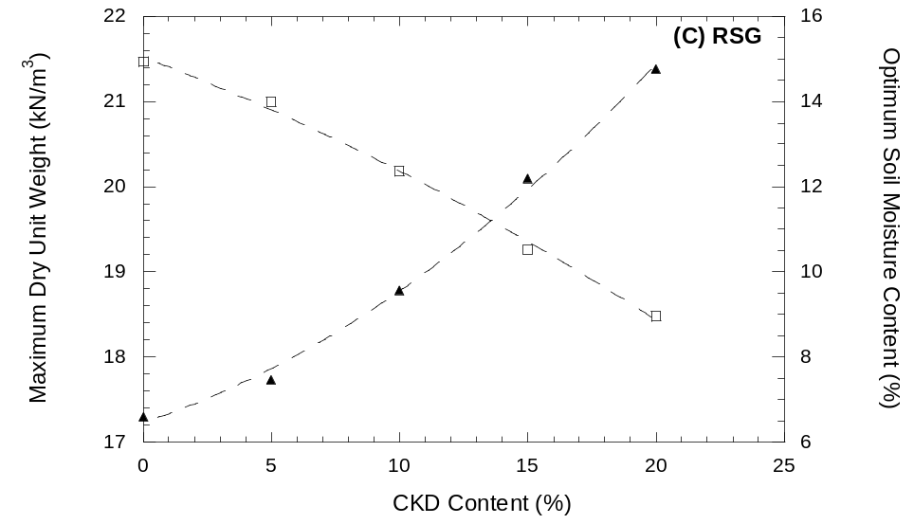
Figure 5.7. Standard Proctor Maximum dry unit weight and optimum soil moisture content with CKD content for (A) RAP, (B) RPM, and (C) RSG. CKD content is by dry weight of aggregate.

California Bearing Ratio

Table 6.6 summarizes the CBR data of the samples compacted at 95% of the MDUW and OMC as determined from the standard Proctor compaction test and cured for 7 days (except the untreated samples). Figure 6.8 shows the changes in CBR with CKD treatment CBR continuously increases with CKD content for RAP and RPM up to a CKD content of 20%. The CBR of RAP increased from 7 to 66 while the CBR of RPM increased from 13 to 87. Cementation of the particles adds to penetration resistance, i.e., bearing capacity.
Road surface gravel demonstrated a different relationship. The CBR of RSG increased from 21 for untreated material to peak at 124 with 10% CKD. CBR then decreased with increased CKD content to 20% CKD. The higher CBRs for RSG compared to those for RPM and RAP up to 10% CKD content may be related to the higher fines content and the nature of the fines: crushed limestone. Such fines should be angular, lending to better particle interlock. Limestone can also contain clay minerals, but the non-plastic nature of the RSG does not support this. Regardless, pozzolanic reactions are relatively slow and should not affect strength significantly after only 7 days. The reduced CBR of the RSG at higher CKD contents may be due to the reduction of inter-particle interaction as the aggregate particles begin to float in the increasing amounts of CKD combined with the already existing fines in the RSG. Figure 6.9 shows normalized increase in CBR as indicator of the degree of improvement provided by CKD stabilization. CBR can be improved 6 to 9 times depending on the base material being improved and CKD content.
CBR of stabilized aggregate could not be found in the literature, although fat clay showed an increase in CBR from 4 for un-stabilized soil to 17 with a CKD content of 25%. Li et al. (2007) found that the un-soaked CBR of RPM compacted to field density and moisture content increased from 9 for un-stabilized material to 89 when stabilized with 10% Class C fly ash and cured for 7 days. The results for RPM with 20% CKD and RSG with a CKD content of 5 to 20% compare well with those seen by Li et al. (2007). shows typical CBRs of materials used in road construction. In addition, CBR tests on Wisconsin Department of Transportation (WisDOT) Grade 2 gravel, a base material, compacted to 95% of standard Proctor MDUW yielded and average CBR of 58. With appropriate CKD treatment the base materials investigated (RPM, RAP, and RSG) can be improved to qualify as a base course material (i.e., having a CBR of 50 or more). Without treatment, based only on CBR, RAP, and RPM do not qualify even as an acceptable subbase material while RSG does. However, CBR is an index property and may not reflect the stiffness behavior adequately.
Table 6.6. Summary of CBR Data.
Material | CKD | Replicate  Specimen | CBR (%)
Material | (%) | Replicate  Specimen | 0.1" | 0.2"
RAP | 0 | A | 8.1 | 9.5
RAP | 0 | B | 6.0 | 7.3
RAP | 5 | A | 30.5 | 32.9
RAP | 5 | B | 26.4 | 25.3
RAP | 10 | A | 41.6 | 37.8
RAP | 10 | B | 39.1 | 37.3
RAP | 15 | A | 60.3 | 53.5
RAP | 15 | B | 43.7 | 43.9
RAP | 20 | A | 67.6 | 61.7
RAP | 20 | B | 63.3 | 53.6
RPM | 0 | A | 15.4 | 20.5
RPM | 0 | B | 10.0 | 13.3
RPM | 5 | A | 32.4 | 34
RPM | 5 | B | 34.0 | 38.7
RPM | 10 | A | 51.0 | 49.5
RPM | 10 | B | 46.0 | 46.7
RPM | 15 | A | 57.0 | 54.7
RPM | 15 | B | 63.5 | 61.3
RPM | 20 | A | 88.4 | 84.0
RPM | 20 | B | 85.2 | 74.3
RSG | 0 | A | 19.3 | 14.9
RSG | 0 | B | 22.0 | 19.5
RSG | 5 | A | 85.0 | 81.0
RSG | 5 | B | 92.0 | 86.0
RSG | 10 | A | 125.0 | 114.3
RSG | 10 | B | 123.0 | 114.3
RSG | 15 | A | 84.5 | 78.0
RSG | 15 | B | 108.0 | 97.3
RSG | 20 | A | 86.0 | 82.7
RSG | 20 | B | 84.0 | 74.0
A and B represent replicate specimens.
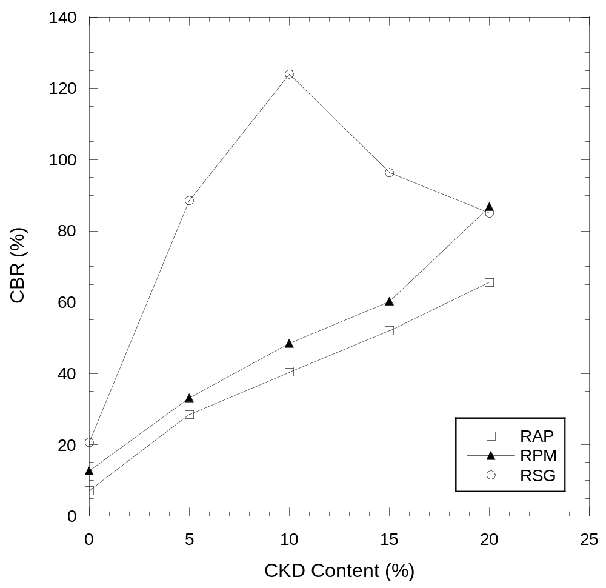
Figure 6.8. Average CBR of stabilized RAP, RPM, and RSG with CKD content. CBR reported for 0.1” penetration. Each point is the average of two replicate tests.
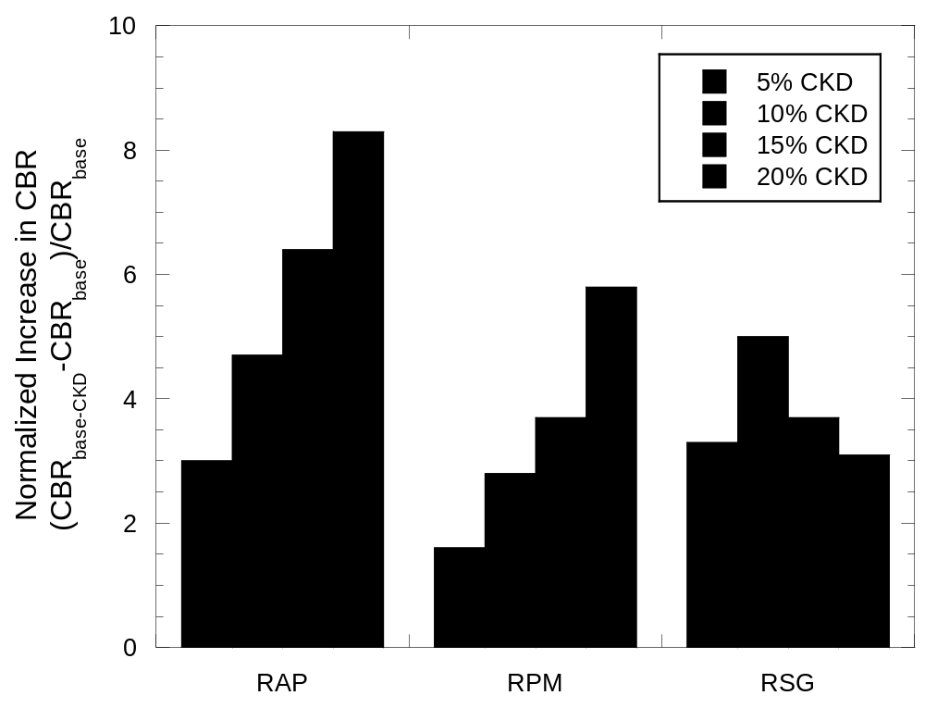
Figure 6.9. Normalized increase in CBR of stabilized base materials (RAP, RPM, and RSG) with CKD content. Each point is the average of two replicate tests.

Table 6.7. Typical CBR for unbound materials (Hunt 1986).
Pavement Course | Material | CBR
Pavement Course | Material | (%)
Base Course | Good quality crushed rock | >80
Base Course | Good quality gravel | 50 to 80
Subbase Course | Good quality soil | 30 to 50
Subbase Course | Very good | 20 to 30
Subgrade | Good to fair | 10 to 20
Subgrade | Questionable to fair | 5 to 10
Subgrade | Poor | <5

Resilient Modulus

Untreated Aggregate
Table 7.8 shows the resilient moduli and plastic strains of untreated materials (base materials). Resilient modulus was calculated at a bulk stress of 208 kPa and octahedral shear stress of 48.6 kPa and referred to as “summary modulus”. These stress levels are considered typical in base course layers (NCHRP 1-28A). Replicate tests were performed on each material at 95% of the maximum dry unit weight and optimum water content as determined from the standard Proctor compaction test. Recycled pavement material had the highest resilient modulus and RSG the lowest. Recycled pavement material contains more gravel than RSG and less asphalt than RAP resulting in a stiffer structure. Recycled asphalt pavement and RPM have a similar plastic strain while the plastic strain of RSG is more than twice that of the other materials. The gap-graded particle size distribution of the RSG and the presence of larger amounts of fines in RSG compared to the other two materials result in less particle interlock and may be the cause of more plastic strains.

Aggregate-Cement Kiln Dust Mixtures
The summary moduli of CKD-treated materials are listed in Table 7.9, Table 7.10, and Table 7.11. Figure 7.10 shows the resilient moduli of RAP, RPM, and RSG stabilized with up to 20% CKD and cured for 7 to 56 days along with the relative change compared to untreated material. These tests were performed on specimens at their 95% of the maximum dry unit weight and optimum water content as determined from the standard Proctor compaction test. Summary resilient modulus was again calculated at a bulk stress of 208 kPa and octahedral shear stress of 48.6 kPa. In almost all cases the modulus is higher than that of the untreated material.
Modulus versus CKD content data for each curing time was fitted with a linear regression for each material having the slope (₁) as:
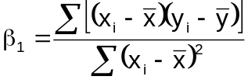 | (7.)
The standard error (SE) of the regression slope is defined by the equation:
 | (7.)
Trend significance was evaluated by determining if the regression slope was statistically different from zero. The null-hypothesis of the slope being zero was tested with a two-tailed analysis using the Student’s t-test performed with n-2 degrees of freedom and α = 0.05. If the probability of falsely rejecting the null-hypothesis is greater than α, the null-hypothesis cannot be rejected. In this case, the slope is not statistically different from zero and cannot be said to have a trend.
summarizes the trend of resilient modulus with CKD content for each curing time. In only two cases was there any significant trend. Recycled asphalt pavement and RPM cured for 7 days demonstrated an increasing resilient modulus with CKD content. Otherwise, predominantly there was no significant trend with CKD content. implies that the lowest CKD content of 5% essentially provides the cementation improvement and additional CKD is not effective in increasing modulus for strains in the range of the resilient modulus test (10⁻³ to 10⁻⁴).
Figure 7.11 shows the distributions of summary resilient moduli for each stabilized material for each curing period. There is relatively small gain with increasing curing times beyond 7 days for RAP and RSG, but there is some gain for RSG between 28 and 56 days. Pozzolanic reactions may account for the continued gain in stiffness as they occur more slowly than cementation reactions. The non-plastic nature of RSG does not support this, and limestone fines are generally inert. However, soft limestones can contain clay minerals that are effecting a reaction. A one-tailed Student’s t-test with α = 0.05 determined only the resilient modulus of RPM treated with 5 and 10% CKD cured for 7 days was not significantly different from the resilient modulus of untreated material. The resilient modulus for all other combinations of CKD content-curing time was higher than untreated material indicating the improvement realized by CKD addition. The normalized increase in average summary resilient modulus of stabilized material is presented in Figure 7.12. Recycled asphalt pavement improved between 30 and 50%. Recycled pavement material improved 15 to 40%. Road surface gravel had the greatest improvement of 125 to 200%. The maximum reported improvement by Zaman et al. (1999) for CKD-stabilized crushed limestone aggregate was 73%. Only RSG exceeded this relative increase in modulus perhaps again due to the presence of crushed limestone fines in addition to cementation.
Resilient modulus shows mixed trends with curing time, but Figure 7.12 shows that moduli tend to be higher at 56 days of curing when compared to moduli at 7 days.
Tests (NCHRP 1-28A Procedure 2) on WisDOT Grade 2 gravel compacted to 95% of MDUW determined by standard Proctor effort yielded an average summary modulus of 112 MPa. Comparison to unstabilized materials in this study show only RSG had a modulus less than the modulus of Grade 2 gravel. All stabilized materials had moduli higher than the modulus of Grade 2 gravel including RSG.

Plastic Deformation
Plastic deformation data are summarized in Table 7.9, Table 7.10, and Table 7.11. Figure 7.13 shows accumulated plastic strains for each specimen at the end of each test as a function of CKD content and curing time. Except for material stabilized with 5% CKD and cured for 7 days all deformations induced during the resilient modulus test were between about 0.7 and 0.18%.
Comparisons with the untreated materials are not feasible because of the different loading sequences between Procedures 1b and 2 of NCHRP 1-28A. There are three load sequences that are the same between the two procedures, but plastic strain is also dependent on what the confining and deviator stresses were in previous load sequences. If the confining stress is lower than the previous one or two sequences, the observed plastic deformation may be negative (specimen lengthening). Procedure 2 cycles the confining pressure from high to low while Procedure 1b cycles it from low to high.
Comparison can be made with the Grade 2 gravel tests as they were run with Procedure 2. The average plastic strain for Grade 2 gravel was 0.2%. Figure 7.13 shows that the plastic strain of stabilized material after at least 28 days of curing or at least 5% CKD content are less than 0.2%

Resilient Modulus Data Summary
Cement kiln dust treatment of RAP, RPM, and RSG improves resilient modulus (35 to 200%) at curing lengths of 56 days. CKD content does not significantly affect resilient modulus for curing lengths of 56 days. The performance of these CKD-stabilized materials with respect to resilient modulus and plastic strain exceeds the performance of Grade 2 gravel.

Table 7.8. Summary of resilient moduli of untreated materials.
Material | Replicate Sample | k₁ | k₂ | k₃ | k₆ | k₇ | M_{r} | M_{r avg} | ε_{plastic} | ε_{plastic avg}
 |  |  |  |  |  |  | (MPa) | (MPa) | (%) | (%)
RAP | A | 6.23×10⁻⁴ | 5.59 | -2.13 | -463.8 | 1 | 144 | 141 | 0.81 | 0.87
RAP | B | 1.50×10⁻⁴ | 6.13 | -2.43 | -464.4 | 1 | 138 | 141 | 0.92 | 0.87
RPM | A | 3.06×10⁻⁴ | 5.99 | -1.94 | -428.9 | 1 | 155 | 152 | 0.83 | 0.85
RPM | B | 86.8 | 2.24 | -1.82 | -93.9 | 1 | 149 | 152 | 0.87 | 0.85
RSG | A | 3.03×10⁻⁴ | 6.12 | -2.57 | -382.2 | 1 | 92 | 96 | 2.35 | 2.47
RSG | B | 2.70×10⁻⁴ | 6.44 | -2.73 | -343.1 | 1 | 101 | 96 | 2.59 | 2.47
Grade 2* | - | - | - | - | - | - | - | 112 | - | 0.20
Note: M_{r} = resilient modulus, ε = strain. Resilient moduli reported for bulk stress (θ) of 208 kPa and octahedral shear stress (τ_{oct}) of 48.6 kPa. A and B represent replicate specimens.
* Grade 2 gravel was tested by Justin Warner with NCHRP 1-28A Procedure 2 and the reported averages are the result of 3 tests. RAP, RPM and RSG were tested with NCHRP 1-28A Procedure 1b.

Table 7.9. Resilient modulus and unconfined compressive strength data for RAP.
CKD | Curing Time | Sample | k₁ | k₂ | k₃ | k₆ | k₇ | M_{r} | ε_{plastic} | q_{u} | E
(%) | (d) |  |  |  |  |  |  | (Mpa) | (%) | (kPa) | (Mpa)
5 | 7 | A | 2607.9 | 0.94 | -2.72 | 0 | 1 | 177 | 0.14 | 172 | 36
5 | 7 | B | 2322.4 | 1.07 | -2.85 | -6.15 | 1 | 181 | 0.15 | 149 | 36
5 | 28 | A | 2355.2 | 1.02 | -2.52 | -1.66 | 1 | 188 | 0.04 | 314 | 69
5 | 28 | B | 2192.9 | 1.10 | -2.65 | -6.97 | 1 | 191 | 0.07 | 286 | 56
5 | 56 | A | 1057.6 | 1.50 | -2.34 | -23.58 | 1 | 196 | 0.06 | 357 | 69
5 | 56 | B | 1840.2 | 1.20 | -2.37 | -10.02 | 1 | 205 | 0.04 | 374 | 101
10 | 7 | A | 2017.4 | 1.13 | -2.47 | 0 | 1 | 173 | 0.07 | 333 | 80
10 | 7 | B | 2187.0 | 1.05 | -2.31 | 0 | 1 | 189 | 0.06 | 323 | 72
10 | 28 | A | 2328.3 | 1.05 | -2.40 | -4.73 | 1 | 209 | 0.03 | 548 | 203
10 | 28 | B | 2984.4 | 0.99 | -2.56 | 0 | 1 | 224 | 0.04 | 555 | 128
10 | 56 | A | 2915.7 | 1.13 | -2.80 | 0 | 1 | 221 | 0.04 | 630 | 166
10 | 56 | B | 1659.1 | 1.41 | -2.73 | -19.16 | 1 | 223 | 0.03 | 667 | 141
15 | 7 | A | 2162.6 | 1.12 | -2.70 | -4.28 | 1 | 181 | 0.05 | 428 | 75
15 | 7 | B | 3238.7 | 1.07 | -3.24 | 0 | 1 | 196 | 0.05 | 445 | 83
15 | 28 | A | 2092.3 | 1.02 | -1.98 | 0 | 1 | 202 | 0.05 | 637 | 211
15 | 28 | B | 2253.8 | 1.05 | -2.31 | 0 | 1 | 195 | 0.03 | 765 | 211
15 | 56 | A | 2251.4 | 1.09 | -2.30 | 0 | 1 | 201 | 0.03 | 690 | 164
15 | 56 | B | 1680.5 | 1.19 | -2.14 | -12.48 | 1 | 211 | 0.03 | 799 | 175
20 | 7 | A | 1967.6 | 1.30 | -2.86 | -6.53 | 1 | 185 | 0.06 | 549 | 111
20 | 7 | B | 2564.1 | 1.06 | -2.69 | 0 | 1 | 192 | 0.06 | 587 | 112
20 | 28 | A | 1260.7 | 1.31 | -2.18 | -17.57 | 1 | 187 | 0.03 | 858 | 176
20 | 28 | B | 2103.2 | 1.01 | -2.15 | -0.61 | 1 | 190 | 0.03 | 879 | 233
20 | 56 | A | 2887.6 | 1.10 | -2.73 | 0 | 1 | 220 | 0.04 | 842 | 183
20 | 56 | B | 2305.4 | 0.97 | -2.07 | -1.14 | 1 | 211 | 0.03 | 827 | 287
Note: M_{r} = resilient modulus, ε = strain, q_{u} = unfined compressive strength, E = Young’s modulus. Resilient moduli reported for bulk stress (θ) of 208 kPa and octahedral shear stress (τ_{oct}) of 48.6 kPa. A and B represent replicated specimens.

Table 7.10. Resilient modulus and unconfined compressive strength data for RPM.
CKD | Curing Time | Sample | k₁ | k₂ | k₃ | k₆ | k₇ | M_{r} | ε_{plastic} | q_{u} | E
(%) | (d) |  |  |  |  |  |  | (Mpa) | (%) | (kPa) | (Mpa)
5 | 7 | A | - | - | - | - | - | - | - | - | -
5 | 7 | B | 2076.8 | 0.85 | -2.71 | 0 | 1 | 133 | 0.16 | 135 | 28
5 | 7 | C | 1828.2 | 1.05 | -2.26 | -9.04 | 1 | 184 | 0.16 | 125 | 34
5 | 28 | A | 2752.9 | 0.97 | -2.45 | 0 | 1 | 212 | 0.06 | 304 | 64
5 | 28 | B | 2728.7 | 0.94 | -2.56 | -0.48 | 1 | 198 | 0.05 | 313 | 64
5 | 56 | A | 2431.5 | 1.13 | -2.67 | 0 | 1 | 193 | 0.04 | 503 | 94
5 | 56 | B | 1958.3 | 1.29 | -2.80 | -11.89 | 1 | 203 | 0.05 | 489 | 104
10 | 7 | A | 2022.0 | 1.04 | -2.58 | 0 | 1 | 156 | 0.07 | 333 | 83
10 | 7 | B | 2270.5 | 1.11 | -2.93 | 0 | 1 | 161 | 0.05 | 259 | 58
10 | 28 | A | 1836.1 | 1.24 | -2.23 | -10.59 | 1 | 224 | 0.04 | 590 | 172
10 | 28 | B | 2427.4 | 1.05 | -2.45 | 0 | 1 | 199 | 0.03 | 785 | 186
10 | 56 | A | 1683.7 | 1.52 | -2.97 | -18.01 | 1 | 223 | 0.07 | 757 | 255
10 | 56 | B | 2548.1 | 1.15 | -2.73 | -4.17 | 1 | 215 | 0.03 | 711 | 161
15 | 7 | A | 2377.8 | 1.07 | -2.72 | 0 | 1 | 178 | 0.05 | 496 | 153
15 | 7 | B | 1963.4 | 1.22 | -2.61 | -4.72 | 1 | 185 | 0.04 | 523 | 126
15 | 28 | A | 2755.8 | 1.06 | -2.15 | 0 | 1 | 256 | 0.03 | 668 | 200
15 | 28 | B | 1990.4 | 0.95 | -1.67 | 0 | 1 | 206 | 0.06 | 785 | 233
15 | 56 | A | 2169.9 | 1.02 | -2.03 | 0 | 1 | 205 | 0.03 | 871 | 315
15 | 56 | B | 2415.9 | 1.08 | -2.37 | 0 | 1 | 208 | 0.03 | 1069 | 394
20 | 7 | A | 2848.5 | 1.06 | -2.86 | 0 | 1 | 199 | 0.08 | 525 | 120
20 | 7 | B | 2228.9 | 1.08 | -2.50 | 0 | 1 | 182 | 0.03 | 756 | 166
20 | 7 | C | 2307.4 | 1.14 | -2.26 | -2.53 | 1 | 226 | 0.06 | 521 | 114
20 | 28 | A | 2576.5 | 0.99 | -2.30 | 0 | 1 | 214 | 0.04 | 1025 | 366
20 | 28 | B | 2149.6 | 1.02 | -2.04 | 0 | 1 | 202 | 0.03 | 1030 | 333
20 | 56 | A | 2440.9 | 1.21 | -2.74 | -4.34 | 1 | 215 | 0.04 | 1200 | 272
20 | 56 | B | 2748.4 | 1.07 | -2.52 | 0 | 1 | 222 | 0.03 | 1195 | 298
Note: M_{r} = resilient modulus, ε = strain, q_{u} = unfined compressive strength, E = Young’s modulus. Resilient moduli reported for bulk stress (θ) of 208 kPa and octahedral shear stress (τ_{oct}) of 48.6 kPa. A and B represent replicated specimens.

Table 7.11. Resilient modulus and unconfined compressive strength data for RSG.
CKD | Curing Time | Sample | k₁ | k₂ | k₃ | k₆ | k₇ | M_{r} | ε_{plastic} | q_{u} | E
(%) | (d) |  |  |  |  |  |  | (Mpa) | (%) | (kPa) | (Mpa)
5 | 7 | A | 1228.4 | 1.82 | -3.69 | -27.54 | 1 | 198 | 0.08 | 293 | 61
5 | 7 | B | 576.8 | 2.02 | -3.19 | -51.56 | 1 | 219 | 0.06 | 276 | 61
5 | 28 | A | 3346.9 | 1.03 | -2.98 | 0 | 1 | 218 | 0.03 | 789 | 377
5 | 28 | B | 2668.8 | 1.26 | -3.05 | -6.38 | 1 | 225 | 0.03 | 678 | 133
5 | 56 | A | 3050.7 | 1.16 | -2.44 | -6.34 | 1 | 301 | 0.04 | 929 | 277
5 | 56 | B | 3227.2 | 1.27 | -3.19 | -7.73 | 1 | 265 | 0.07 | 972 | 249
10 | 7 | A | 3229.1 | 1.07 | -2.81 | -1.86 | 1 | 239 | 0.05 | 446 | 111
10 | 7 | B | 2689.8 | 1.23 | -2.92 | -10.40 | 1 | 247 | 0.05 | 508 | 80
10 | 28 | A | 549.6 | 1.85 | -2.50 | -50.72 | 1 | 219 | 0.02 | 1043 | 399
10 | 28 | B | 1391.1 | 1.41 | -2.48 | -23.85 | 1 | 222 | 0.03 | 1051 | 377
10 | 56 | A | 2685.9 | 1.13 | -2.17 | -10.77 | 1 | 308 | 0.04 | 1656 | 383
10 | 56 | B | 2222.1 | 1.63 | -3.18 | -17.30 | 1 | 300 | 0.04 | 1340 | 333
15 | 7 | A | 1723.2 | 1.36 | -2.54 | -17.14 | 1 | 229 | 0.04 | 691 | 153
15 | 7 | B | 520.1 | 2.06 | -2.86 | -49.25 | 1 | 229 | 0.03 | 623 | 146
15 | 28 | A | 1803.7 | 1.29 | -2.60 | -13.46 | 1 | 208 | 0.04 | 1660 | 686
15 | 28 | B | 2866.8 | 0.95 | -2.30 | 0 | 1 | 230 | 0.03 | 1365 | 545
15 | 56 | A | 2801.7 | 1.23 | -2.69 | -4.75 | 1 | 258 | 0.04 | 1547 | 478
15 | 56 | B | 3031.7 | 1.39 | -3.04 | -11.11 | 1 | 309 | 0.04 | 1790 | 506
20 | 7 | A | 1801.4 | 1.46 | -2.91 | -22.08 | 1 | 247 | 0.03 | 763 | 233
20 | 7 | B | 2434.4 | 1.34 | -3.06 | -16.29 | 1 | 257 | 0.04 | 706 | 174
20 | 28 | A | 1555.6 | 1.33 | -2.36 | -11.49 | 1 | 198 | 0.08 | 1576 | 647
20 | 28 | B | 2659.0 | 0.93 | -2.30 | 0 | 1 | 212 | 0.02 | 1611 | 765
20 | 56 | A | 2052.1 | 1.21 | -2.42 | -17.05 | 1 | 250 | 0.03 | 1812 | 544
20 | 56 | B | 4034.8 | 1.09 | -2.80 | 0 | 1 | 297 | 0.03 | 2006 | 460
Note: M_{r} = resilient modulus, ε = strain, q_{u} = unfined compressive strength, E = Young’s modulus. Resilient moduli reported for bulk stress (θ) of 208 kPa and octahedral shear stress (τ_{oct}) of 48.6 kPa. A and B represent replicated specimens.

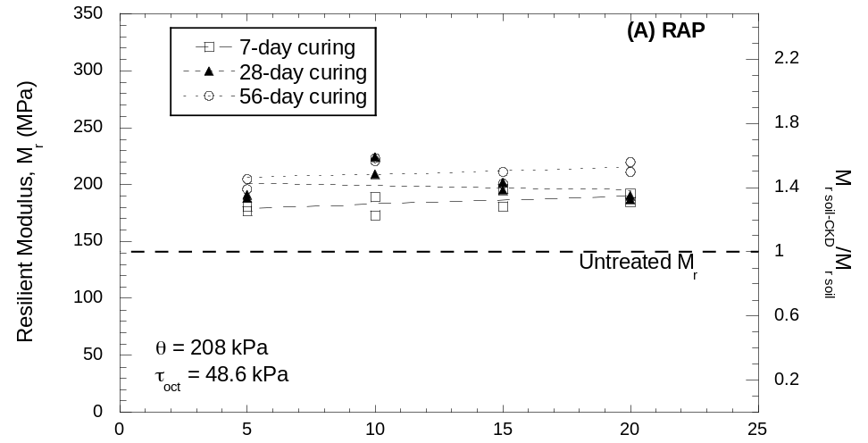
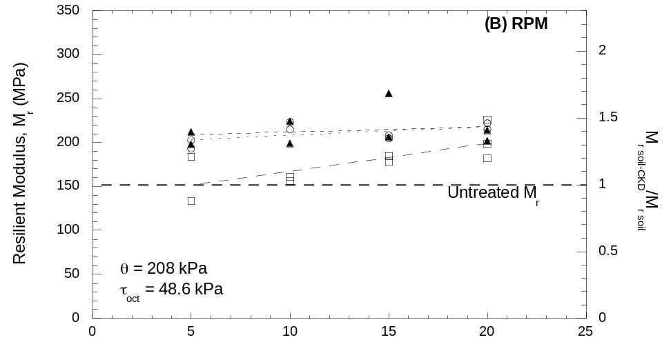
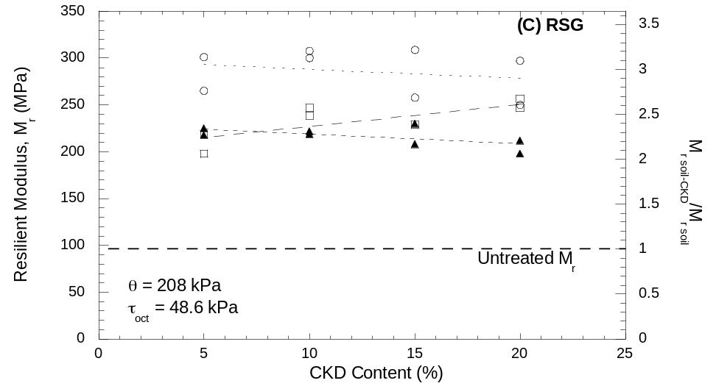
Figure 7.10. Resilient moduli with CKD content and curing time for treated (A) RAP, (B) RPM, and (C) RSG. Resilient moduli reported for bulk stress (θ) of 208 kPa and octahedral shear stress (τ_{oct}) of 48.6 kPa.

Table 7.12. Trends in resilient modulus with CKD content.
Material | Constant | M_{r} Trend | Average M_{r} | SD_{Mr} | Compared to untreated M_{r}
Material | Constant | M_{r} Trend | (Mpa) | (Mpa) | Compared to untreated M_{r}
RAP | 7-day cure | No trend | 184 | 7.8 | Increased
RAP | 28-day cure | No trend | 198 | 12.7 | Increased
RAP | 56-day cure | No trend | 211 | 10.0 | Increased
RAP | All cure lengths | No trend | 198 | 14.9 | Increased
RPM | 7-day cure | Increasing | 178 | 26.2 | No Difference
RPM | 28-day cure | No trend | 214 | 19.0 | Increased
RPM | 56-day cure | No trend | 208 | 9.4 | Increased
RPM | All cure lengths | No trend | 200 | 25.6 | Increased
RSG | 7-day cure | Increasing | 233 | 18.8 | Increased
RSG | 28-day cure | No trend | 217 | 10.3 | Increased
RSG | 56-day cure | No trend | 286 | 24.2 | Increased
RSG | All cure lengths | No trend | 245 | 35.1 | Increased
Note: M_{r} = resilient modulus, SD = standard deviation.
Resilient moduli reported for bulk stress (θ) of 208 kPa and octahedral shear stress (τ_{oct}) of 48.6 kPa.

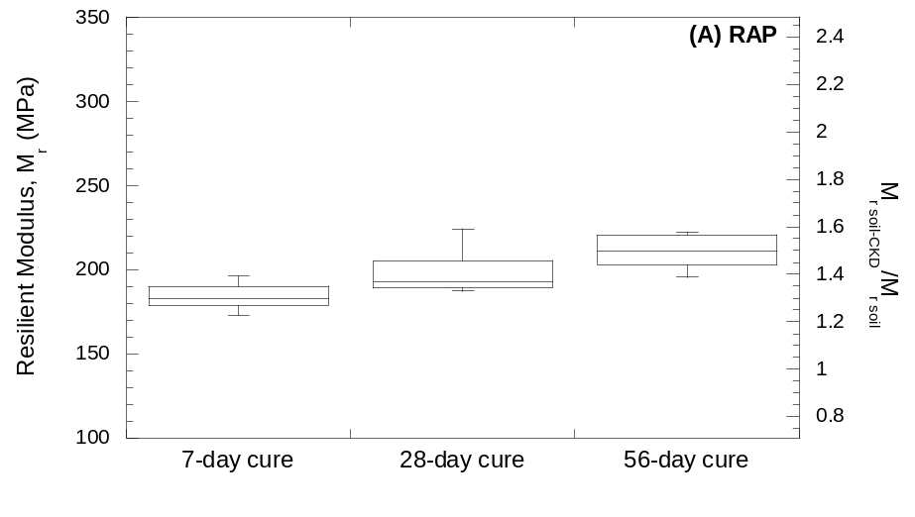
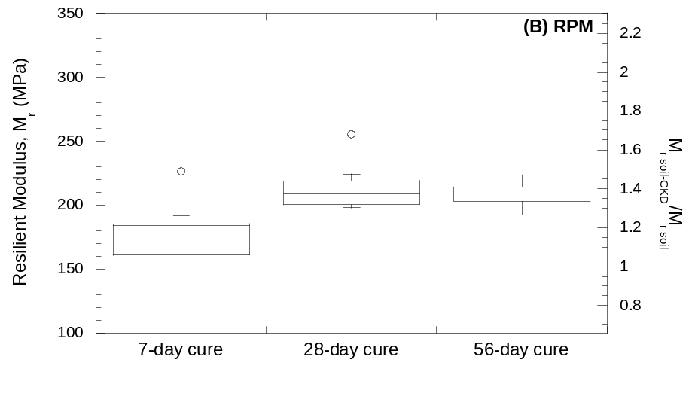
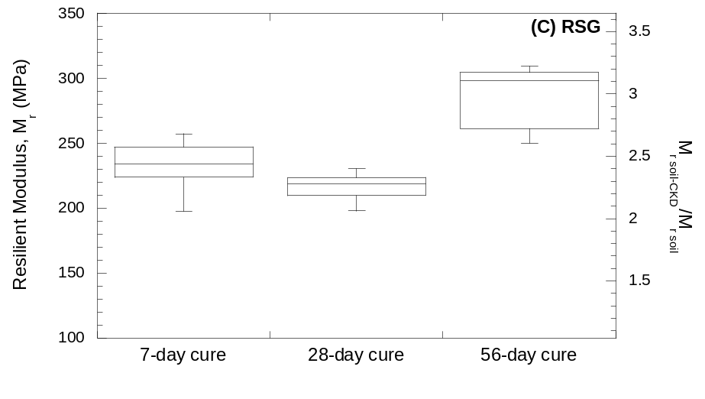
Figure 7.11. Box plots of resilient moduli distributions of stabilized (A) RAP, (B) RPM, and (C) RSG at curing lengths of 7, 28, and 56 days. Resilient moduli reported for bulk stress (θ) of 208 kPa and octahedral shear stress (τ_{oct}) of 48.6 kPa.

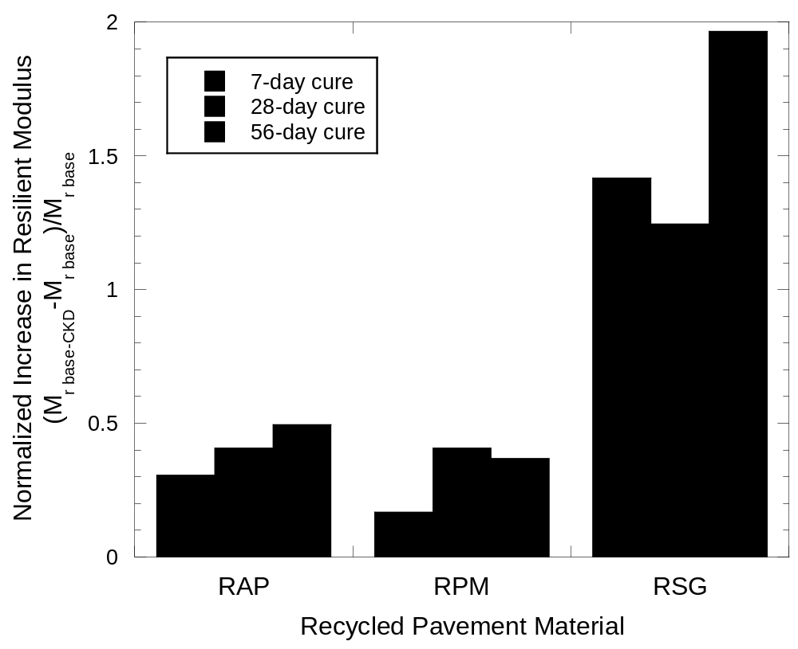

Figure 7.12. Normalized increase in resilient moduli for stabilized base materials. Resilient moduli reported for bulk stress (θ) of 208 kPa and octahedral shear stress (τ_{oct}) of 48.6 kPa.
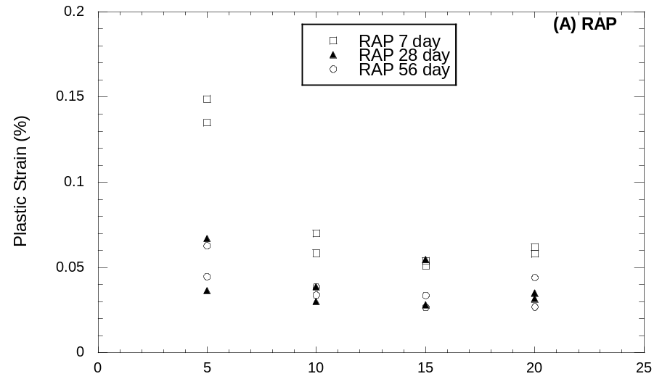
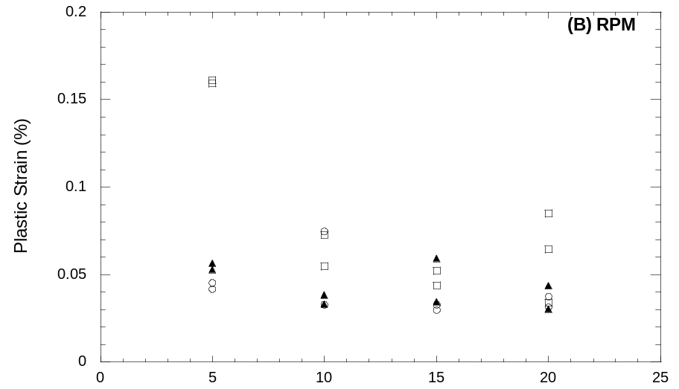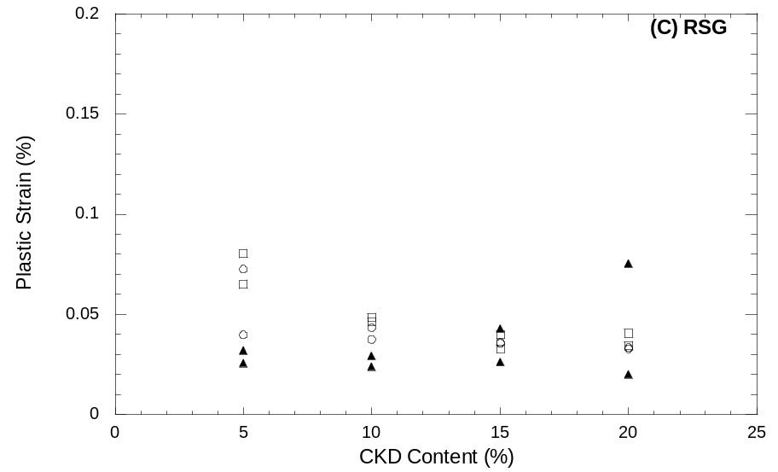
Figure 7.13. Total plastic strain of treated material during resilient modulus test for treated (A) RAP, (B) RPM, and (C) RSG.

Unconfined Compressive Strength

Unconfined Compressive strength data is presented in Table 7.9, Table 7.10, and Table 7.11. Figure 8.14 shows that unconfined compressive strength has an approximately linear relationship, increasing with CKD content at contents up to 20%. Unconfined compressive strength increases with curing time as well. Recycled asphalt pavement does not display any strength gain after 28 days but RPM and RSG continue to gain strength, albeit at a reduced rate compared to pre-28-day strength gain.
Young’s modulus was calculated by determining the maximum slope of the straightest part of the stress-strain curve, i.e., as a tangent modulus as a measure of static large-strain stiffness. The relationship between Young’s modulus and CKD is shown in Figure 8.15. Young’s modulus increases with CKD content. Young’s modulus also increases for curing times up to 28 days. After 28 days the trend is unclear. The discrepancy between Young’s modulus and resilient modulus may be due to the differences in amplitude and rate of strain induced in the two tests.
These results conflict with the resilient modulus data in that strength and large-strain stiffness do show a relationship with CKD content as well as curing time whereas there is no such strong relationship for resilient modulus, which involves lower strains. The discrepancy may have to do in addition to the differences in amplitude and rate of strain with the differences between confined and unconfined states.
NCHRP 1-37A suggests a minimum UCS for lime- and fly ash-stabilized material as base course in a flexible pavement system of 5175 kPa and 1725 kPa for subbase. The highest UCS observed in this study was about 2000 kPa for RSG stabilized with 20% CKD and cured for 56 days. All specimens in this study were soaked which may have reduced strength compared to un-soaked material (Baghdadi et al. 1995). Even if the strength is reduced to 80% of the un-soaked strength, the requirements for use as base course according to NCHRP 1-37A cannot be met. These requirements can be adjusted depending on local conditions and the thickness of each layer in the pavement system.
Unconfined compression can be a very noisy test as any irregularity on the ends of the specimens or weak planes within specimens combined with the lack of confinement can cause progressive or premature failure. These factors result in strength and large-strain modulus irregularities. Since deflection control under repetitive loading that induces lower strains, rather than strength and failure, is the performance requirement for pavement layers constructed and confined, unconfined compression behavior is not relevant to pavement design.
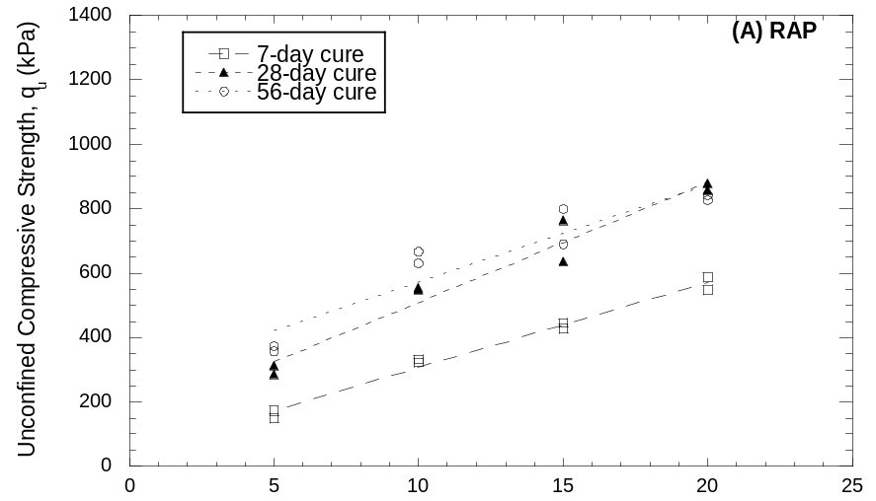
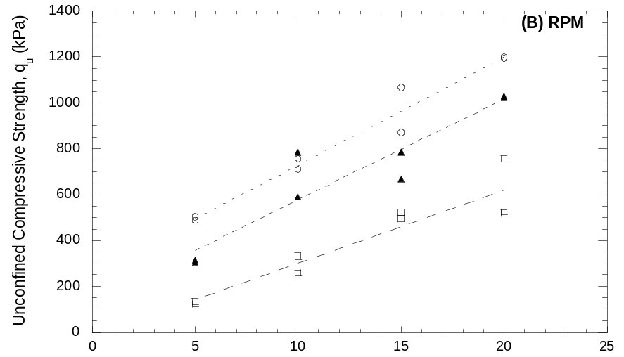
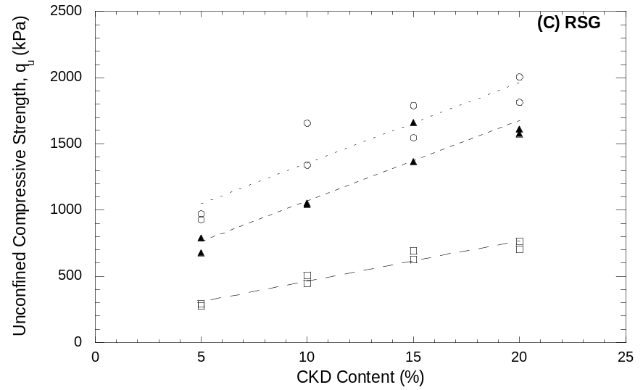
Figure 8.14. Unconfined compressive strength with CKD content and curing time for treated (A) RAP, (B) RPM, and (C) RSG.
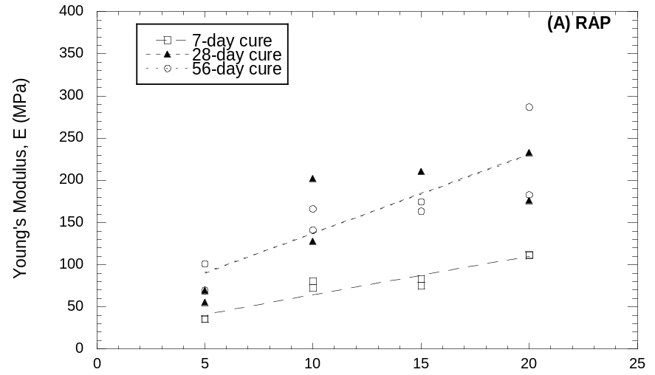
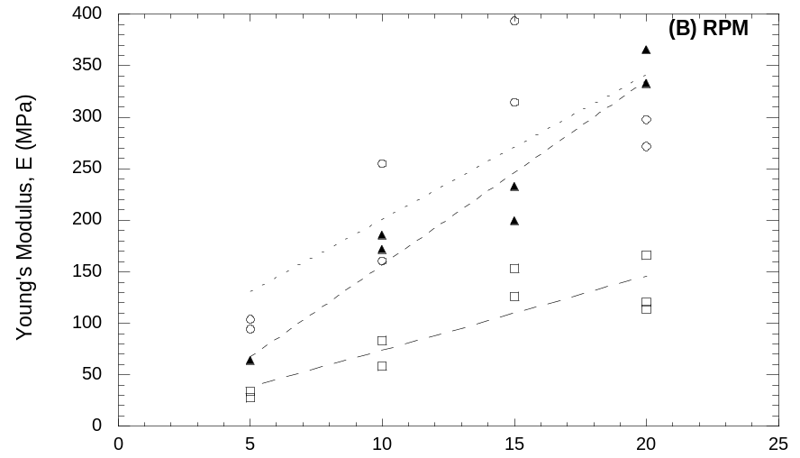
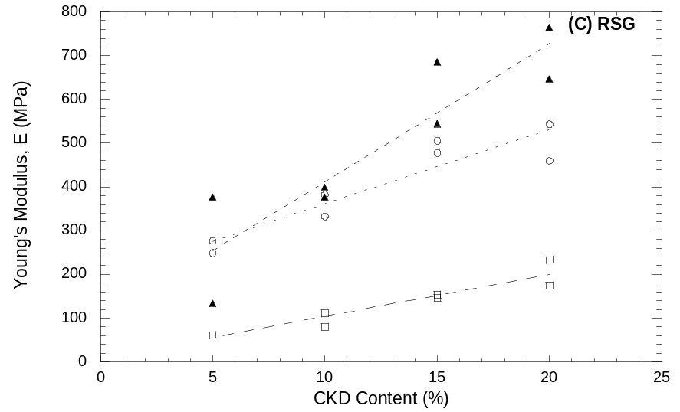
Figure 8.15. Young’s modulus with CKD content and curing time for treated (A) RAP, (B) RPM, and (C) RSG.

Freeze-Thaw Durability

Resilient Modulus
Resilient modulus data is presented in Table 9.13, Table 9.14, and Table 9.15. Figure 9.16 shows that resilient modulus decreases with freeze-thaw cycles after cuing for 7 days. The resilient modulus of CKD treated RAP and RPM level off by 10 cycles while the resilient modulus of treated RSG continues to decrease. A one-tailed Student’s t-test with α = 0.05 comparing the average resilient modulus at 10 cycles with that of untreated material. The resilient modulus of RAP and RSG is still higher than that of untreated material while the resilient modulus of RPM is not. Table 9.16 shows that the relative decrease in modulus increases with CKD content. These results are more favorable than the 67.5% decrease in modulus with 8 cycles of freeze-thaw found by Zaman et al. (1999).

Plastic Deformation
Figure 9.17 shows that plastic deformation increases with freeze-thaw cycles. Based on a one-tailed Student’s t-test with α = 0.05, there is still an increase in deformations from 5 to 10 cycles for RAP and RPM. However, the plastic strains of RSG at 10 cycles are not significantly different from the deformations at 5 cycles. While the relative changes in plastic strain are large (30 to 300%) (Table 9.17) over 10 cycles of freeze-thaw, the plastic strains still compare favorably with the plastic stain of Grade 2 gravel (0.2%).

Unconfined Compressive Strength
Unconfined compressive strength data is presented in Table 9.13, Table 9.14, and Table 9.15. Figure 9.16 shows normalized unconfined compressive strength as a function of freeze-thaw cycles. The unconfined compressive strengths of treated RAP and RSG decrease about 25% over 10 freeze-thaw cycles with most of the loss occurring over the first 5 cycles. An exception is the RPM with 5% CKD which showed some strength gain but is almost the same as the un-cycled specimens. Stabilized RSG showed little change in unconfined compressive strength with freeze-thaw cycling, with a maximum strength loss of about 15%.
Figure 9.19 shows normalized Young’s modulus as a function of freeze-thaw cycles. The moduli of RAP and RPM are reduced by 25 to 50% and 45 to 70% respectively over 10 cycles. Again, RPM stabilized with 5% CKD is an exception to the trend. Treated RSG showed a remarkably similar trend for CKD contents of 5, 15, and 20%. A CKD content of 10% showed an increase in modulus after 5 cycles. The reduction in modulus between 5 and 10 cycles of the 10% CKD treated RSG was comparable to the change in moduli of the other treatment amounts over the same range.
The unconfined compressive strength test is inherently noisy. Progressive failure can occur if the ends of the specimen are not perfectly flat. Any plane of weakness will reduce the strength, especially with the unconfined nature of the test. Freeze-thaw specimens are particularly susceptible to specimen disturbance, since they are handled much more than un-cycled specimens.

Freeze-Thaw Synthesis
Freeze-thaw cycles are detrimental to resilient modulus and plastic strain of CKD-treated granular materials. The resilient modulus of RAP and RPM stabilized by 10 cycles while the modulus of RSG continues to decrease. The increase in the resilient modulus of treated RSG over untreated is such that even after the decrease the modulus is still much improved. The plastic strain of treated RAP and RPM is still increasing at 10 cycles while that of RSG stabilizes.
Unconfined compressive strength and Young’s modulus mostly decrease with freeze-thaw cycles for RAP and RPM while there is little change in either for RSG.
It may have been more meaningful to test freeze-thaw specimens after 28 days of curing because the cementation reaction would have slowed. The continued reaction conflicts with the detrimental effects of the freeze-thaw cycles, which may provide inconsistencies. Actual base course in a road project would have more than 7 days to cure before freezing.
Table 9.13. Resilient modulus and unconfined compressive strength data for RAP with freeze-thaw cycles.
CKD | F-T Cycles | Sample | k₁ | k₂ | k₃ | k₆ | k₇ | M_{r} | ε_{plastic} | q_{u} | E
(%) |  |  |  |  |  |  |  | (Mpa) | (%) | (kPa) | (Mpa)
5 | 0 | A | 2607.9 | 0.94 | -2.72 | 0 | 1 | 177 | 0.14 | 172 | 36
5 | 0 | B | 2322.4 | 1.07 | -2.85 | -6.15 | 1 | 181 | 0.15 | 149 | 36
5 | 5 | A | - | - | - | - | - | - | - | - | -
5 | 5 | B | 1585.6 | 1.25 | -2.92 | -12.67 | 1 | 153 | 0.25 | 112 | 25
5 | 5 | C | 2173.4 | 0.95 | -2.24 | 0 | 1 | 180 | 0.22 | 139 | 25
5 | 10 | A | 1403.6 | 1.32 | -2.72 | -15.39 | 1 | 164 | 0.23 | 128 | 30
5 | 10 | B | 2603.6 | 1.04 | -3.07 | 0 | 1 | 165 | 0.25 | 113 | 25
10 | 0 | A | 2017.4 | 1.13 | -2.47 | 0 | 1 | 173 | 0.07 | 333 | 80
10 | 0 | B | 2187.0 | 1.05 | -2.31 | 0 | 1 | 189 | 0.06 | 323 | 72
10 | 5 | A | 1931.9 | 1.18 | -2.92 | -7.35 | 1 | 163 | 0.15 | 239 | 31
10 | 5 | B | 1851.1 | 1.14 | -2.74 | -5.31 | 1 | 156 | 0.17 | 209 | 33
10 | 10 | A | 2207.7 | 1.09 | -2.89 | -5.68 | 1 | 170 | 0.17 | 240 | 31
10 | 10 | B | 2945.2 | 1.02 | -3.25 | -0.02 | 1 | 172 | 0.20 | 231 | 41
15 | 0 | A | 2162.6 | 1.12 | -2.70 | -4.28 | 1 | 181 | 0.05 | 428 | 75
15 | 0 | B | 3238.7 | 1.07 | -3.24 | 0 | 1 | 196 | 0.05 | 445 | 83
15 | 5 | A | 746.9 | 1.72 | -2.87 | -32.03 | 1 | 163 | 0.15 | 316 | 52
15 | 5 | B | 1330.5 | 1.27 | -2.52 | -13.77 | 1 | 156 | 0.12 | 303 | 58
15 | 10 | A | 395.4 | 1.98 | -2.93 | -51.32 | 1 | 158 | 0.20 | 349 | 36
15 | 10 | B | 2212.6 | 1.04 | -3.07 | 0 | 1 | 140 | 0.22 | 300 | 39
20 | 0 | A | 1967.6 | 1.30 | -2.86 | -6.53 | 1 | 185 | 0.06 | 549 | 111
20 | 0 | B | 2564.1 | 1.06 | -2.69 | 0 | 1 | 192 | 0.06 | 587 | 112
20 | 5 | A | 2265.3 | 1.12 | -3.13 | 0 | 1 | 149 | 0.07 | 434 | 64
20 | 5 | B | 1017.6 | 1.58 | -3.00 | -21.72 | 1 | 151 | 0.14 | 497 | 55
20 | 10 | A | 2351.7 | 0.96 | -2.91 | 0 | 1 | 150 | 0.20 | 419 | 47
20 | 10 | B | 1321.9 | 1.46 | -3.15 | -19.02 | 1 | 157 | 0.22 | 404 | 53
Note: M_{r} = resilient modulus, ε = strain, q_{u} = unfined compressive strength, E = Young’s modulus. Resilient moduli reported for bulk stress (θ) of 208 kPa and octahedral shear stress (τ_{oct}) of 48.6 kPa. A and B represent replicated specimens.

Table 9.14. Resilient modulus and unconfined compressive strength data for RPM with freeze-thaw cycles.
CKD | F-T Cycles | Sample | k₁ | k₂ | k₃ | k₆ | k₇ | M_{r} | ε_{plastic} | q_{u} | E
(%) |  |  |  |  |  |  |  | (Mpa) | (%) | (kPa) | (Mpa)
5 | 0 | A | - | - | - | - | - | - | - | - | -
5 | 0 | B | 2076.8 | 0.85 | -2.71 | 0 | 1 | 133 | 0.16 | 135 | 28
5 | 0 | C | 1828.2 | 1.05 | -2.26 | -9.04 | 1 | 184 | 0.16 | 125 | 34
5 | 5 | A | 2185.6 | 1.25 | -3.29 | -8.96 | 1 | 173 | 0.15 | 151 | 39
5 | 5 | B | - | - | - | - | - | - | - | - | -
5 | 5 | C | - | - | - | - | - | - | - | - | -
5 | 10 | A | 1611.6 | 1.43 | -3.28 | -15.73 | 1 | 168 | 0.18 | 116 | 20
5 | 10 | B | 2849.4 | 1.10 | -3.31 | 0 | 1 | 172 | 0.22 | 166 | 36
10 | 0 | A | 2022.0 | 1.04 | -2.58 | 0 | 1 | 156 | 0.07 | 333 | 83
10 | 0 | B | 2270.5 | 1.11 | -2.93 | 0 | 1 | 161 | 0.05 | 259 | 58
10 | 5 | A | 1757.4 | 1.10 | -2.77 | -7.33 | 1 | 147 | 0.14 | 224 | 28
10 | 5 | B | 2404.8 | 1.17 | -3.18 | -2.11 | 1 | 167 | 0.15 | 201 | 39
10 | 10 | A | 2804.8 | 1.10 | -3.27 | 0 | 1 | 172 | 0.16 | 214 | 44
10 | 10 | B | 1506.2 | 1.64 | -3.76 | -18.39 | 1 | 166 | 0.19 | 230 | 39
15 | 0 | A | 2377.8 | 1.07 | -2.72 | 0 | 1 | 178 | 0.05 | 496 | 153
15 | 0 | B | 1963.4 | 1.22 | -2.61 | -4.72 | 1 | 185 | 0.04 | 523 | 126
15 | 5 | A | 1819.2 | 1.26 | -2.79 | -6.87 | 1 | 170 | 0.14 | 350 | 50
15 | 5 | B | 589.2 | 1.90 | -2.98 | -37.69 | 1 | 166 | 0.14 | 338 | 47
15 | 10 | A | 1557.0 | 1.37 | -3.03 | -11.68 | 1 | 158 | 0.17 | 356 | 50
15 | 10 | B | 2157.4 | 1.19 | -3.23 | 0 | 1 | 144 | 0.18 | 365 | 53
20 | 0 | A | 2848.5 | 1.06 | -2.86 | 0 | 1 | 199 | 0.08 | 525 | 120
20 | 0 | B | 2228.9 | 1.08 | -2.50 | 0 | 1 | 182 | 0.03 | 756 | 166
20 | 0 | C | 2307.4 | 1.14 | -2.26 | -2.53 | 1 | 226 | 0.06 | 521 | 114
20 | 5 | A | 1799.5 | 1.22 | -2.74 | -6.12 | 1 | 165 | 0.15 | 452 | 67
20 | 5 | B | 919.8 | 1.55 | -3.00 | -28.00 | 1 | 148 | 0.14 | 497 | 77
20 | 10 | A | 2037.3 | 1.32 | -3.47 | -6.97 | 1 | 154 | 0.20 | 428 | 52
20 | 10 | B | 1904.7 | 1.20 | -2.92 | -5.42 | 1 | 159 | 0.16 | 479 | 61
Note: M_{r} = resilient modulus, ε = strain, q_{u} = unfined compressive strength, E = Young’s modulus. Resilient moduli reported for bulk stress (θ) of 208 kPa and octahedral shear stress (τ_{oct}) of 48.6 kPa. A and B represent replicated specimens.

Table 9.15. Resilient modulus and unconfined compressive strength data for RSG with freeze-thaw cycles.
CKD | F-T Cycles | Sample | k₁ | k₂ | k₃ | k₆ | k₇ | M_{r} | ε_{plastic} | q_{u} | E
(%) |  |  |  |  |  |  |  | (Mpa) | (%) | (kPa) | (Mpa)
5 | 0 | A | 1228.4 | 1.82 | -3.69 | -27.54 | 1 | 198 | 0.08 | 293 | 61
5 | 0 | B | 576.8 | 2.02 | -3.19 | -51.56 | 1 | 219 | 0.06 | 276 | 61
5 | 5 | A | 1354.0 | 1.49 | -2.93 | -24.26 | 1 | 198 | 0.10 | 231 | 61
5 | 5 | B | 835.3 | 1.67 | -2.84 | -40.02 | 1 | 197 | 0.12 | 257 | 56
5 | 10 | A | 1394.2 | 1.50 | -3.33 | -22.22 | 1 | 169 | 0.12 | 234 | 61
5 | 10 | B | 2548.4 | 0.92 | -2.81 | 0 | 1 | 164 | 0.11 | 245 | 51
10 | 0 | A | 3229.1 | 1.07 | -2.81 | -1.86 | 1 | 239 | 0.05 | 446 | 111
10 | 0 | B | 2689.8 | 1.23 | -2.92 | -10.40 | 1 | 247 | 0.05 | 508 | 80
10 | 5 | A | 2487.0 | 1.04 | -2.52 | -5.42 | 1 | 212 | 0.09 | 502 | 129
10 | 5 | B | 2850.6 | 1.05 | -2.65 | 0 | 1 | 215 | 0.10 | 533 | 144
10 | 10 | A | 2629.7 | 1.08 | -3.19 | 0 | 1 | 164 | 0.08 | 545 | 122
10 | 10 | B | 1681.0 | 1.31 | -3.04 | -14.09 | 1 | 167 | 0.10 | 488 | 108
15 | 0 | A | 1723.2 | 1.36 | -2.54 | -17.14 | 1 | 229 | 0.04 | 691 | 153
15 | 0 | B | 520.1 | 2.06 | -2.86 | -49.25 | 1 | 229 | 0.03 | 623 | 146
15 | 5 | A | 2494.9 | 1.17 | -2.87 | -6.80 | 1 | 211 | 0.09 | 635 | 139
15 | 5 | B | 1647.8 | 1.35 | -2.50 | -17.21 | 1 | 221 | 0.08 | 699 | 146
15 | 10 | A | 2543.1 | 1.14 | -3.22 | -3.78 | 1 | 175 | 0.07 | 658 | 129
15 | 10 | B | 2422.0 | 0.99 | -2.90 | 0 | 1 | 159 | 0.10 | 601 | 122
20 | 0 | A | 1801.4 | 1.46 | -2.91 | -22.08 | 1 | 247 | 0.03 | 763 | 233
20 | 0 | B | 2434.4 | 1.34 | -3.06 | -16.29 | 1 | 257 | 0.04 | 706 | 174
20 | 5 | A | 3066.3 | 1.86 | -5.43 | -16.77 | 1 | 208 | 0.12 | 536 | 109
20 | 5 | B | 3494.7 | 1.17 | -3.38 | 0 | 1 | 217 | 0.07 | 1087 | 244
20 | 5 | C | 2020.4 | 1.01 | -1.82 | 0 | 1 | 206 | 0.07 | 821 | 194
20 | 5 | D | 2465.4 | 1.08 | -2.61 | 0 | 1 | 194 | 0.07 | 897 | 227
20 | 10 | A | 2383.5 | 0.97 | -2.66 | 0 | 1 | 169 | 0.07 | 773 | 175
20 | 10 | B | 1648.0 | 1.44 | -3.19 | -16.73 | 1 | 182 | 0.06 | 785 | 186
Note: M_{r} = resilient modulus, ε = strain, q_{u} = unfined compressive strength, E = Young’s modulus. Resilient moduli reported for bulk stress (θ) of 208 kPa and octahedral shear stress (τ_{oct}) of 48.6 kPa. A and B represent replicated specimens.

Table 9.16. Change in average summary modulus after 10 freeze-thaw cycles.
CKD Content | Change in M_{r} (%) after 10 Freeze-Thaw Cycles
(%) | RAP | RPM | RSG
5 | -8.1 | 7.2 | -20.2
10 | -5.5 | 6.8 | -31.7
15 | -21.1 | -16.9 | -27.2
20 | -18.4 | -22.9 | -30.3

Table 9.17. Change in average plastic strain after 10 freeze-thaw cycles.
CKD Content | Change in ε_{plastic} (%) after 10 Freeze-Thaw Cycles
(%) | RAP | RPM | RSG
5 | 72.3 | 26.4 | 58.8
10 | 189.1 | 173.0 | 86.7
15 | 291.4 | 260.6 | 127.8
20 | 250.1 | 193.7 | 72.5

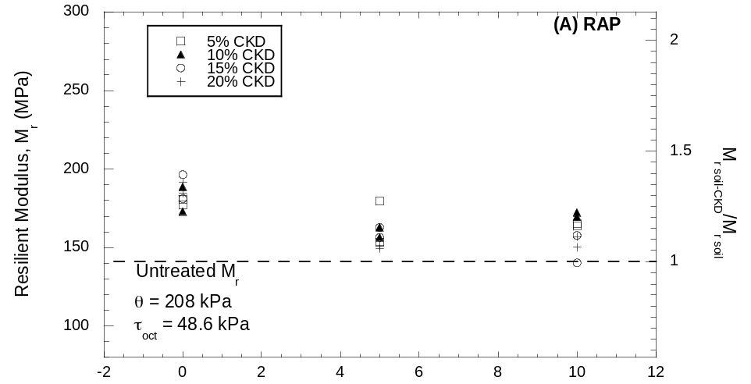
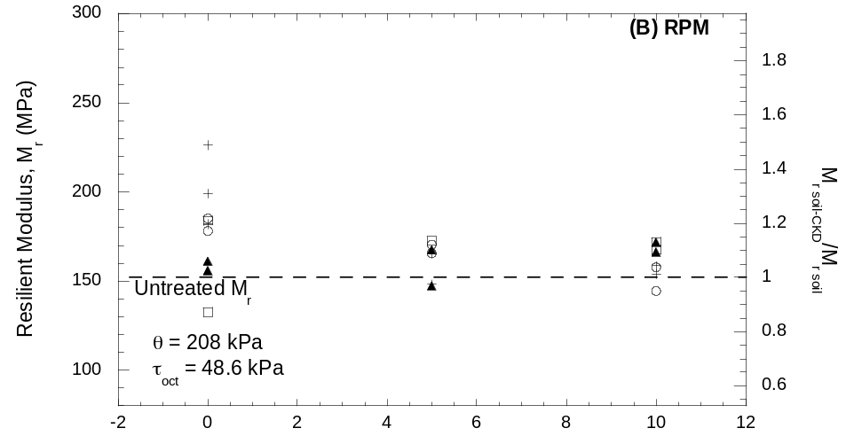
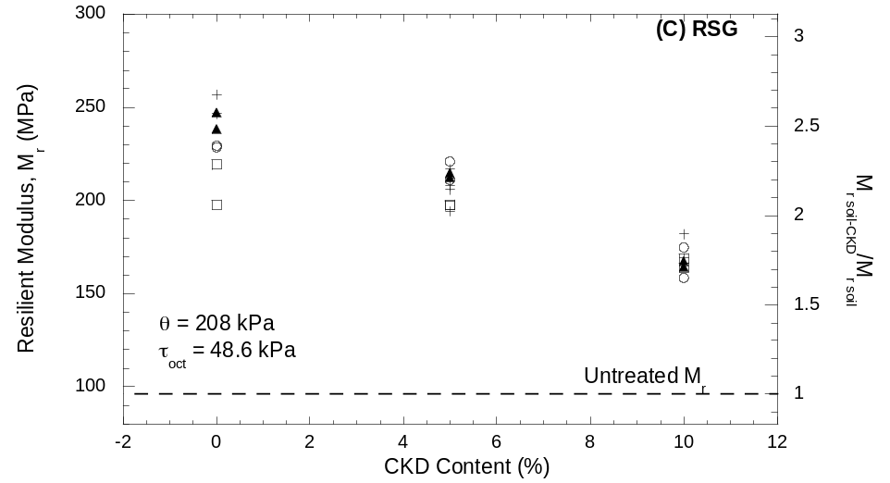
Figure 9.16. Resilient moduli with freeze-thaw cycles for treated (A) RAP, (B) RPM and (C) RSG. Resilient moduli reported for bulk stress (θ) of 208 kPa and octahedral shear stress (τ_{oct}) of 48.6 kPa.

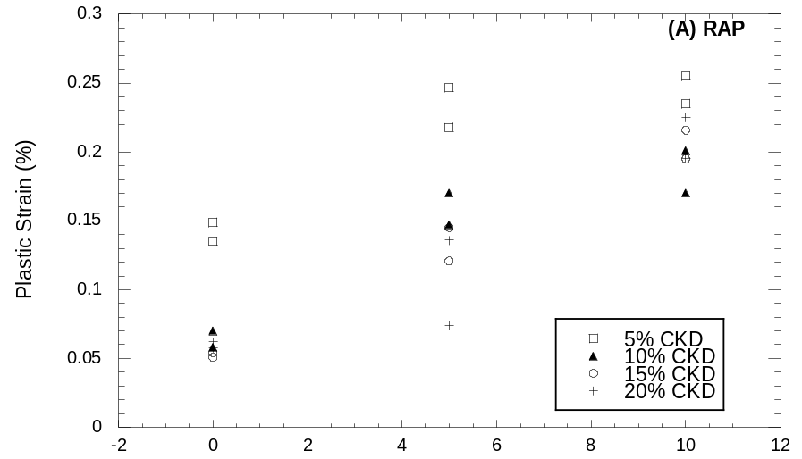
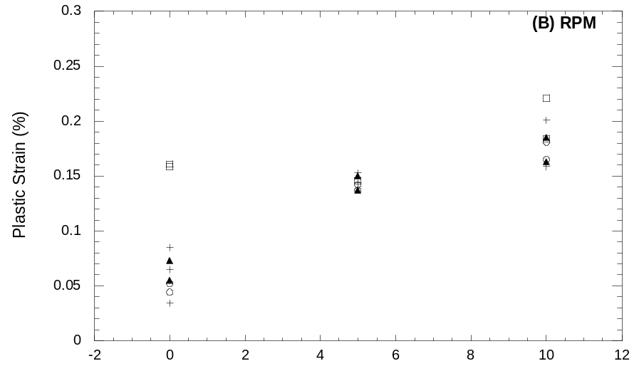
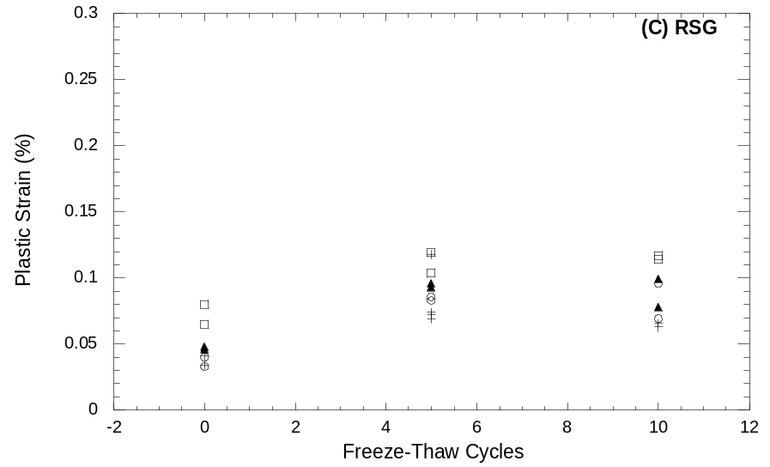
Figure 9.17. Total plastic strain during resilient modulus test with freeze-thaw cycles for treated (A) RAP, (B) RPM, and (C) RSG.
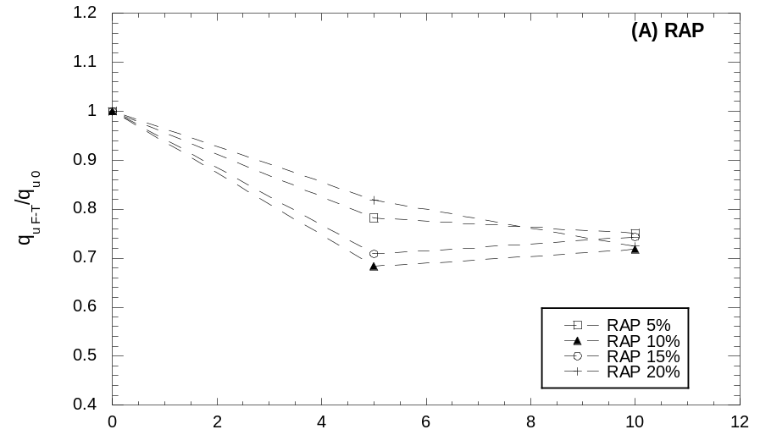
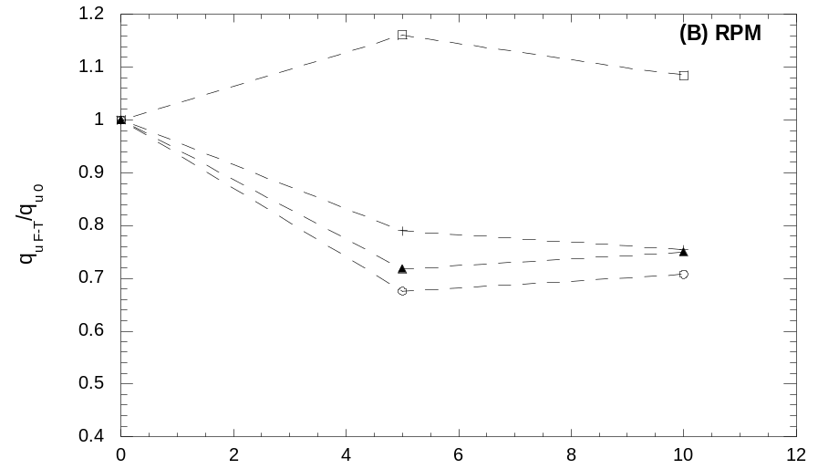
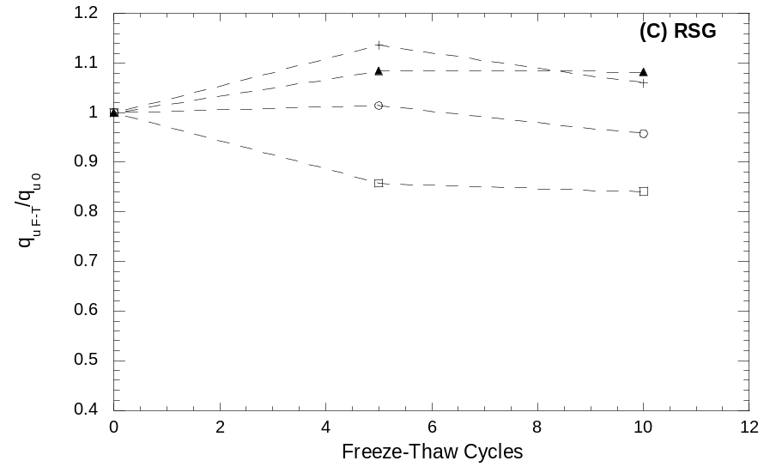
Figure 9.18. Normalized average unconfined compressive strength (q_{u}) with freeze-thaw cycles for treated (A) RAP, (B) RPM, and (C) RSG.
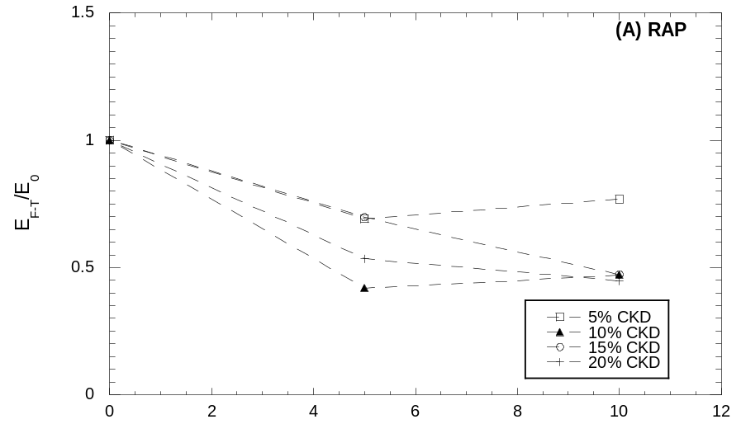
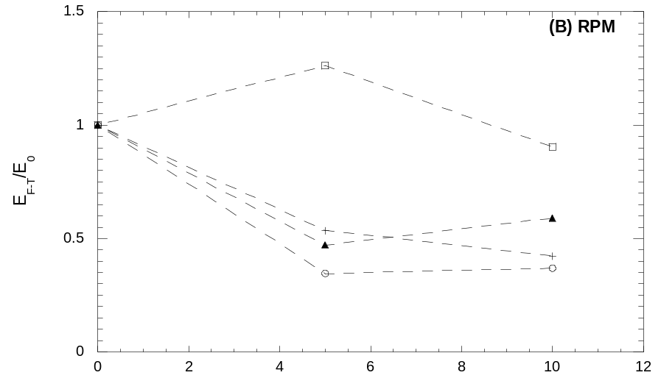
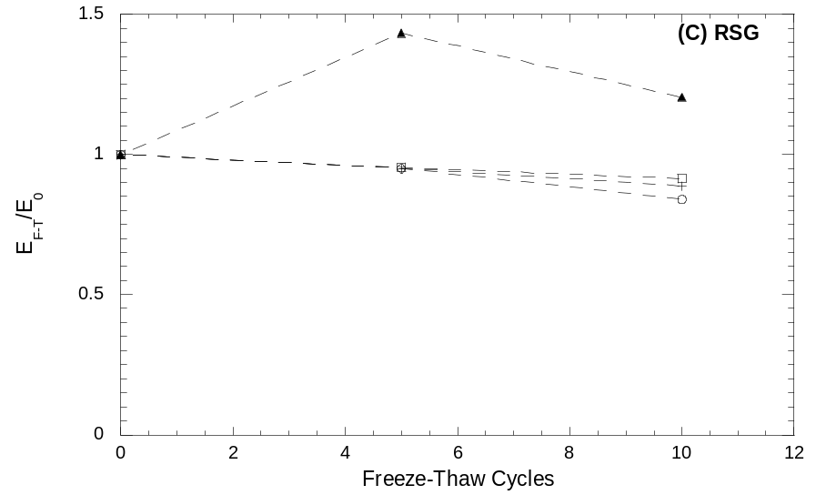
Figure 9.19. Normalized average Young’s modulus (E) with freeze-thaw cycles for treated (A) RAP, (B) RPM, and (C) RSG.

Leaching Characteristics

Table 10.18 shows the properties and concentrations of metals measured after water leach tests (WLT). Bold numbers exceed the USEPA maximum contaminant levels (MCL) for drinking water or are of concern. Among the metals exceeding the MCLs are lead and thallium. These metals are generally not mobile in groundwater. Also, cadmium and lead are not mobile at high pH. pH above 12.5 may be defined as corrosive under RCRA Subtitle C, defining these materials as hazardous waste.
Bin-Shafique et al. (2006) performed WLTs, column leach tests (CLTs), and field lysimeter tests on fine-grained soils treated with fly ash and found that the initial concentrations in effluent from the column tests was 10 to 50 times higher than the concentrations found in the WLT. The concentrations seen in the field were comperable to four times lower than concentrations in the CLTs. Concentrations decreased as the pH and/or cation exchange capacity (CEC) increased. This study suggests CLTs can be used to conservatively estimate field concentrations. With scaling factors WLTs can also be used. The soils in the current study are not fine-grained and contain little, if any, clay.
Table 10.18. Summary of concentrations from water leach test.
Sample | pH | Eh | EC | P | K | Ca | Mg | S | Zn | B | Al
Sample | pH | (mV) | (μS) | (ppm) | (ppm) | (ppm) | (ppm) | (ppm) | (ppm) | (ppm) | (ppm)
RAP | 9.70 | 34 | 166.9 | <0.05 | 0.94 | 5.56 | 4.26 | 0.32 | <0.001 | <0.02 | <0.05
RPM | 9.90 | 14 | 183.4 | <0.05 | 0.90 | 5.80 | 3.95 | 0.49 | <0.001 | <0.02 | <0.05
RSG | 10.03 | 42 | 191 | <0.05 | 1.18 | 11.93 | 5.77 | <0.05 | <0.001 | <0.02 | <0.05
RAP + 20% CKD | 12.65 | -100 | 10180 | <0.05 | 89.63 | 703.59 | <0.007 | 0.39 | <0.001 | <0.02 | <0.05
RPM + 20% CKD | 12.61 | -100 | 10270 | <0.05 | 97.16 | 696.81 | <0.007 | 0.40 | 0.01 | <0.02 | <0.05
RSG + 20% CKD | 12.62 | -101 | 10270 | <0.05 | 95.05 | 795.84 | <0.007 | 0.47 | 0.00 | <0.02 | <0.05
CKD | 12.59 | -105 | 11140 | <0.05 | 314.08 | 722.01 | <0.007 | 0.36 | 0.00 | <0.02 | <0.05
DI Water | 5.05 | 159 | 10.21 | <0.05 | 0.06 | <0.02 | <0.007 | <0.05 | <0.001 | <0.02 | <0.05
USEPA MCL or TT | - | - | - | - | - | - | - | - | - | - | -
Sample | Na | Cd | Co | Cr | Cu | Fe | Mn | Mo | Ni | Pb | Zn
Sample | (ppm) | (ppm) | (ppm) | (ppm) | (ppm) | (ppm) | (ppm) | (ppm) | (ppm) | (ppm) | (ppm)
RAP | 0.87 | <0.004 | 0.005 | <0.001 | <0.005 | 0.042 | < 0.001 | <0.004 | <0.003 | <0.02 | <0.001
RPM | 3.21 | <0.004 | 0.007 | 0.004 | <0.005 | 0.010 | < 0.001 | 0.005 | <0.003 | <0.02 | <0.001
RSG | 0.49 | <0.004 | 0.004 | 0.002 | <0.005 | 0.853 | 0.079 | <0.004 | <0.003 | <0.02 | <0.001
RAP + 20% CKD | 3.61 | 0.004 | <0.003 | 0.026 | <0.005 | < 0.001 | < 0.001 | <0.004 | <0.003 | <0.02 | <0.001
RPM + 20% CKD | 5.65 | 0.006 | 0.005 | 0.026 | <0.005 | 0.002 | 0.001 | 0.005 | <0.003 | 0.024 | 0.006
RSG + 20% CKD | 3.65 | <0.004 | 0.004 | 0.024 | <0.005 | < 0.001 | < 0.001 | 0.038 | <0.003 | 0.036 | 0.001
CKD | 11.23 | <0.004 | <0.003 | 0.032 | <0.005 | 0.018 | < 0.001 | 0.013 | <0.003 | <0.02 | 0.003
DI Water | <0.005 | <0.004 | <0.003 | <0.001 | <0.005 | 0.023 | < 0.001 | 0.007 | <0.003 | <0.02 | <0.001
USEPA MCL or TT | - | 0.005 | - | 0.100 | 1.300 | - | - | - | - | 0.015 | -
Sample | Li | As | Se | Ti | V | Sr | Ag | Be | Sb | Sn | Tl
Sample | (ppm) | (ppm) | (ppm) | (ppm) | (ppm) | (ppm) | (ppm) | (ppm) | (ppm) | (ppm) | (ppm)
RAP | 0.001 | <0.03 | <0.03 | <0.001 | <0.003 | 0.013 | 0.010 | <0.001 | <0.01 | <0.002 | 0.093
RPM | 0.001 | 0.091 | <0.03 | <0.001 | <0.003 | 0.015 | <0.001 | <0.001 | <0.01 | 0.039 | 0.085
RSG | 0.002 | <0.03 | 0.067 | 0.006 | <0.003 | 0.009 | 0.002 | <0.001 | 0.021 | 0.003 | <0.03
RAP + 20% CKD | 0.018 | <0.03 | <0.03 | <0.001 | <0.003 | 0.580 | 0.014 | <0.001 | 0.021 | <0.002 | 0.114
RPM + 20% CKD | 0.018 | 0.059 | <0.03 | <0.001 | 0.004 | 0.642 | 0.014 | <0.001 | 0.012 | <0.002 | 0.078
RSG + 20% CKD | 0.015 | 0.059 | <0.03 | <0.001 | 0.014 | 0.724 | 0.011 | <0.001 | 0.018 | <0.002 | 0.078
CKD | 0.072 | <0.03 | 0.101 | <0.001 | 0.005 | 1.846 | 0.015 | <0.001 | 0.018 | <0.002 | 0.194
DI Water | < 0.001 | <0.03 | <0.03 | <0.001 | <0.003 | < 0.001 | 0.016 | <0.001 | <0.01 | 0.056 | 0.071
USEPA MCL or TT | - | 0.010 | 0.05 | - | - | - | - | 0.004 | 0.006 | - | 0.002

Summary and Conclusions

The affects of CKD treatment on three base materials (RAP, RPM, and RSG) was evaluated. Each material was tested untreated as well as with CKD contents of 5, 10, 15, and 20% by dry weight of aggregate. Tests included standard Proctor compaction, CBR, resilient modulus, unconfined compression, and WLT. In addition, the effects of freeze-thaw cycling on the resilient modulus and unconfined compressive strength of the stabilized materials were investigated. All specimens were compacted to 95% of the MDUW and OMC determined during compaction tests.
CBR generally increased with CKD content up to 20% except for RSG which had a peak CBR at 10%. All three materials obtained a CBR greater than 50, equivalent to good quality gravel (see Table 6.2), with CKD treatment. The increases in CBR for all three materials improve their suitability as working platforms during construction.
Unconfined compressive strength showed an increasing trend with CKD content and curing time, with RPM and RSG continuing to gain strength after 28 days. Young’s modulus also increases with CKD content and curing time up to 28 days. NCHRP 1-37A suggests a minimum unconfined compressive strength of 1725 kPa for chemically treated subbase which only the RSG treated with 20% CKD surpassed. Stiffness is a more critical factor in pavement system design.
Resilient modulus was also improved with CKD treatment, although CKD contents above 5% showed no additional increase in stiffness. Resilient modulus at 56 days of curing was increased by 50% for RAP, 35% for RPM, and 195% for RSG. While the average summary resilient modulus of untreated RAP and RPM was already higher than that of Grade 2 gravel, treated RSG outperformed all other materials in this study. Plastic strains accumulated during the NCHRP 1-28A Procedure 2 test were less for the treated base materials than for Grade 2 gravel.
Freeze-thaw cycling was detrimental to strength and stiffness. The unconfined compressive strength of treated RAP and RSG decreases about 25% and Young’s modulus about 50% over 10 cycles. Treated RSG had a maximum decrease in strength and Young’s modulus of 15%. The reductions in resilient moduli of treated RAP and RPM occurred by 5 cycles. The modulus of treated RSG continued to show a downward trend at 10 cycles. The moduli of treated RAP and RSG were still higher than that of untreated material, while the modulus of RPM was not. Plastic strains of RAP and RPM continue to increase at 10 cycles, while the plastic strains of RSG level out by 5 cycles.
Concentrations after WLTs of treated base materials are of concern as some elements including thallium were over the EPA MCLs. In addition, the pH was above 12.5, which qualifies as a RCRA corrosive. WLTs may not represent the concentrations found in the field, though. Column leach tests (CLT) and field testing would provide more accurate data on the environmental implications of CKD treatment.
CKD clearly improves the strength and stiffness of the three materials in this study. The improvement in CBR results in better working platforms, while the increases in strength and stiffness mean potentially better performing pavement systems. Environmental concerns should be evaluated with more strenuous testing, though. The wide variations in the chemical composition of CKDs mean that they must be evaluated on a case-by-case basis. If locally available, CKD could provide another option for DOTs and municipalities in road rehabilitation.

References

Acosta, H.A. (2002). Stabilization of Soft Subgrade Soils Using Fly Ash, M.S. thesis, Department of Civil and Environmental Engineering, University of Wisconsin-Madison, Madison, WI.

American Coal Ash Association (2003). Fly Ash Facts for Highway Engineers, Report for the Federal Highway Administration (FHWA), Report no. FHWA-IF-03-019, Web site: http://www.fhwa.dot.gov/pavement/recycling/fatoc.cfm.

Baghdadi, Z.A. (1990). “Engineering Study of Kiln Dust-Kaolinite Mixtures.” Proceedings, Tenth Southeast Asian Geotechnical Conference, Taipei, Taiwan, pp. 17-21.

Baghdadi, Z.A. and Rahman, M.A. (1990). “The Potential of Cement Kiln Dust for the Stabilization of Dune Sand in Highway Construction.” Building and Environment, vol. 25, no. 4, pp. 285-289.

Baghdadi, Z.A., Fatani, M.N., and Sabban, N.A. (1995). “Soil Modification by Cement Kiln Dust.” Journal of Materials in Civil Engineering, ASCE, pp. 218-222.

Bhatty, J.I. (1995). Alternative Uses of Cement Kiln Dust. Research and Development Information RP327, Portland Cement Association, Skokie, IL.

Bhatty, J.I., Bhattacharja, S., and Todres, H.A. (1996). Use of Cement Kiln Dust in Stabilizing Clays, RP343, Portland Cement Association, Skokie, IL.

Bin-Shafique, S., Benson, C.H., Edil, T.B., Hwang, K. (2006). “Leachate Concentrations from Water Leach and Column Leach Tests on Fly Ash-Stabilized Soils.” Environmental Engineering Science, vol. 23, no. 1, pp. 53-67.

Environmental Protection Agency (EPA) (1993). Report to Congress – Cement Kiln Dust Waste. Web site: http://www.epa.gov/epaoswer/other/ckd/cement2.htm.

Freer-Hewish, R.J., Ghataora, G.S., and Niazi, Y. (1999). “Stabilization of Desert Sand with Cement Kiln Dust Plus Chemical Additives in Desert Road Construction.” Proceedings of the Institution of Civil Engineers, Transport, vol. 135, no. 1, pp. 29-36.

Hawkins, G.J., Bhatty, J.I., and O’Hare, A.T. (2003). “Cement Kiln Dust Production, Management, and Disposal.” Proc., Air and Waste Management Association’s 96th Annual Conference and Exhibition, San Diego, CA.

Hunt, R.E. (1986). Geotechnical Engineering Techniques and Practices. McGraw Hill Book Company.

Khoury, N.N. and Zaman, M.Z. (2007). “Environmental Effects on Durability of Aggregates Stabilized with Cementicious Materials.” Journal of Materials in Civil Engineering, ASCE, pp. 41-48.

Légère, G. and Tremblay, H. (2003). “Laboratory and Field Evaluation of Cement Kiln Dust and Lime for Stabilizing Clayey Silt on Low-Volume Roads.” Transportation Research Record, Journal of the Transportation Research Board, TRB Record 1819, Washington D.C., pp. 3-10.

Li, L., Benson, C.H., Edil, T.B., Hatipoglu, B., and Tastan, O. (2007). “Evaluation of Recycled Asphalt Pavement Material Stabilized with Fly Ash.” Proceedings, Geo-Denver 2007, Denver, CO.

McCoy, W.J. and Kriner, R.W. (1971). “Use of Waste Kiln Dust for Soil Consolidation.” Mill Session Paper, M197-7, Portland Cement Association, pp. 72-81.

Miller, G.A. and Azad, S. (2000). “Influence of Soil Type on Stabilization with Cement Kiln Dust.” Construction and Building Materials, vol. 14, pp. 89-97.

Miller, G.A. and Zaman, M. (2000). “Field and Laboratory Evaluation of Cement Kiln Dust as a Soil Stabilizer.” Transportation Research Record, Journal of the Transportation Research Board, TRB Record 1714, Washington D.C., pp. 25-32.

Oklahoma Department of Transportation (OklaDOT) (2002). Special Provision for Cement Kiln Dust. Special Provision no. 702-1(a-b)99. Web site: http://www.okladot.state.ok.us/materials/700index.htm.

Parsons, R.L. and Kneebone, E. (2004). “Use of Cement Kiln Dust for the Stabilization of Soils.” Geotechnical Special Publication, n. 1261, Geotechnical Engineering for Transportation Projects: Proceedings of Geo-Trans 2004, pp. 1124-1131.

Sreekrishnavilasam, A., King, S., and Santagata, M. (2006). “Characterization of Fresh and Landfilled Cement Kiln Dust for Reuse in Construction Applications.” Engineering Geology, vol. 85, pp. 165-173.

Sreekrishnavilasam, A., Rahardja, R., Kmetz, R., and Santagata, M. (2007). “Soil Treatment Using Fresh and Landfilled Cement Kiln Dust.” Construction and Building Materials, vol. 21, pp. 318-327.

Taha, R. (2003). “Evaluation of Cement Kiln Dust-Stabilized Reclaimed Asphalt Pavement Aggregate Systems in Road Bases.” Transportation Research Record, Journal of the Transportation Research Board, TRB Record 1819, Washington D.C., pp. 11-17.

Todres, H.A., Mishulovich, A., and Ahmad, J. (1992). Cement Kiln Dust Management: Permeability, Research and Development Bulletin RD103T, Portland Cement Association, Skokie, IL.

Zaman, M., Laguros, J.G., and Sayah, A. (1992). “Soil Stabilization Using Cement Kiln Dust.” Proceedings, 7th International Conference on Expansive Soils. Dallas, TX, pp. 347-351.

Zaman, M.Z., Zhu, J., and Laguros, J.G. (1999). “Durability Effects on Resilient Moduli of Stabilized Aggregate Base.” Transportation Research Record, Journal of the Transportation Research Board, TRB Record 1687, Washington D.C., pp. 29-38.

Appendix A
PVC Compaction Mold Volumes

Table A.0.19. PVC compaction mold volumes.

Mold | Volume
Mold | cm³ | ft³
A | 2140 | 0.0756
B | 2147 | 0.0758
C | 2142 | 0.0757
D | 2140 | 0.0756
E | 2143 | 0.0757
F | 2140 | 0.0756
G | 2142 | 0.0756
H | 2143 | 0.0757
I | 2143 | 0.0757
J | 2140 | 0.0756
K | 2141 | 0.0756
L | 2139 | 0.0755
M | 2141 | 0.0756
N | 2142 | 0.0756
O | 2146 | 0.0758
P | 2136 | 0.0754
Q | 2144 | 0.0757
R | 2143 | 0.0757

Appendix B
Calibrations of Resilient Modulus Testing Equipment

Table B.0.20. Calibration factors for resilient modulus testing equipment.
Device | Calibration Factor | Units | Date
External LVDT M781820-18 | 1.1074 | mm/V | 15-Feb-07
External LVDT M781820-09 | 1.0493 | mm/V | 15-Feb-07
Load Cell | 2.2861 | kN/V | 23-Mar-07
Cell Pressure | 70.711 | kPa/V | 23-Mar-07

