BE²ST-IN-HIGHWAYSTM
(Building Environmentally and Economically
Sustainable
Transportation-Infrastructure-Highways)


Recycled Materials Resource Center /
University of Wisconsin-Madison

Getting Started

System Requirements
The BE²ST-in-Highways program runs on computers with at least 15 MB of available disk space. 2007 or higher version of the Microsoft Excel program is recommended.

Installing BE²ST in-Highways
The BE²ST- in-Highways system is an Excel based program which is interlinked to several other publicly available open sources (i.e., M-EPDG, PaLATE, RealCost, and TNM-LookUp). A new folder, including a folder named “Support”, should be installed so the Excel-based BE²ST-in-Highways program can be installed in it. In the “Support” folder, all those open sources required for the BE²ST- in-Highways system should be installed from each download site.

CONTENTS

Getting Started……………………………………………………………………….i
Contents………………………………………………………………………………ii
- Introduction……………………………………………………...……………….1
- System Description………………………………………………...……………..4
2.1 The Big Picture (Vision): Criteria and Target Value…………………..….4
2.2 Criteria Weighting………………………………………………………….10
2.3 Decision of a Typical Conventional Design Concept……………………..10
- Rating Procedure……………………………………………………………….11
3.1 Layer 1: Screening………………………………………………..………...11
3.2 Layer 2: Judgment………………………………………………………….12
3.3 Conducting a Life Cycle Assessment………………………………………13
3.4 In Situ Recycling Rate and Total Recycled Material Content…………...14
3.5 Conducting LCCA and Evaluation of Social Carbon Cost Saving……...16
3.6 Simulation of Traffic Noise………………………………………………...18
3.7 Evaluation of Water Consumption and Stormwater Management Plan.18
3.8 Normalization of Assessment Result………………………………………20
3.9 Criteria without Standard Measurement Methods………………………21
3.9.1 Protection of Wild Animal Habitat………………………………….22
3.9.2 Energy Efficient Lighting and Communication……………………22
3.9.3 Landscape Quality……………………………………………………23
3.9.4 Safety Improvement………………………………………………….24
3.10 Summarization of Results and Development of AMOEBA……………24

- Program Details………………………………………………………………...28
  - Description of Project Details……………………………………………...28
  - Criteria Weighting………………………………………………………….30
  - Estimation of Service Life and Rehabilitation Plan……………………...32
  - Calculation of Energy Consumption and Global Warming Potential…..34
  - Life Cycle Cost Analysis……………………………………………………37
  - Traffic Noise Model………………………………………………………...38
  - Water Consumption and Evaluation of Stormwater Management Plan.40
  - In situ Recycling Rate and Total Recycled Material Content…………...44
  - BE²ST-in-Highways Scorecard…………………………………………….45
- A Case Study……………………………………………………………………48
  - Step 1: General Information of a Project’s Configuration………………48
  - Step 2: Weighting of Criteria……………………………………………...50
  - Step 3: Service Life Prediction…………………………………………….51
  - Step 4: Performance Simulations…………………………………………54
5.4.1 Life Cycle Assessment……………………………………………….54
5.4.2 In Situ Recycling Rate and Total Recycled Material Content……55
5.4.3 Conducting LCCA and Evaluation of Social Carbon Cost Saving.56
5.4.4 Simulation of Traffic Noise………………………………………….60
5.4.5 Evaluation of Water Consumption and Stormwater Management
Plan…………………………………………………………………....61
  - Step 5: Normalization of Assessment Result……………………………..62
  - Step 6: Summarization of Results and Development of AMOEBA…….63
Refereces………………………………………………………………………………..67

1. INTRODUCTION

There is considerable amount of research showing that construction projects directly or indirectly cause adverse environmental impacts (Kibert 2002; Horvath 1998; U.S. EPA 2009). For example, built environment accounts for 30% of all primary energy use in the U.S. (Kibert 2002). Approximately 7.0×10⁶ MJ of energy are required to construct a 1-km length of a typical two-lane road with asphalt concrete pavement (Horvath 1998). The U.S. national highway system continuously requires additional new construction of highways and their periodic improvement in order to meet the growing demand of traffic. However, the conventional project value of the construction industry has primarily emphasized three aspects: cost, schedule, and quality (Mendler and Odell 2000). Using these relatively short-term strategies limits the ability of construction projects to avoid the conflicts between satisfying human demands and abatement of environmental and social responsibility risks.
It is argued that development can be accomplished without significant impacts on the environment and on project costs. Sustainable development is considered an attainable goal which incorporates these goals simultaneously. Sustainable development, a new term, was introduced in the World Commission on the Environment and Development report titled “Our Common Future”; this prescription of sustainability has proliferated in various fields in the last two decades (Vos 2007). Sustainable development is defined as the ability to “meet the needs and aspirations of the present without compromising the ability to meet those of the future” (U.N. Department of Economic and Social Affairs 1987). Elkington (1994) suggested three equally important components (i.e., the triple bottom line) to measure sustainable development. In this concept, financial, environmental, and social performances of a project are recommended to be incorporated into an assessment framework for the measurement of sustainable performance of human activities.
In accordance with this movement, construction industry should employ efforts to green the built environment (Kibert 2002). For instance, Mendler and Odell (2000) suggested a paradigm shift in the decision strategy for construction design process. While the conventional decision strategy model emphasizes a balance between three elements (i.e., cost, schedule and quality), this triangular model can be expanded to include additional components: social and environmental aspects.
ASCE (2007) also suggests that the role of engineers must be increasingly modified from designers or builders to project life-cycle sustainers. A sustainable approach to material consumption during construction begins with designing and planning that reuses and incorporates insofar as possible suitable byproducts that would otherwise be disposed. However, lack of comparative analysis methods, examples, and protocols for actual construction projects hinders the ability to quantify tangible environmental and economic benefits that can be achieved through reusing and recycling in pavement design and construction.
Although established evaluation systems similar to the Leadership in Energy and Environmental Design (LEED) are currently being developed in the U.S. and elsewhere, the majority of them are results of benchmarking the LEED program and lack transparency and objectiveness in the criteria selection and weighting process. At the same time, their rating procedures are not based on a standardized method of performance measurement. For this reason, those rating systems may lead to some improvements, but the quantitative impact on meeting environmental targets is not known.
Consequently, a point system for which a design team is getting obsessive about obtaining credits, regardless of whether they can add environmental value, may lead to point mongering (Schendler and Udall 2005). Lord Kelvin said, “When you can measure what you are speaking about, and express it in numbers, you know something about it.” Therefore, in answering this call for sustainable highway construction, the objective of the BE²ST-in-HighwaysTM system is to provide a quantitative comparative analysis and rating method for sustainable highway construction.
In this context, this manual was prepared to make users of the program easily understand the theories underpinning the program and feel no difficulty in using the program.

2. SYSTEM DESCRIPTION

Figure 2.1 shows the structure of the Building Environmentally and Economically Sustainable Transportation-Infrastructure-HighwaysTM (BE²ST-in-HighwaysTM) system. The BE²ST-in-HighwaysTM system is intended for use during the process of planning and designing highway construction projects to implement the sustainability goal of the projects as shown in Figure 2.2.

2.1 The Big Picture (Vision): Criteria and Target Value
An overall picture of sustainable highway construction consists of two general components: the criteria and the target value of each criterion. To build this big picture, the first task was “to identify and bring together the stakeholders in the project and to gain a clear vision of the sustainability system which is expected to emerge from the project process” (Bell and Morse 2008). Criteria selection was based on whether or not standardized measurement is available. After criteria selection was done, the next step was to make decisions about the target value of each criterion.

Figure 2.1. Schematic Structure of the BE²ST-in-HighwaysTM System.

A stakeholder group participates in developing a vision of sustainable highway construction. Among many candidates of criteria suggested through literature reviews, nine criteria were selected as judgment indicators by a stakeholder group for BE²ST-in-HighwaysTM. Some criteria that can be hardly quantifiable were designated as voluntary indicator (e.g., reconnecting natural habitats using eco-bridges). Figure 2.2 is an example of a vision which was produced for the BE²ST-in-HighwaysTM system by a stakeholder group in Wisconsin.
The big picture includes a specific target value for each criterion. Target values are projected numbers which the system is ultimately trying to achieve. For example, the target value of global warming potential (GWP) could be acquired through a series of calculations based on related theories and information. The 2002 Census results show that road construction accounts for 6.8% of the total construction industry on the basis of cost (U.S. DOC 2005). Thus, if the construction industry is one wedge of the stabilization triangle (i.e., 25 billion Mg-CO₂e), 1.7 billion Mg-CO₂e will be allocated to the road construction industry for the overall construction industry.
The U.S. alone is projected to construct 6 million km of roadway over the next 40 years (Carpenter et al. 2007). Based on this construction rate (assuming 150,000 km of construction annually based on the projection by Carpenter et al (2007)), reduction of 227 Mg-CO₂e per km is required. The LCA for the Burlignton Bypass case study (Lee et al. 2010) indicates that a reduction of 192 Mg-CO₂e (20% reduction) could be achieved using recycled materials in the 1-km portion of the Burlington Bypass considered in this study. Thus, with other modest changes to pavement design, reducing 227 Mg-CO₂e per km in roadway construction appears practical. The underlined intentions of the other criteria’s target values are summarized and presented in Table 2.1.

Sustainable
Highway
Construction
Energy Use
(20% reduction)
Hazardous Waste
(20% less hazardous waste)
Water Consumption
(10% more reduction)
Life Cycle Cost
(10% reduction)
Material Reuse/ Recycling
(20% recycling of CWD)
Global Warming Potential (GWP)
(20% reduction)
Figure 2.2. Proposed General Components of Sustainable Highway Construction in
Wisconsin.

Table 2.2 depicts a summary of the developed criteria and their target values, which also defines the boundary of the system. The boundary of the system can be expanded in the future as new technologies (e.g., new performance indicators, information technologies, etc) become available.

Table 2.1. Objectives of the Target Values of BE²ST-in-HighwaysTM.
Criteria | Objectives | Reference
Life Cycle Cost | Rethinking Construction (Egan, 1998) suggests a 10% reduction in construction cost is a practical goal. | 1. Egan, S. J. (1998)
Energy Consumption | Reducing energy consumption can directly reduce construction cost. The result of a case study shows a 10% reduction appears practical. | 1. Gambatese, J. A.(2005)  2. Lee et al. (2010)
In Situ Recycling/ Total Recycling Content | Reducing cement in PCC from 12% to 8% can contribute to a 20% reduction of energy use. No more than 20% of asphalt pavement can be recycled. | 1. Gambatese, J. A. (2005)  2. Wisconsin DOT (2009)
RCRA Hazardous Waste | Reducing the hazardous waste as much as possible is ideal, but a case study shows a 10% reduction appears practical. | 1. Lee et al. (2010)
Water Consumption | Reducing water consumption as much as possible is ideal, but a case study shows a 10% reduction appears reasonable. | 1. Lee et al. (2010)
Traffic Noise | Stimulating efforts of mitigating traffic noise. | 1. Kandhal, P. S. (2004)
Social Carbon Cost | Reducing carbon dioxide can directly contribute to financial benefits by reallocating the resrouces to other purposes (e.g., creating new jobs). | 1. U.S. DOE (2010)

Table 2.2. Criteria and Target Value of the BE²ST-in-HighwaysTM System.
Major Criteria | Subcriteria | Target (1 point each)
Mandatory Screening | Social Requirements Including Regulation & Local Ordinances | Satisfied or unsatisfied
Judgment | Greenhouse Gas Emission | 10% reduction
Judgment | Greenhouse Gas Emission | 20% reduction
Judgment | Energy Use | 10% reduction
Judgment | Energy Use | 20% reduction
Judgment | Waste Reduction (Including Ex situ Materials) | 10% reduction
Judgment | Waste Reduction (Including Ex situ Materials) | 20% reduction
Judgment | Waste Reduction (Recycling In situ Materials) | Utilize in situ waste for 10% volume of the structure
Judgment | Waste Reduction (Recycling In situ Materials) | 20%
Judgment | Water Consumption | 5% reduction of water  consumption
Judgment | Water Consumption | 10% reduction
Judgment | Social Carbon Cost Saving | Greater than $12,344/km
Judgment | Social Carbon Cost Saving | Greater than $24,688/km
Judgment | Life Cycle Cost | 5% reduction by recycling
Judgment | Life Cycle Cost | 10% reduction by recycling
Judgment | Traffic Noise | 1 point for HMA
Judgment | Traffic Noise | Additional 1 point for adapting ideas to reduce noise
Judgment | Hazardous Waste | 10% less hazardous  waste
Judgment | Hazardous Waste | 20% less hazardous waste

2.2 Criteria Weighting
Once criteria selection is completed, a decision on how much weighing should be assigned to each criterion is required. In this rating system, three different weighting categories were considered: (1) equally assigned weighting; (2) weighting assigned by consensus of a stakeholder group; and (3) project specific weighting assignment. Weighting values for both the second and third situations can be obtained using the analytical hierarchy process (AHP) method. The procedure for computing the weighting value with AHP can be found elsewhere (Saaty 1980).

2.3 Decision of a Typical Conventional Design Concept
A judgment on the sustainability of highway construction can be expressed as the quantitative discrepancies between the performance of a typical conventional design concept and an alternative design concept. Since the score of a selected project is calculated relative to the conventional design concept, care should be taken to define the conventional highway construction concept. A design approach in which no sustainability concepts are incorporated, can be a typical conventional design concept.

3. RATING PROCEDURE
Rating procedure of highway construction starts at the screening phase. Since the amount of material and energy required for highway construction is dominated by the service life of the structure, the first step of the rating procedure is estimating the service life of the selected project. Rehabilitation strategies could be set up based on this estimated service life. Once these construction and rehabilitation plans are set up, required prerequisite assessments (i.e., modeling traffic noise and modeling chosen stormwater best management practices) should be conducted. After it is confirmed that all required prerequisites are satisfied, judgment assessments (i.e., life cycle assessment, life cycle cost analysis, calculation of recycled material content, and analysis of social carbon cost) need to be conducted.

3.1 Layer 1: Screening
As stated earlier, this rating system consists of two layers: a mandatory screening layer and a judgment layer. At the mandatory screening layer, a regulatory/social indicator and a project-specific indicator are used to measure the conformance of a project to a set of laws, regulations, local ordinances, and also project specific requirements. A regulatory/social indicator encompasses the criteria required for meeting public perceptions or demands, local official requests or requirements, and project needs. For instance, a highway project requires compiling of an environmental impact statement (EIS) to demonstrate the conformance of the project to the National Environmental Policy Act (NEPA). An EIS is part of a mandated process that should be completed for a project to be eligible for federal funds. A project-specific indicator can address cultural and aesthetic concerns, e.g., preserving a specific historical site (Dasgupta and Tam 2005), Without being screened through these mandated processes, no project can be further evaluated with judgment indicators.

3.2 Layer 2: Judgment

The core procedure for the judgment layer was introduced elsewhere (Lee et al. 2009). A pavement performance analysis is required to decide how often rehabilitation activities should be scheduled. Judgment for major rehabilitation period is most commonly based on a change in road roughness using the pavement performance analysis. FHWA uses the International Roughness Index (IRI) as an index to support the judgment for appropriate rehabilitation frequency. According to FHWA (1998), an IRI level of 2.7 m/km is considered an indication that the pavement has reached its terminal serviceability index and needs to be scheduled for rehabilitation. The modeling tool chosen in this rating system for performance analysis is the Mechanistic-Empirical Pavement Design Guide (M-EPDG) Version 1.0 (NCHRP 2006). The M-EPDG integrates pavement knowledge and experiences acquired during the last five decades. M-EPDG mainly uses three key variables: (1) traffic data; (2) climatic conditions; and (3) material properties to determine the expected service life.
Once the expected service life is calculated using the M-EPDG, a variety of rehabilitation strategies can be established accordingly. Then judgment indicators are used to measure the performance of the project relative to environmental and economic perspectives.

3.3 Conducting a Life Cycle Assessment
The LCA program used for the rating system is PaLATE Version 2.0, the LCA spread sheet program developed by the Recycled Materials Resource Center (RMRC 2004). PaLATE provides a unique platform to carry out LCAs for highway construction. A variety of recycled material uses are also included in PaLATE (e.g., fly ash, bottom ash, foundry sand, etc.). For example, energy use, water consumption, and green house gas emission during production, transportation, and construction process of those recycled materials can be simulated using PaLATE data. Since Economic Input-Output LCA approaches were applied to the program, it is possible to simulate environmental impact of a whole supply chain of those materials. PaLATE provides many options of transportation means for materials and construction equipment as well. If a user defines the dimension of each pavement layer, the distance between material sources and the project site, and transportation and construction equipments used for the project, PaLATE calculates cumulative environmental effects (i.e., energy and water consumption as well as atmospheric emissions). A more detailed procedure of an LCA with PaLATE can be found in its user manual (RMRC 2004).
Among selected criteria, Resource Conservation and Recovery Act (RCRA) hazardous materials are used to weight how much an alternative strategy in material consumption can potentially reduce the adverse impacts on human health when compared with the conventional material consumption. Identification of hazardous waste is based on the procedure defined by RCRA to evaluate whether a waste is non-hazardous or hazardous. The evaluation is conducted by checking if the waste material is on the list of the Environmental Protection Agency (EPA). The U.S. EPA lists waste materials either according to its regulation or the waste shows one of following four properties: reactivity, ignitability, corrosivity, or toxicity (Ashekrana 2004). The full list of the characteristic wastes is provided by U.S. EPA (2010). The efforts to reduce hazardous wastes result in lower management costs (U.S. EPA 2009).
Greenhouse gas emission and energy consumption can be evaluated based on values of Global Warming Potential (GWP) and the amount of energy consumption, respectively. The amount of water consumed during highway construction and rehabilitation can be obtained during the LCA study as well.

3.4 In Situ Recycling Rate and Total Recycled Material Content
Approximately 7.6 billion tons of general industrial solid waste is annually generated in the U.S. (U.S. EPA 2010). More than 160 million tons of building related construction and demolition waste (CDW) was generated in 2003 (U.S. EPA 2008). In order to contribute to mitigating industrial solid waste and CDW, the intention of this criterion is not only reduction of initial waste production but also an enhancement of recycling activity.
Equation 1 is a modified form of the equation currently being used in the LEED rating system in order to calculate the CDW recycling rate. Equation 1 is used to calculate the total quantity of recycling materials, including ex situ materials.". Under the LEED rating system, a building can get 1 or 2 credits if recycled ratio exceeds 50% or 75%, respectively. Therefore, efforts to recycle materials can be evaluated using following Equation 1:

Total recycled material content (%) =

$\frac{\text{Total construction material used }(\text{volume})\text{ - Actual material recycled }(\text{volume})}{\text{Total construction material used }(\text{Volume})\text{- Target material recycled }(\text{volume})}$ (1)

Recycling old pavement materials in situ can maximize the benefits of recycling efforts by reducing haulage needs and energy use for recycling plant operation. In situ recycling rate can be evaluated by comparing the actual amount of material recycled in situ with the target amount of material recycling in situ as following Equation 2:

In situ recycling rate (%) =

$\frac{\text{Total construction material used }(\text{volume})\text{ - Actual in-situ material recycled }(\text{volume})}{\text{Total construction material used }(\text{volume})−\text{ Target in-situ material recycled }(\text{volume})}$ (2)

Both of these equations are used to assess the recycled materials obtained from external sources or generated in situ depending on the circumstances.

3.5 Conducting LCCA and Evaluation of Social Carbon Cost Saving
As noted earlier, LCCA is a cost centered engineering economic analysis whose objective is to systematically determine the costs attributable to each alternative course of action over a specified period of time. In the assessment system, the life cycle cost of highway construction incorporates both agency costs and work zone user costs. Work zone user costs cover both delay costs and crash costs. Delay costs are costs of time spent in work zones during highway construction or rehabilitations. Crash costs are costs associated with crashes due to work zone.
In order to compute life cycle cost of highway constructions, RealCost version 2.1 (FHWA, 2004) was selected as the main LCCA platform of the assessment system. RealCost is a spreadsheet program, which defines individual input parameters by two alternatives, i.e., a discrete value or a frequency distribution.
Social cost of carbon (SCC) is a marginal cost of producing extra amount of carbon dioxide. Therefore, SCC can be used to allow an agency (e.g., a state DOT) to incorporate the social benefits of reducing global warming potential into the cost-benefit analysis of sustainable construction efforts. For 2010, the estimates of the average SCC are US$5, US$21, and US$35 per Mg (in 2007 dollar) across models’ scenarios at the 5, 3, and 2.5 percent discount rates, respectively. $65 is additionally estimated to represent the higher than-expected impacts (U.S. DOE 2010). Among these values the worst case scenario (US$65) was used to evaluate SCC saving in this rating system. Equation 3 will be used as a method to evaluate the SCC savings of a project.

SCC Saving ($) = $[\text{GWP}(\text{Conventional design})−\text{GWP}(\text{Alternative design})]×\text{US\$65}$ (3)

The average annual salary of Americans is US$39,500 (U.S. Census Bureau 2006). So the amount of SCC savings of US$39,500 is equivalent to creating a new job and, the project can be given full credit (2 points). If the amount of SCC saving is equivalent to 50% of the average annual salary of Americans (US$19,750), 1 point will be granted to the project.

3.6 Simulation of Traffic Noise
Noise is usually defined as any unwanted sound. At very high levels, such as 75 to 80 A-weighted decibels [dBA], noise can cause hearing loss. Once the exterior continuous levels reach 65 to 70 dBA, people inside a building have to close their windows to converse. So, noise levels in homes should not exceed 40 to 45 dBA (NCHRP 2002). The exterior criterion of equivalent noise level (Leq) in residential areas is 67 dBA (FHWA 2010). For this reason, maintaining the noise below 67 dBA is set as a prerequisite to get credits in this criterion. In order to simulate traffic noise during operation of a selected highway, TNM-LookUp Table (FHWA, 2004) is used as a traffic noise modeling tool. TNM-LookUp Table illustrates the effect of noise levels due to changes in traffic volume. Since TNM-LookUp cannot address the effect of different surface types, mitigation of noise level depends on the selection from the respective surface types shown in Table 3.
Some states (e.g., Arizona, California, and Texas) have made efforts to mitigate traffic noise by diverse methods such as placing asphalt rubber or Open Graded Friction Courses (OGFC). In this context, up to 2 points will be awarded to projects that incorporate such extra methods of noise mitigation as above mentioned. Points will be awarded based on the result of absolute evaluation. The considered point scheme is summarized in Table 3.3.

3.7 Evaluation of Water Consumption and Stormwater Management Plan
This section reviews an overall evaluation procedure of Best Management Practices (BMPs) for stormwater management. The effectiveness of BMPs for storm water management can be assessed with cost and benefit analysis with respect to

Table 3.3. Average Comparative Noise Levels of Different Surface Types (Adapted
from Kandhal, 2004).
Pavement Surface Type | dB(A) | Credit
Open Graded Friction Courses (OGFC) | -4 | 2
Stone Matrix Asphalt (SMA) | -2 | 2
Dense-graded Hot Mix Asphalt (HMA) | 0 | 1
Portland Cement Concrete (PCC) | +3 | 0
control of stormwater volume, total suspended solid (TSS), and their life cycle costs.

The Center of Watershed Protection (CWP) developed a unified approach for the four storm water management criteria: runoff reduction (RR), water quality volume (WQv), channel protection (CP), and flood control (FC). These storm water management criteria can best be understood by considering the overall volume of runoff generated by a site. Each of the stormwater management criteria relates to a certain volume of the overall runoff volume to be managed (Dreelin, Fowler, and Carroll 2006). Since consideration of CP and FC at the project level can cause significant conflicts such as overestimation of project cost and confusion of project scope, the threshold of stormwater management of this rating system is focused on the capacity of BMPs to control whole WQv. The Minnesota Department of Transportation (2006) developed a metric to evaluate BMPs with respect to these aspects. The metric provides an analysis tool for life cycle cost and capacity of stormwater volume control. This metric is incorporated into the standard performance measurement software (BE²ST-in-HighwaysTM).
Once a project satisfies the stormwater management criteria that are prerequisite, up to two points will be awarded to the project based on the achievement of reduction in water consumption calculated using the PaLATE program.

3.8 Normalization of Assessment Result
According to ISO 14042, normalizations are defined as calculating the magnitude of performance value relative to a benchmark value. A benchmark value, in this case, can be a future target value that an agency is trying to accomplish by adopting a certain policy. Normalizing the performance factors mainly aims at gaining a better understanding of the relative magnitude and importance of these performance factors for each project or service under evaluation (Guinée 2002).
For the assessment system being developed, Fuzzy logic was selected as the normalization methodology. Fuzzy logic is a superset of Boolean logic. With conventional Boolean logic, only two variables are available to obtain as a result from the analysis. On the contrary, Fuzzy logic makes it possible to generate partial truths, which vary between completely true and completely false. A set of ordered pairs of a variable are required to express Fuzzy logic, i.e., 1 to represent completely true, 0 to represent completely false, and values between 0 and 1 to represent intermediate degrees of truth. Equation 4 is an example of membership function, which is utilized for this rating system (Dasgupta and Tam, 2005; Zadeh, 1996; Andriantiatsaholiniaina and Phillis 2001).
Global Warming Potential =

0, if reduction of CO₂ ≤ conventional level

$\frac{\text{Conventional level - Actual emission}}{\text{Conventional level - Target emission}}$, if conventional level < reduction of CO₂ < target value (4)

1, if reduction of CO₂ ≥ target value

3.9 Criteria without Standard Measurement Methods

As the fifth clause of the ten Bellagio Principles indicates, the measurement of progress toward sustainable development should be based on a limited number of indicators with standard measurement methods. However, some elements closely associated with the vision of the development may not yet satisfy the clause. For this reason, some elements can be measured based on non standardized methods such as compiling the requirements: protection of wild animal habitat, energy efficient lighting and communication, landscape quality, safety improvement, etc. Other criteria can be additionally added to the system as more criteria are being required to assess the sustainability of highway construction. Since these criteria couldn’t be anticipated or modeled, the performance measurement of these criteria should be based on actual performance. For instance, an effort to protect wildlife habitats from being split by highway construction could be evaluated by monitoring the animal mortality rate on the highway section subject to assessment.

Giving pride stickers to a project to reward its superior performance is to recognize a project, which meets the goals in nonstandard criteria. A reward can be certified by compiling documents required to satisfy the pre-decided criteria. Example criteria motivated by U.K. Highway Agency (2003) are presented below. More detail about the compiling method and submittal documentation can be restricted by a state DOT.

3.9.1 Protection of Wild Animal Habitat

The conservation of wild animal habitats is essential to maintaining the ecological health of our society. Road construction may result in incidental impacting of wild animals such as turtles that are sometimes listed as threatened species. However, connection of two split habitats by installing connection routes can significantly reduce the problem. The requirements to get a reward in this criterion are described as follows:

- Compiling documents describing habitat protection plans.
- Compiling data demonstrating the reduction of the animal mortality rate due to the planned facilities such as eco-bridges, turtle-culverts, etc.

3.9.2 Energy Efficient Lighting and Communication

Energy is consumed not only during the construction phase and maintenance phases but also through the use of lighting and communication equipment for highway operations. In other words, a highway itself is a large consumer of energy. Use of renewable energy sources for lighting and communication, which exceeds a certain target level can be rewarded. Required documents that should be compiled are presented as follows:

- Annual energy consumption directly related with the highway section subject to evaluation.
- Source of energy consumed for the highway section.

3.9.3 Landscape Quality

Highway construction often causes adverse impacts on surrounding landscapes. For example, the visual quality of an area can be disrupted by construction of new structures. The visual effects of a highway construction project can be estimated by consulting area residents about their preferences and perceptions (NCHRP 2002). Compiling requirements are suggested as follows:

- Compilation of documents demonstrating the effort to preserve landscape quality.
- An annual survey result which indicates the highway section subject to evaluation has superior landscape quality.

3.9.4 Safety Improvement

Projects involving new highway construction or major maintenance of existing highways have potential to improve the safety of drivers. For instance, a construction project that expands highway system capacity will likely reduce accidents (NCHRP 2002). However, effects of safety strategies can be identified during the post construction period. Therefore, the performance of safety improvement can be measured by comparing the annual crash rate of the highway section subject to evaluation with other sections of highways. The detailed procedure of Road Safety Audit (RSA) is provided by FHWA (2010). Compiling requirements are suggested as follows:

- Compilation of documents describing safety improvement plans.
- Submission of the annual accident rate and the fatal injuries rate after the highway is opened.

3.10 Summarization of Results and Development of AMOEBA
This section describes how to summarize the outputs acquired with the proposed assessment system. Normalization of assessed performance values is required to better understand the relative magnitude and importance. The final score is expressed as a ratio of the sum of normalized performance value to the conventional performance. Based on the calculated ratio, a certain level of label can be awarded to the project. The Burlington Bypass project obtained 83% of the total score (see Table 3.4). Since a project obtaining greater than 75% of the total score deserves the Green Highway Silver label, the Green Highway Silver label was awarded accordingly. Table 3.4 is a sample score card.
The other important feature of this rating system is that this assessment system provides the AMOEBA approach which is a strategic decision support tool. The AMOEBA allows a quantitative comparison between the target values of criteria and present values. The AMOEBA approach attempts to reconstruct systems where fundamental target values would be achieved. The AMOEBA (Figure 3.3) approach will provide the decision makers with a useful snapshot to observe evolvement of the highway design. The purpose of this procedure is to provide planners and designers with the score they accomplished and areas in which they should invest more time and

Table 3.4. A Sample Scorecard (The Burlington Bypass Project).
Criteria | Reference | Alternative “1”  (Specific Project) | Normalized  Value
Criteria | Generic | RPM+15%FA | Normalized  Value
Energy Consumption | 72,474,598 MJ | 60,932,771 MJ | 2
Global Warming Potential | 4,064 Mg | 3,245 Mg | 2
Water consumption | 18,064 kg | 16,080 kg | 2
In-situ Recycling Ratio | 0 | 22% | 2
Recycled Material Content | 0 | 82% | 2
Life Cycle Cost | $9,055,138 | $7,115,615 | 2
Social Carbon Cost | - | $17,224 | 0.87
Traffic Noise | +1 (HMA) | +1 (HMA) | 1
RCRA Hazardous Material | 669,819kg | 630,893kg | 1.16
Score and Label (Figure 5) |  | 15/18 = 83 (%) (Silver)

effort. For instance, more effort and time should be made and spent for the area of reducing RCRA hazardous material, traffic noise, and SCC to make the Burlington Bypass project more sustainable project.
The fact that the process of the system is cyclical is one of the most significant features of the soft system approach. Under the soft system approach, the problem is not defined as a fixed one; rather, its evolution is progressive. As shown in Figure 3.4 an AMOEBA has a strong tendency to create ubiquitous equilibrium in all areas. In other words, “the more the AMOEBA initiates a perfect circle within the equilibrium band, the more the project tends towards sustainability” (Bell and Morse 2008). Based on the shape of the AMOEBA describing the status of progress, planners and designers can spend more time and effort to initiate a perfect circle.

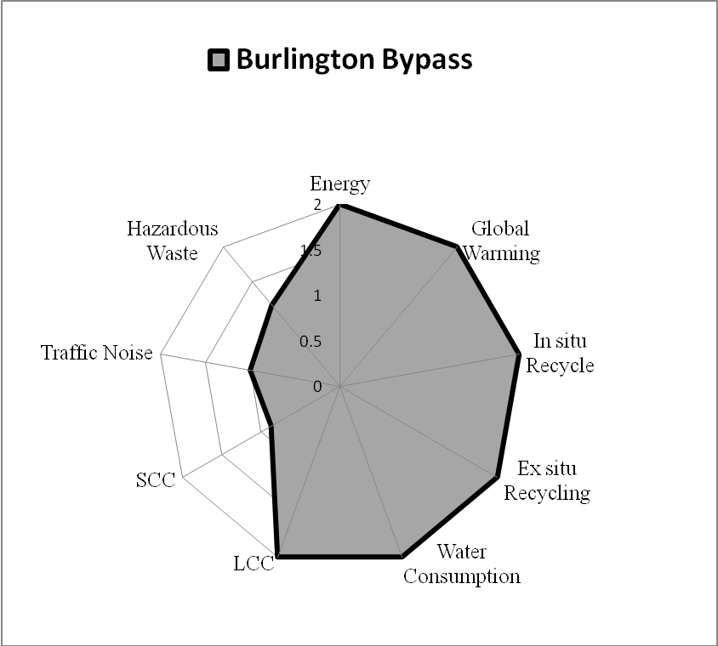
Figure 3.3. The AMOEBA of the Burlington Bypass Project.

Figure 3.4. Extending the AMOEBA Over Time (Adapted from Bell and Morse,
2008).

4. PROGRAM DETAILS

4.1 Description of Project Details

The first step of an assessment procedure starts from describing the project details. Figure 4.1 shows the pop up form incorporating a link to the project detail form (Figure 4.2).

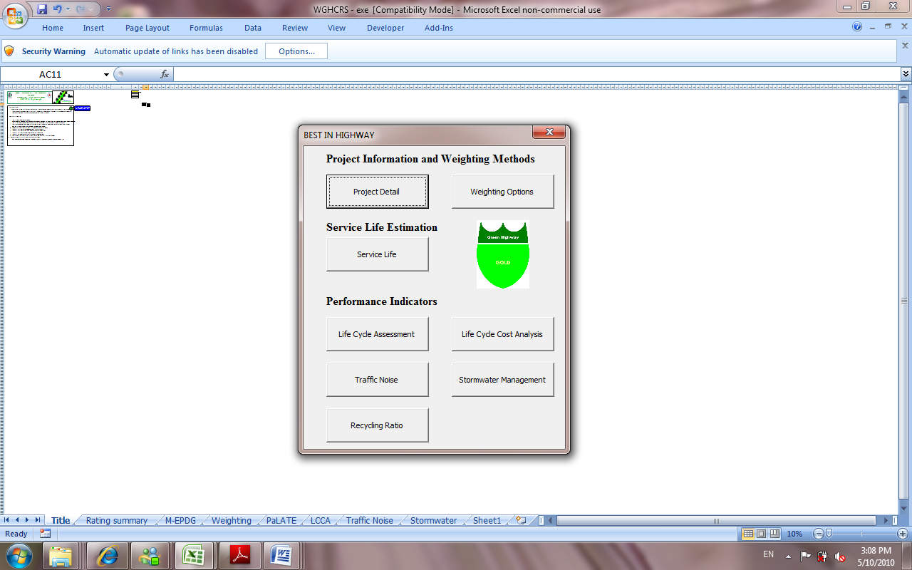

Figure 4.1. The Main Menu Form of BE²ST-in-Highways.

The form of the project detail includes text boxes to allow a user to input the project name, the name of a highway, the length of the project subject to an assessment, and the unit social carbon cost (SCC). A combo box for the surface type of the project selection is included in the form for the project detail as well. The project name and the state route name will be shown on the Rating Summary window as well as on the AMOEBA graph. The surface type selected using a combo box will be used to judge a noisy mitigation effort. The unit SCC cost default value has been set to $69. However, an analyzer can choose and input his or her own unit cost of SCC through this textbox. The assessment length will be used to calculate the unit SCC saving by dividing the total SCC saving of the project by the length of the project. Once all text boxes are filled in and the combo box is set to a designed surface type, all input variables move to their designated places by clicking the Input button.

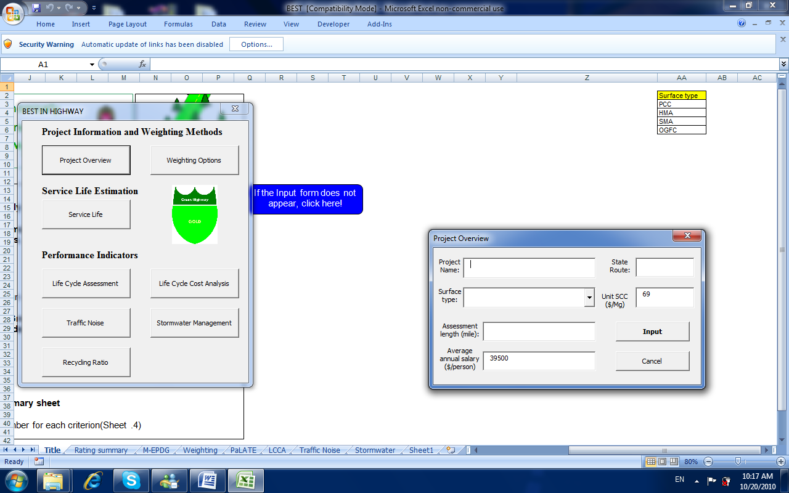

Figure 4.2. Project Detail Input Form.

4.2 Criteria Weighting

Criteria weighting is an important part of sustainability assessment. In this rating system, three different weighting categories (Figure 4.3) were considered: (1) equally assigned weighting, (2) weighting assigned by consensus of a board, and (3) project specific weighting assignment.

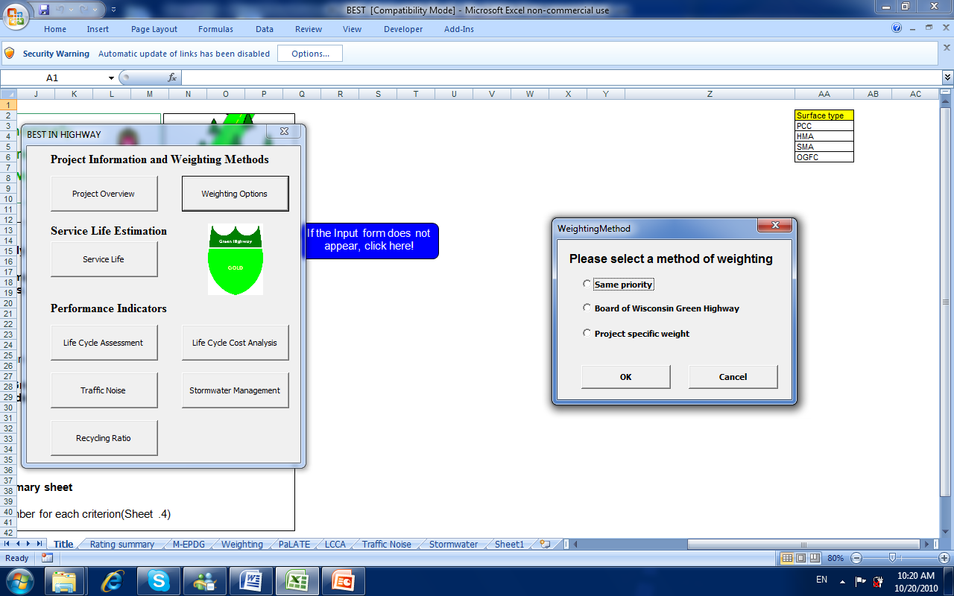

Figure 4.3 Weighting Method Form.

Weighting can be equally assigned to each criterion by clicking the option button, “Same priority.” Weighting values for both the second and third situations can be obtained using the Analytic Hierarchy Process (AHP) method. The procedure for computing the weighting value with AHP can be found elsewhere (Saaty 1980). This system provides an AHP tool (Figure 4.4). 1 means that two criteria contribute equally to the sustainable highway construction, whereas 9 means that one criterion is absolutely more important than the other.

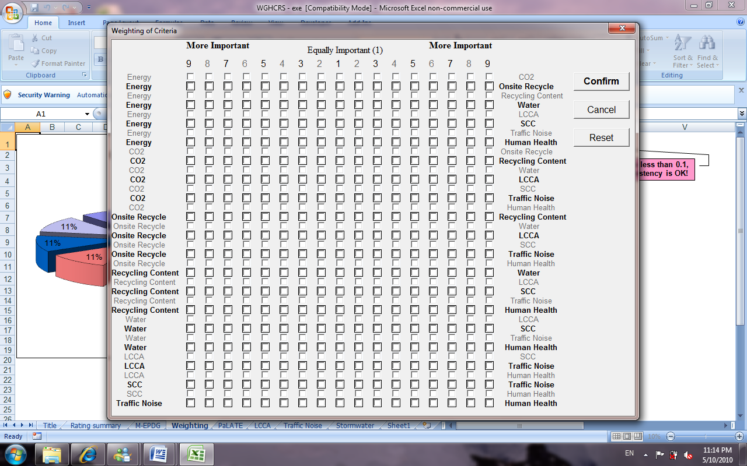

Figure 4.4. Weighting of Criteria Form.

By clicking the check boxes corresponding to the degree of importance of a criterion comparing to other criteria and the confirm button, weighting values are applied to each score. If a relevant board has weighting values already decided, then they can use those values through the form shown in Figure 4.5. In this case, the sum of weighting values should be 100. Otherwise the message box saying “the sum of weightings is not 100” pops up. A reset button is provided so that users can get the entries reset to the initial state.

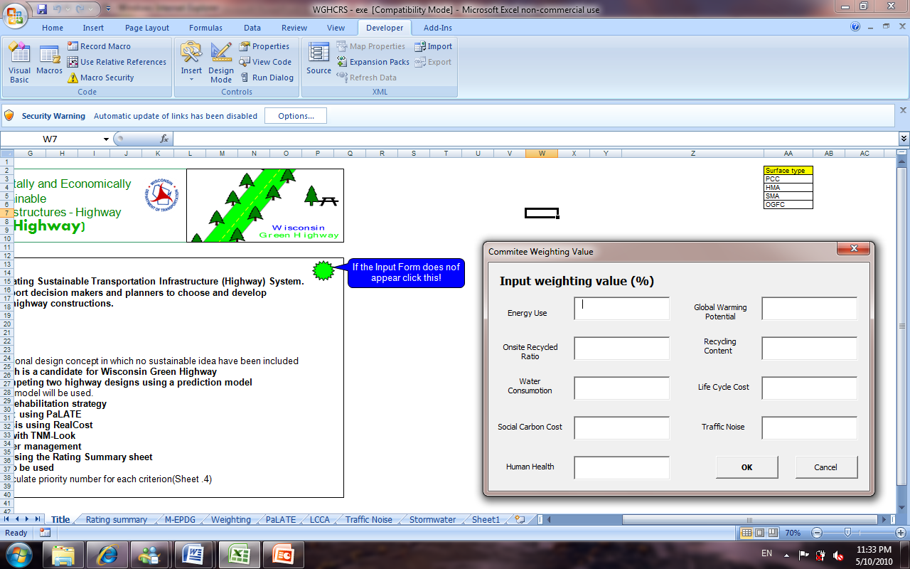

Figure 4.5. Weighting Value Input Form for a Committee.

4.3 Estimation of Service Life and Rehabilitation Plan
In order to decide how often rehabilitation activities should be scheduled, pavement performance analysis is required. Judgment of major rehabilitation period based on a change in road roughness is one of most commonly used pavement performance analyses. FHWA is using the International Roughness Index (IRI) as an index to support the judgment for appropriate rehabilitation frequency. According to FHWA (1998), an IRI level of 2.7 m/km is considered a signal that a selected pavement has reached its terminal serviceability index and is needed for the pavement to be scheduled a certain form of rehabilitation. A modeling tool to be utilized in this rating system is the Mechanistic-Empirical Pavement Design Guide (M-EPDG) Version 1.0 (NCHRP 2006). NCHRP has developed the M-EPDG to address shortcomings in the conventional pavement design methods by integrating pavement knowledge and experiences developed during the last five decades. M-EPDG mainly uses three key variables: (1) traffic data, (2) climate condition, and (3) material properties. Once the expected service life is calculated by M-EPDG, a variety of rehabilitation strategies can be established accordingly. For instance, IRI threshold values for two competing designs of the Burlington Bypass project are exceeded 17 years (conventional design using natural virgin materials) and 18 years (alternative design using recycled materials) respectively after the road is initially opened to users. Consequently, it can be assumed that a selected highway needs one major rehabilitation activity during the whole analysis period. This system provides a link to the M-EPDG program. Figure 4.6 illustrates a typical example of IRI’s prediction for both a reference design and a candidate design. Figure 4.6 presents that the selected two different alternatives reach their terminal serviceability about 300 months after the road is initially open to users.

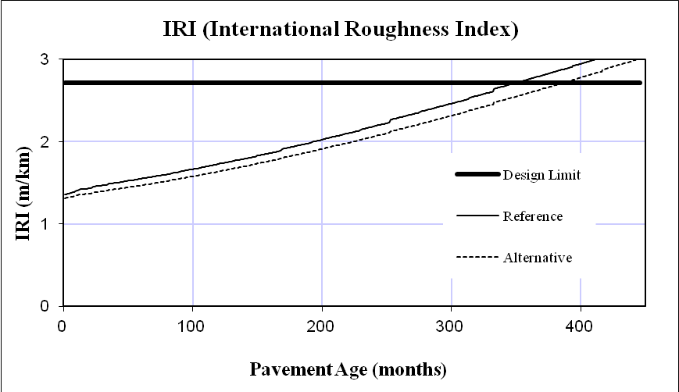
Figure 4.6. A Typical Example of IRI Prediction Using M-EPDG.

4.4 Calculation of Energy Consumption and Global Warming Potential
The Discrepancy of Environmental Impacts of two competing designs can be calculated using a LCA model. This system provides the Pavement Life-Cycle Assessment Tool for Environmental and Economic Effects (PaLATE) model. The PaLATE model is a life cycle assessment tool that contains environmental and engineering information and data to evaluate the use of conventional and recycled materials in construction and the maintenance of pavements (Horvath 2004). The user defines the dimensions of each layer in the pavement, the distance between the project site and material sources, and the density of the construction materials. These yield types and volumes of construction materials, sources and hauling distances, a set of construction activities, and a set of prescribed maintenance activities. From this information, PaLATE calculates cumulative environmental effects such as energy and water consumption; emissions of CO₂, CO, NO_{X}, SO_{X}, and PM₁₀ particulate, emissions of Pb and Hg, RCRA hazardous waste, and a human toxicity potential (cancerous and non-cancerous).
Several different sources of information and analysis methods are used in PaLATE to characterize the environmental impact of road construction projects. One is based on environmentally augmented economic input-output analysis (EIO-LCA), a Leontief general equilibrium model of the entire US economy. The economy is divided into a square matrix of 480 commodity sectors. The economic model quantifies energy, material, and water use as well as emissions. Because EIO-LCA emission factors are available in metric tons per dollar of sector output, PaLATE uses average US producer prices ($/metric ton, e.g., from Means 2008) to calculate emissions per mass of material used. The databases used in PaLATE are described in Horvath (2004). The PaLATE window provided in this system is shown in Figure 4.7. There are two links on the window: a link to the PaLATE program for reference design and a link to the program for an alternative design. By filling in the required information for the analyses of both competing designs, LCA results are automatically incorporated into the assessment result.

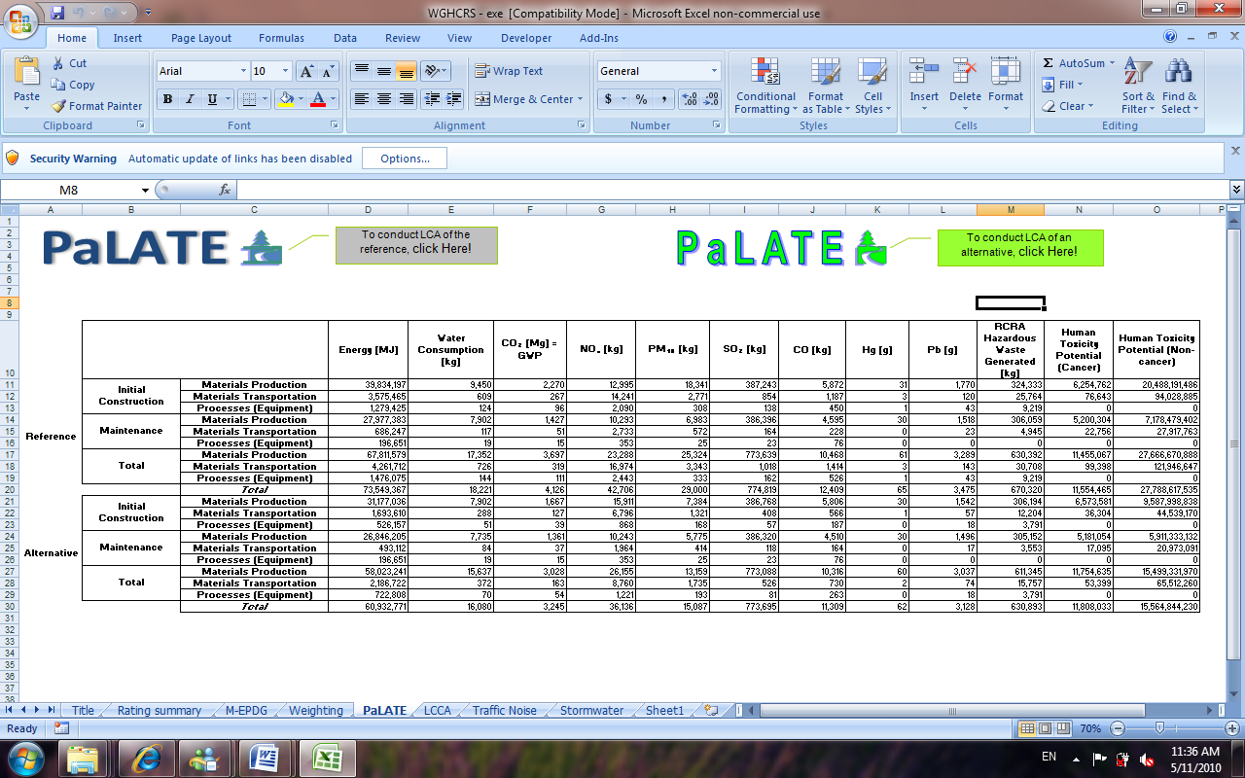
Figure 4.7. The PaLATE Window for LCA Studies.

Energy consumption for material production, transportation, and process phases during initial construction and maintenance activities are evaluated using the PaLATE model. Energy consumption is expressed in megajoules (MJ). The Production of Global Warming Potential (GWP) for initial construction and maintenance of the highway is illustrated on the same window. The Discrepancy of GWP of two competing designs can be calculated by taking the same procedure as for energy consumption. GWP is expressed in megagrams (Mg).

4.5 Life Cycle Cost Analysis

According to FHWA (1998), “LCCA is an analysis technique that builds on the well-founded principles of economic analysis to evaluate the over-all-long-term economic efficiency between competing alternative investment options.” LCCA incorporates initial and future agency cost in discounted value. LCCA also incorporates user cost and other relevant costs over the defined life cycle. LCCA attempts to identify the best value. The best value is the lowest long-term cost that satisfies the performance objective being sought for investment expenditures (FHWA 1998). Horvath (2003) stated LCCA for pavement construction as follows: If a chosen construction material “fulfills the technical requirements but the life-time of the structure is reduced due to its use, a life-cycle cost analysis can determine whether the use of virgin or recycled material is more advantageous.” A common procedure of LCCA proposed by the FHWA (1998) includes: 1) Establish alternative pavement design strategies for the analysis period; 2) Determine performance periods and activity timing; 3) Estimate agency costs; 4) Estimate user costs; 5) Develop expenditure stream diagrams; 6) Compute Net Present Value (NPV); 7) Analyze results; 8) Reevaluate design strategies.

RealCost, a LCCA tool selected for this rating system, is a spreadsheet program made by FHWA (1998) to support LCCAs of roadway construction (Figure 4.8). The features of RealCost are as follows:

RealCost applies a simulation technique that entails defining individual input parameters by either a frequency (or probability) distribution or by a discrete value, as is done typically in deterministic LCCA and computing an array of life-cycle cost (using an iterative sampling of the pre-defined cycle costs or unique probability distribution of costs), can then be examined and compared with the cost or cost distribution of a competing design alternatives. The simulation technique utilized by RealCost for probability simulation is the Monte Carlo simulation (FHWA 1998).

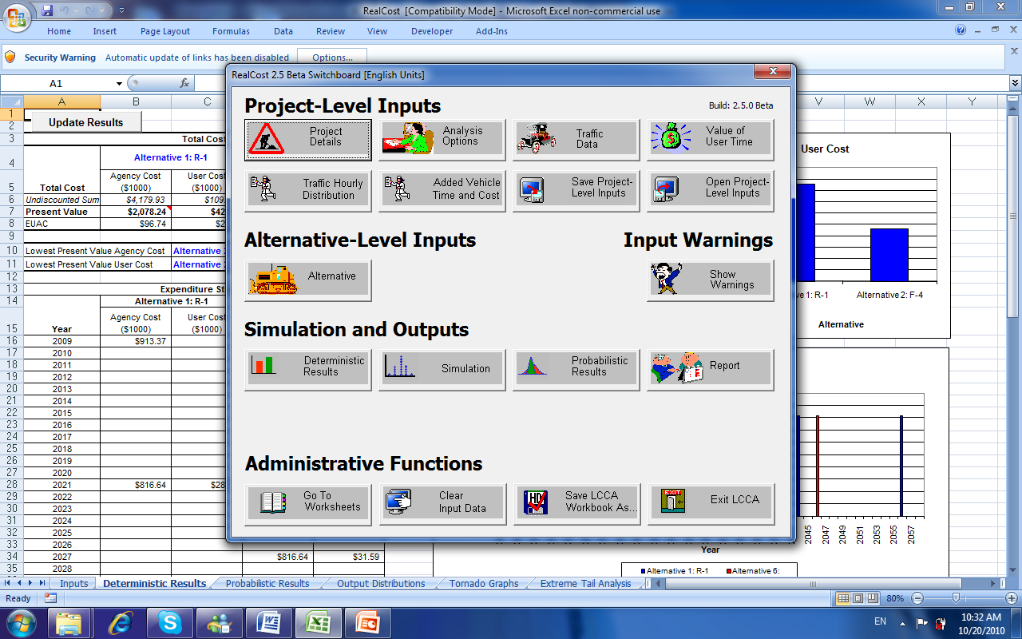

Figure 4.8. A Screen Shot of the RealCost Program

4.6 Traffic Noise Model
Noise is “usually defined as any unwanted sound.” And, “at very high levels (75 to 80 A-weighted decibels [dBA]), noise can cause hearing loss and tinnitus.” Once exterior continuous levels reach 65 to 70 dBA, people inside a building have to close their windows for conversation. So, noise levels in home should not exceed 40 to 45 dBA (NCHRP Report 456). The exterior criterion of equivalent noise level (Leq) in residential area is 67 dBA (FHWA 2009). For this reason, maintaining the noise below 67 dBA is a prerequisite to get credits in this criterion. An appropriate measurement plan to mitigate the noise level down to 67 dBA in residential areas should be incorporated into the construction plan.
Some states (e.g. Arizona, California, and Texas) have made effort to mitigate traffic noise by methods such as placing asphalt rubber Open Graded Friction Courses (OGFC). In this context, up to 2 points will be awarded to a project that incorporates such diverse methods of noise mitigation as previously mentioned. The considered point scheme is summarized in Table 4.1.

Table 4.1. Average Comparative Noise Levels of Different Surface Types (Kandhal 2004).
Pavement Surface Type | dB(A) | Credit
Open Graded Friction Courses (OGFC) | -4 | 2
Stone Matrix Asphalt (SMA) | -2 | 2
Dense-graded Hot Mix Asphalt (HMA) | 0 | 1
Portland Cement Concrete (PCC) | +3 | 0

In order to simulate traffic noise during the operation of the selected road, TNM-LookUp Table illustrates the effect on noise levels of changes in traffic volume (FHWA 2004). Since TNM-LookUp cannot address the application of different surface types, mitigation of noise level depends on the selection of respective surface types shown in Table 4.1.

Users can pick a surface type by selecting a surface type through the Surface type combo box. Four different options for selecting a surface type are available: PCC, HMA, SMA, and OGFC.

4.7 Water Consumption and Evaluation of Stormwater Management Plan
This section reviews the overall evaluation procedure of Best Management Practices (BMPs) for stormwater management which is the prerequisite of measurement of water consumption. The effectiveness of BMPs for storm water management could be assessed with cost and benefit analysis with respect to the control of stormwater volume, total suspended solid (TSS), and their life cycle cost. Figure 4.9 depicts a unified approach for the storm water management criteria developed by the Center of Watershed Protection (CWP). According to CWP (2008), Figure 4.9 can best be understood by considering the overall volume of runoff generated by a site. Each stormwater management criterion relates to a certain volume of the overall runoff volume to be managed.

Figure 4.9. Graphic Representation of the Nested Approach to Storm Water Management Criteria (CWP 2008, Modified).

Since consideration of Channel Protection (CP) and Flood Control (FC) at the project level can cause significant conflicts such as overestimation of project cost and confusion of project scope, the threshold of storm water management of this rating system is focused on the capacity of BMPs to control whole Water Quality Volume (WQv). Fortunately, the Minnesota Department of Transportation developed a metric to evaluate BMPs with respect to these aspects. The metric provides an analysis tool for life cycle cost and capacity of stormwater volume control. Table 4.2 is an example of cost estimation for infiltration basins provided by the metric. Other metrics for stormwater management can be found elsewhere (Arika et al. 2005).

Table 4.2. Basic Data and Equations for Dry Ponds (Arika et al. 2005).
Basic Data and Equation for Dry Ponds
LFC = CC + DC + MC LFC: Life Cycle Cost ($)
CC: Construction Cost($)
DC: Design, Erosion Control, Contingency Cost ($)
CC = 97.338 Qv-0.3872 CC in $/cf DC = 32% CC
MC = 1% CC*MDF MDF is the multiyear discount factor
MDF =$\sum_{t=1}^{t=n}{\frac{1}{(i+1)^{t}}}$ i is the discount rate (fraction)
t is the period of analysis (year)

The input parameters for stormwater managements are a type of BMP, a ratio of runoff to rainfall, a discount rate, a design precipitation depth, and the watershed area. A type of BMP can be chosen by clicking on an alternative of the BMPs in the combobox as shown in Figure 4.10.

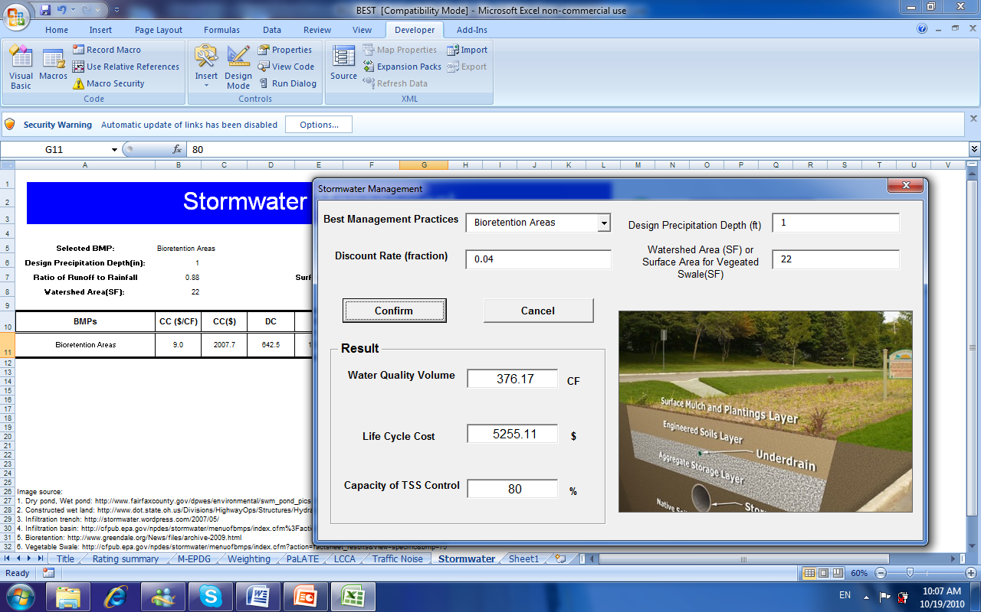
Figure 4.10. Stormwater Management Form.

The outputs of stormwater management analysis are water quality volume, life cycle cost, and capacity of total suspended solid (TSS) control. A picture of a selected BMP is also provided as a result of a stormwater management analysis.
Once the stormwater management plan satisfies the threshold of the prerequisite, the water consumptions of two competing designs (i.e., the reference design and an alternative design) need to be compared. The LCA result used for the comparison of energy and CO₂ emission (Figure 4.7) can be used for the evaluation as well.

4.8 In Situ Recycling Rate and Total Recycled Material Content
According to Scheuer and Keoleian (2002), 371 million Mg of Municipal Solid Waste (MSW) were generated in the US in 2000, an increase of 7% since 1999. A study in 1999 revealed that construction and demolition waste (CDW) account for 11.6% of the total MSW waste stream in California (Scheuer and Keoleian 2002). In order to contribute to mitigating these problems, the intention of this criterion is not only reduction of initial waste production but also an enhancement of recycling activity.
The performance assessment of a project in terms of the total recycled material content and the in situ recycling ratio could be implemented by inputting required information in the Recycling Ration form as shown in Figure 4.11. In situ recycling means recycling the old pavement materials salvaged on the site for rehabilitation. If the old pavement materials salvaged on the site are not recycled in situ, they should be hauled to a landfill site, thus incurring additional adverse environmental and economic impacts due to the transportation of the materials, construction of the landfill, and operation and maintenance of the landfill. Thus recycling of old pavement is considered the best practice of material use.

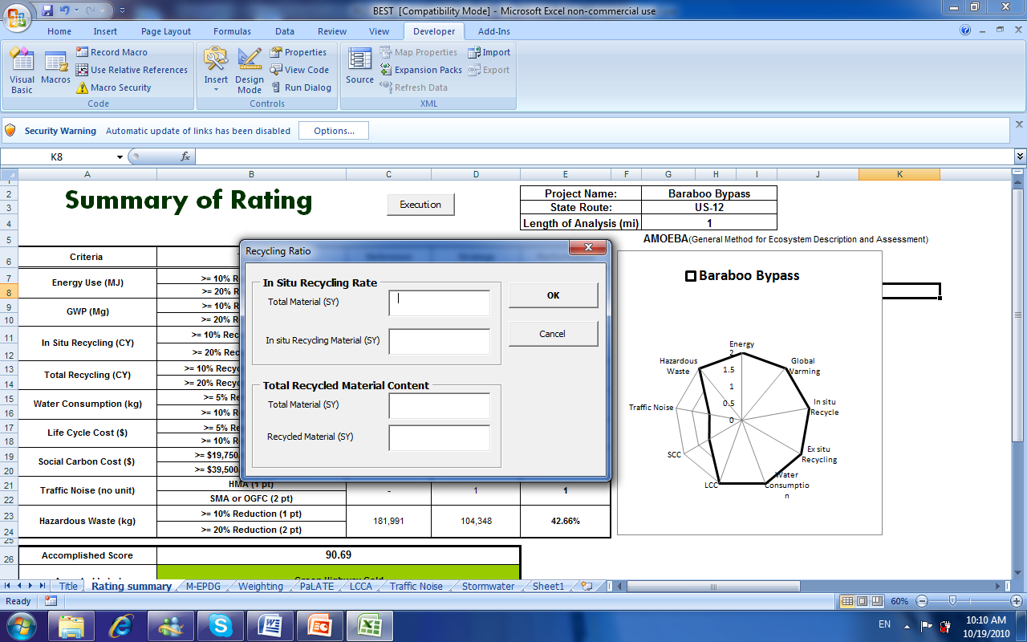
Figure 4.11. Recycling Ratio Form.

If a highway project does not produce waste materials to be sent to a landfill because there was no old pavement, the project still has a chance to contribute to the recycling of construction materials by binding the project section to use recycled material during rehabilitation phases in the future.

4.9 BE²ST-in-Highways Scorecard
All project information collected through input forms of each criterion is colligated in the Rating Summary window. In other words, the Rating Summary window is the comprehensive scorecard of a project. The Rating Summary window (Figure 4.12) incorporates the performances of each criterion, total score, and an AMOEBA graph.

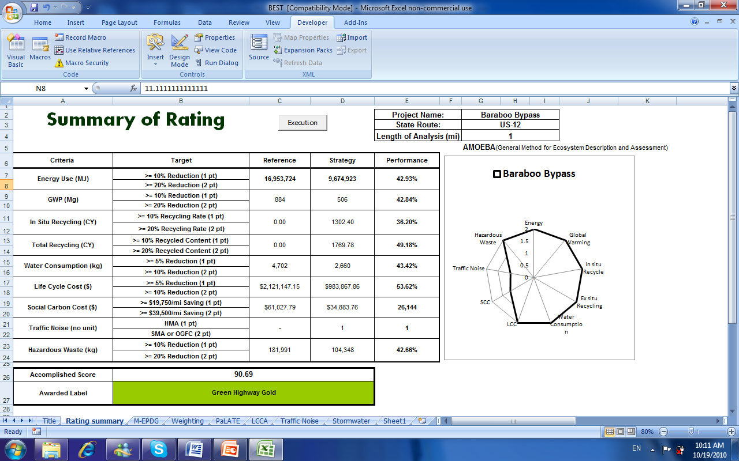
Figure 4.12. The BE²ST- in-Highways Scorecard.

As indicated earlier, the BE²ST in-Highways system was not developed to take a fixed snapshot of a project. Rather, the system was developed to provide project designers and planners with a guide of sustainable highway construction. With this guide, project designers and planners can continuously improve a project toward more sustainable way. The AMOEBA graph can play a role as a milestone with which project planners and designers can identify where and how much they should spend their effort and time.
Although all calculations related to the rating procedure are automatically completed by inputting required input parameters (e.g., project information, performance criteria, weighting values, etc.), the Execution button is another option to implement the final rating calculation. By clicking the Execution button after inputting all required parameters, rating calculations, and assigning the weighting value to each criterion, a label awarding is executed.

5. A CASE STUDY
A real highway construction project was rated using the BE²ST in-HighwaysTM software to help users understand this program by following the procedure presented. The project is a construction of a section of US-12 near Baraboo, Wisconsin (the Baraboo Bypass) for the pavement structure constructed with conventional or recycled materials. The first portion of this improvement, from I-90/94 south to the existing four-lane roadway at Tarrytown Road (9.2 km), is scheduled for 2009 - 2011. Constructing 21,703 m² of concrete pavement and 34,681 Mg of Hot mix asphalt is included in the 3.7 million dollar project. A 1.6-km long section of the bypass was analyzed in this study.

5.1 Step 1: Identification of a Project’s Configuration
A rating procedure using the BE²ST-in-HighwaysTM begins with inputting project information (Table 5.1) as shown in Figure 5.1. The Project Overview command button makes the Project Overview form pop up. Then, a user needs to input all information indicated on the form. A surface type, an assessment length, and a unit SCC are required input data. A surface type determines the score in traffic noise, a unit SCC is used to determine the score of SCC saving, and the assessment length is required to calculate the unit production of CO² per 1-mile of road construction.

Table 5.1. Schematic of Two Pavement Designs.
Design # | Surface type | Recycled material in surface | Thickness of surface  (mm) | Base type | Thickness  of base  (mm) | Recycled  Material in base
F-1  Reference | HMA | No | 140 | Aggregate | 152 | No
F-4 | HMA | RAP  (15%) | 140 | RPM with  10% FA | 94 | RPM with  10% FA

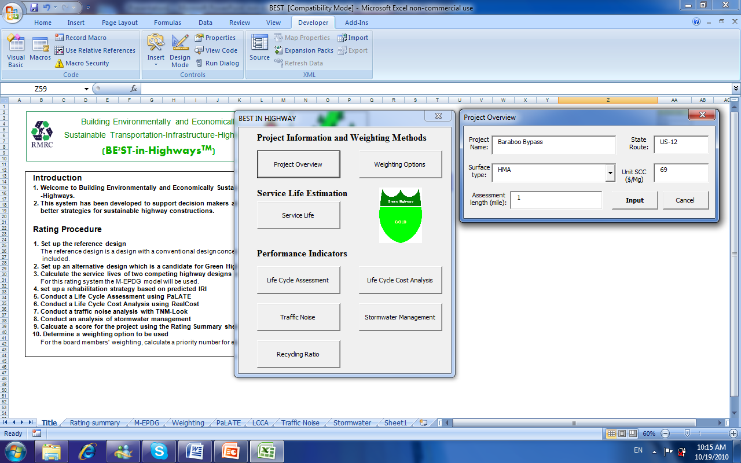
Figure 5.1. Input of a Project’s Information.

5.2 Step 2: Weighting of Criteria
The Weighting Method command button provides three options with regard to the weighting of criteria: i.e., same priority, a weighting value decided by the board of Wisconsin Green Highway in advance, and project specific weighting. In this example, the Same priority option was selected, as shown in Figure 5.2.

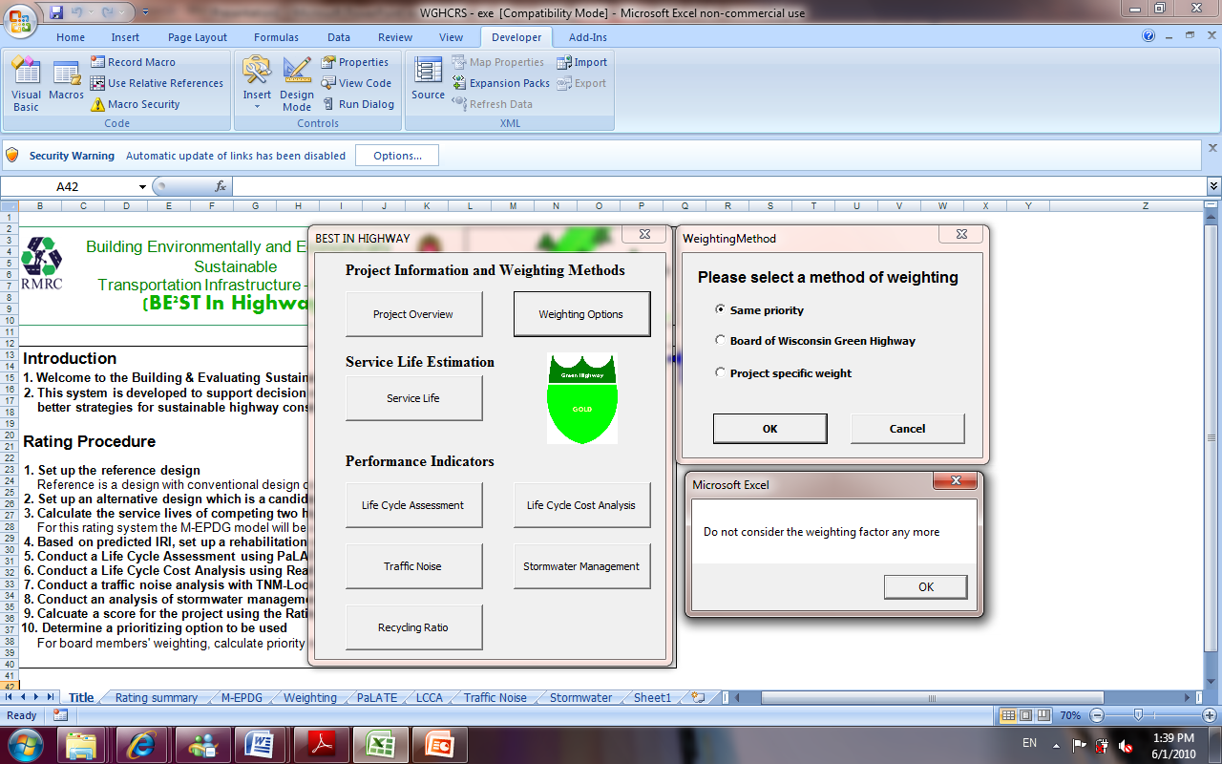
Figure 5.2. Weighting Methods.

5.3 Step3: Service Life Prediction

The pavements can be assumed to be serviceable until the International Roughness Index (IRI) reaches 2.7 m/km, as recommended in FHWA (1998). Once this IRI is reached, the pavement is assumed to require rehabilitation. The IRI can be predicted using the Mechanistic-Empirical Pavement Design Guide (M-EPDG) Version 1.0 (Figure 5.3) (NCHRP 2006). M-EPDG primarily uses three key variables in the analysis: (1) traffic data, (2) climate conditions, and (3) material properties.


Figure 5.3. The Screenshot of the M-EPDG Program Used to Estimate the Service Life of A Highway.

The instruction of the M-EPDG program is not provided in this manual. An instruction of the software is available elsewhere (e.g., http://www.in.gov/dot/div/contracts/standards/MEPDG_hma_User_instructions.pdf).
Predictions of the IRI for the conventional and recycled designs are shown in Figure 5.4. The conventional and recycled material designs reach their terminal serviceability at 12 and 18 years, respectively. The service life for the pavement using recycled materials is 6 years longer because of the superior properties of the recycled materials relative to the conventional materials.
Figure 5.4. Result of Service Life Prediction.

5.4 Step 4: Performance Simulations
5.4.1 Life Cycle Assessment
BE²ST-in-HighwaysTM provides links to metrics to measure the performances in five areas: life cycle assessment, life cycle cost analysis, recycled material content, traffic noise modeling, and BMPs for storm water management.
The LCA program to be used for the rating system is the RMRC’s LCA spread sheet program, PaLATE Version 2.0 (RMRC 2004). PaLATE provides a unique platform to carry out LCAs of highway constructions. A variety of recycled material uses are considered in PaLATE, e.g. fly ash, bottom ash, foundry sand, FGD, etc. Energy use and global warming potential are key outputs of the program. Energy use and global warming potential are used to measure the environmental impacts of highway construction in this system. Resource Conservation and Recovery Act (RCRA) hazardous materials are used to weight how much an alternative strategy in material consumption can potentially reduce the adverse impacts on human health compared to conventional material consumption. Since Economic Input-Output LCA approaches were applied to the program, it is possible to simulate the environmental impact of a whole supply chain of those materials. PaLATE provides many options of transportation means and construction equipment as well. A more detailed procedure of a LCA with PaLATE can be found in its user manual (RMRC 2004).
Among selected criteria, hazard mitigation for human health and safety is evaluated based on the value of RCRA hazardous material. RCRA hazardous waste is a metric to measure its impact on human health and safety. The identification of hazardous waste is based on the procedure defined by RCRA to evaluate whether a waste is non-hazardous or hazardous. The evaluation is conducted by checking if the waste material is on the list of the Environmental Protection Agency (EPA). The EPA lists waste materials either according to its regulations or if the waste shows one of following four properties: reactivity, ignitability, corrosivity, or toxicity (Ashekrana 2004). Greenhouse gas emission and energy consumption can be evaluated based on the values of global warming potential (GWP) and the amount of energy consumption, respectively. The amount of water consumed during highway construction and rehabilitation can be obtained during an LCA study as well. The result of LCA is automatically summarized in the PaLATE window of the program and an excerpt of the summary is shown in Table 5.2.

Table 5.2. The Result of LCA.
 | Energy (MJ) | CO₂ (kg) | Water (kg) | RCRA Hazardous Waste (kg)
Reference | 16,953,724 | 884 | 4,702 | 181,991
Alternative | 9,674,923 | 506 | 2,660 | 104,348

5.4.2 In situ Recycling Rate and Total Recycled Material Content
“Recycling Ratio” button on the main menu form takes users to the input form for the In Situ Recycling Rate and Total Recycled Material Content (Figure 5.5).

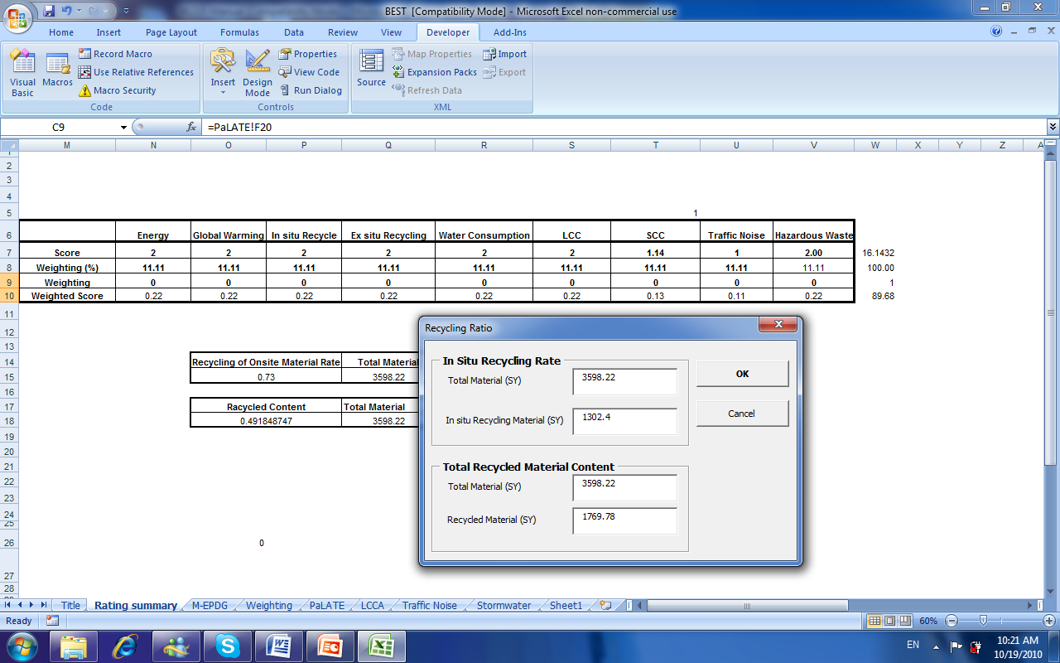

Figure 5.5. Recycling Rate Input Form.

49% of construction materials used for the project is recycled materials and 36% of the material comes from in situ old materials. Users need to input the quantity of total material and recycled material on the text boxes for the evaluation of the construction in this criterion.

5.4.3 Conducting LCCA and Evaluation of Social Carbon Cost Saving
As noted earlier, LCCA is a cost centered engineering economic analysis whose objective is to systematically determine the costs attributable to each alternative course of action over a specified period of time. In the assessment system, the life cycle cost of highway construction incorporates both agency costs and work zone user costs. Work zone user costs address both delay costs and crash costs. Delay costs are costs of time spent in work zones during highway construction or rehabilitations. Crash costs are costs associated with crashes due to the work zone.
In order to compute the life cycle cost of highway constructions, RealCost version 2.1 (FHWA 2004) was selected as a main LCCA platform of the assessment system. RealCost is a spreadsheet program which accompanies defining individual input parameters by two alternatives, i.e., a discrete value or a frequency distribution.
Once all estimated construction costs and required data are input to the Real Cost program and the Deterministic Results button is hit, the total life cycle cost of the project is automatically calculated and summarized on the LCCA window as shown in Figure 5.6.

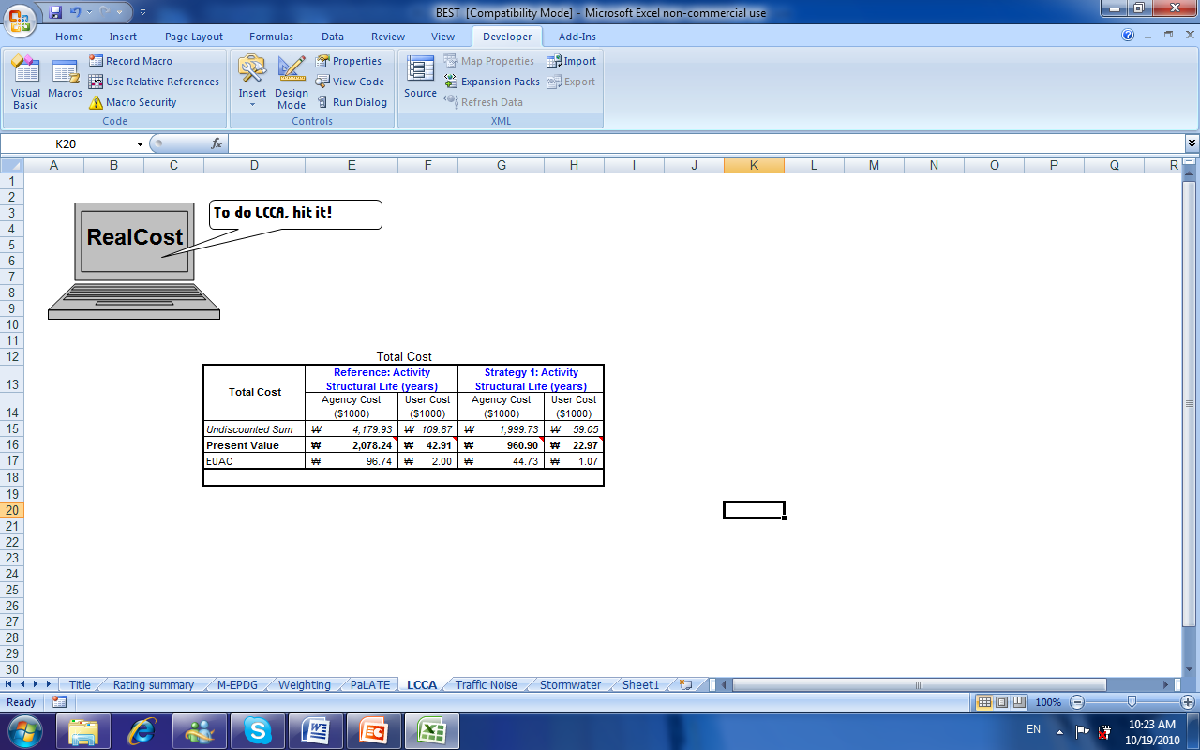
Figure 5.6. Result of LCCA Calculation

The purpose of the SCC saving point is to allow an agency (e.g., Wisconsin DOT) to incorporate the social benefits of reducing global warming potential into cost-benefit analyses of sustainable construction efforts.
For 2010, the estimates of the average social carbon cost (SCC) are spanning from $5.3 to $69 to represent the best case scenario and the higher than-expected impacts (US DOE 2010). Among these values the worst case scenario ($69) was used to evaluate SCC saving in this appraisal system.
The average annual salary of Americans is $39,500 (U.S. Census Bureau 2006). So, when the amount of SCC savings is equivalent to $39,500, the project can obtain full credits (2 points). If the amount of SCC saving is equivalent to 50% of the average annual salary of Americans ($19,750), 1 point will be granted to the project.
To evaluate a total SCC, users need to determine the unit cost of SCC. As shown in Figure 5.7, the input textbox of the unit SCC is located on the Project Overview form. Currently, the default value is being set to $69/Mg which is the 2010 value.

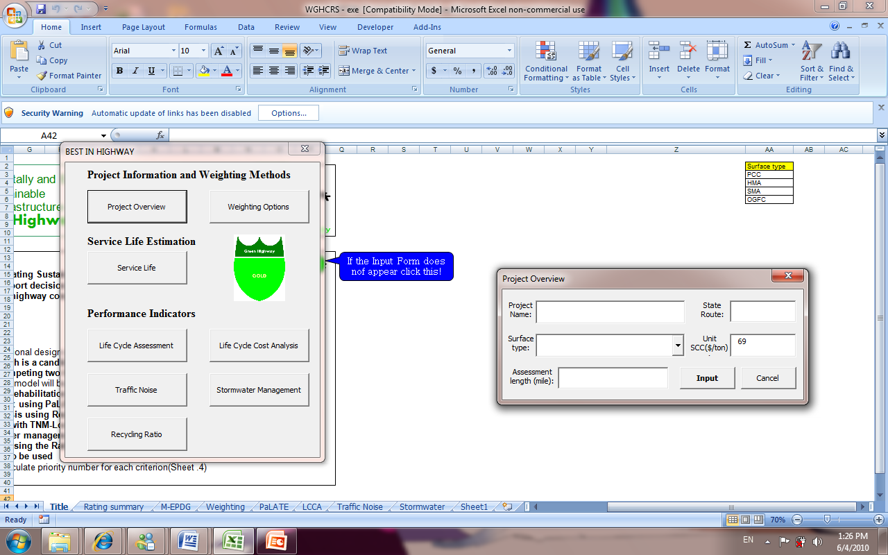
Figure 5.7. Unit Cost Input Textbox in the Project Overview Form.

5.4.4 Simulation of Traffic Noise
Noise is usually defined as any unwanted sound. At very high levels, such as 75 to 80 A-weighted decibels [dBA], noise can cause hearing loss. Once the exterior continuous levels reach 65 to 70 dBA, people inside a building have to close their windows to converse. So, noise levels in homes should not exceed 40 to 45 dBA (NCHRP 2002). The exterior criterion of equivalent noise level (Leq) in residential areas is 67 dBA (FHWA 2010). For this reason, maintaining the noise below 67 dBA has been decided as a prerequisite to get credits in this criterion. In order to simulate traffic noise during the operation of a selected highway, TNM-LookUp Table (FHWA 2004) will be used as a traffic noise modeling tool. TNM-LookUp Table (Figure 5.8) illustrates the effect of noise levels of changes in traffic volume.

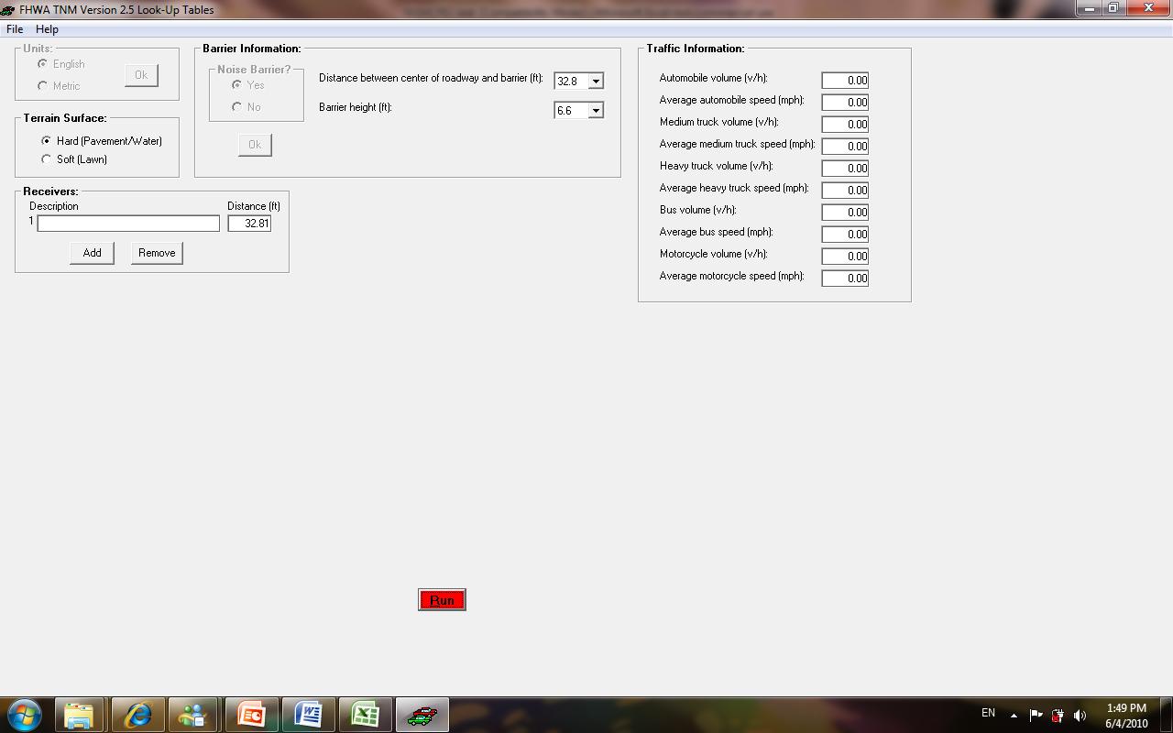
Figure 5.8. TNM-LookUp Table.

For this example, it was assumed that the project conforms to the noise level restriction. Since TNM-LookUp cannot address the application of different surface types, mitigation of the noise level depends on the selection from the respective surface types shown in Table 4.1. Since the project satisfied the prerequisite of traffic noise outlined in the TNM-LookUp Table, and the pavement type is HMA, the project obtained one credit in this criterion.

5.4.5 Evaluation of Water Consumption and Stormwater Management Plan
This section reviews an overall evaluation procedure of Best Management Practices (BMPs) for stormwater management. The effectiveness of BMPs for storm water management can be assessed with cost and benefit analysis with respect to control of stormwater volume, total suspended solid (TSS), and their life cycle costs.
The Center of Watershed Protection (CWP) developed a unified approach for the six storm water management criteria: runoff reduction (RR); water quality volume (WQv); channel protection (CP); and flood control (FC). These storm water management criteria can best be understood by considering the overall volume of runoff generated by a site. Each of the stormwater management criteria relates to a certain volume of the overall runoff volume to be managed.

Since consideration of CP and FC at the project level can cause significant conflicts such as overestimation of project cost and confusion of project scope, the threshold of storm water management of this rating system is focused on the capacity of BMPs to control whole WQv. Fortunately, the Minnesota Department of Transportation developed a metric to evaluate BMPs with respect to these aspects. The metric provides an analysis tool for life cycle cost and capacity of stormwater volume control. This metric will be incorporated into the standard performance measurement software (Wisconsin BE²ST in-highways).
Once a project satisfies these stormwater management criteria that are prerequisites, up to two points will be awarded to the project based on its accomplishment of water saving calculated using PaLATE model.
Since installation of an appropriate BMP is a prerequisite for the evaluation of water consumption, it is assumed that vegetated swale was selected as BMP for the project, thus satisfying the prerequisite.

5.5 Step 5: Normalization of Assessment Result
BE²ST-in-Highways automatically normalize the calculated performance values of each criterion.
According to ISO 14042, normalizations are defined as calculating the magnitude of performance value relative to a bench mark value. A bench mark value, in this case, can be a future target value that an agency is trying to accomplish by adopting a certain policy. Normalizing the performance values is mainly aiming to understand the relative magnitude and importance of these performances for each project or service under evaluation (Guinée 2002).
For the rating system being developed, Fuzzy Logic was selected as the normalization methodology. Fuzzy Logic is a superset of Boolean logic. With conventional Boolean logic, only two variables are available to be obtained as a result of analysis. On the contrary, Fuzzy Logic makes it possible to generate partial truths which are variables between completely true and completely false. A set of ordered pairs of a variable are required to express Fuzzy logic, i.e., 0 to represent completely true, 1 to represent completely false, and variables in between 0 and 1 to represent intermediate degrees of membership (Dasgupta and Tam 2005, Zadeh 1996, Andriantiatsaholiniaina and Phillis 2001).

5.6 Step 6: Summarization of Results and Development of AMOEBA
This section describes how to summarize the outputs acquired with the proposed assessment system. Normalization of assessed performance values is required to better understand the relative magnitude and importance. The final score is expressed as a ratio of the sum of normalized performance value to the reference value. Based on the calculated ratio, a certain level of label can be awarded to the project. The Baraboo Bypass project obtained 91% of the total score (see Table 5.3). Since a project obtaining greater than 90% of the total score deserves the Green Highway Gold label, the Green Highway Gold label was awarded accordingly.

Table 5.3. A Scorecard of the Baraboo Bypass Project.
Criteria | Reference | Alternative “1”  (Specific Project) | Normalized  Value
Criteria | Generic | RPM+15%FA | Normalized  Value
Energy Consumption | 16,953,724 MJ | 9,674,923 MJ | 2
Global Warming Potential | 884 Mg | 506 Mg | 2
Water consumption | 4,702 kg | 2,660 kg | 2
In-situ Recycling Ratio | 0 | 36% | 2
Recycled Material Content | 0 | 49% | 2
Life Cycle Cost | $2,121,147 | $983,867 | 2
Social Carbon Cost | $61,027 | $34,884 | 1.3
Traffic Noise | - | +1 (HMA) | 1
RCRA Hazardous Material | 181,991kg | 104,348kg | 2
Score and Label (Figure 45) |  | 16.3/18 = 91 (%) (Gold)

The other important feature of this rating system is that this assessment system provides the AMOEBA approach which is a strategic decision support tool. The AMOEBA allows for a quantitative comparison between the target values of criteria and present values. The AMOEBA approach attempts to reconstruct systems where fundamental target values would be achieved. The AMOEBA approach will provide the decision makers with a useful snapshot to observe evolvement of the highway design. The purpose of this procedure is to provide planners and designers with the score they accomplished and areas in which they should invest more time and efforts. For instance, more effort and time should be made and spent for the area of reducing RCRA hazardous material, traffic noise, and SCC to make the Baraboo Bypass project more sustainable project. In this context, AMOEBA, as shown in Figure 5.9, is a useful tool to guide a decision making process toward a more sustainable way.

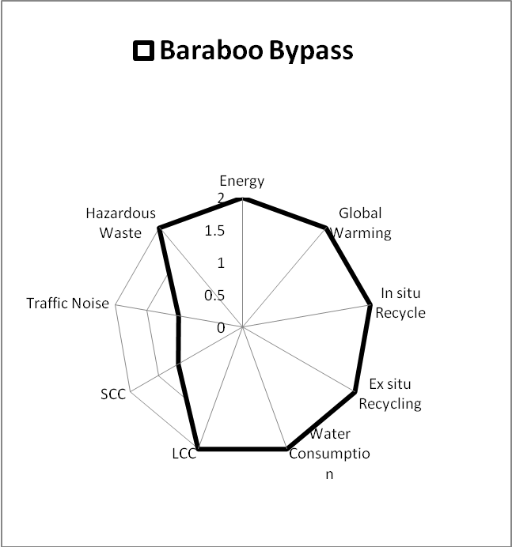
Figure 5.9. The AMOEBA of the Baraboo Bypass Project.

The fact that the process of the system is cyclical is one of the most significant features of the soft system approach. Under the soft system approach, the problem is not defined as a fixed one; rather, its evolution is progressive. Figure 5.10 shows a rating summary and the AMOEBA graph of the project incorporated in BE²ST in-Highways.

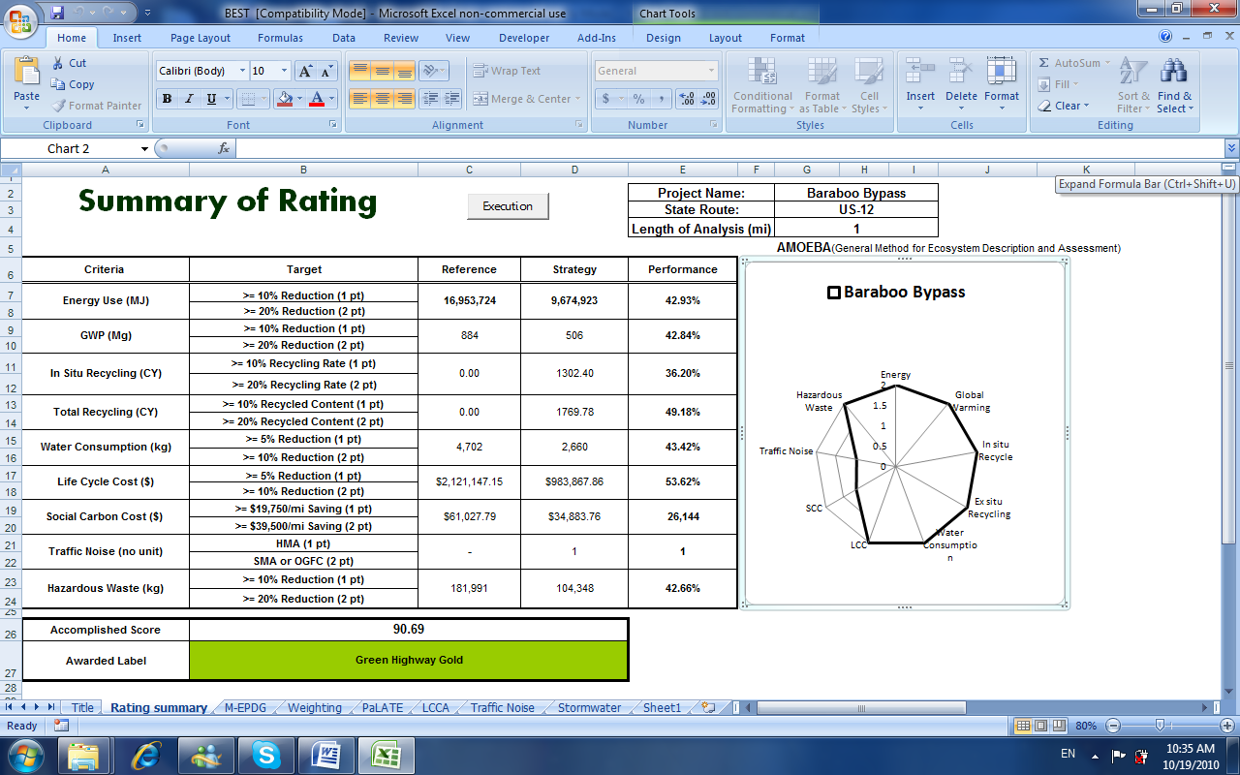

Figure 5.10. The Rating Summary and AMOEBA Graph of the Project.

REFERENCES
AASHTO (2008). Primer on Transportation and Climate Change.
Anderson, D. R. (2005). Corporate Survival: The Critical Importance of Sustainability Risk Management, New York, iUniverse.
Andriantiatsaholiniaina and Phillis, Y.A. (2001). “Sustainability: An Ill-defined Concept and Its Assessment Using Fuzzy Logic”, Ecological Economics, 37, 435-456.
Arika, C., Canelon, D. J., Nieber, J. L., and Sykes, R. D. (2006). Impact of Alternative Storm Water Management Approaches on Highway Infrastructure: Project Task Reports– Volume 2, Minnesota DOT Research Service Section, St. Paul.
ASCE (2007). “The Vision for Civil Engineering in 2025.” The Summit on the Future of Civil Engineering (June).
ASHEKRANA, A. S. M. (2004). Evaluation of Recycled Material Performance in Highway Applications and Optimization of Their Use, PhD Dissertation, Texas Tech University.
Bell, S. and Morse, S. (1999). Sustainability Indicator: Measuring the Immeasurable?, London, Earthscan Publications Ltd.
Carpenter, A. C., Gardner, K. H., Fopiano, J., Benson, C. H. and Edil, T. B. (2007). “Life Cycle Based Risk Assessment of Recycled Materials in Roadway Construction” Waste Management, 27, 1458-1464.
Center for Watershed Protection (2008). Managing Stormwater in Your Community: A Guide for Building and Effective Post-Construction Program.
Dasgupta, S. and Tam, E.K.L. (2005). “Indicators and Framework for Assessing Sustainable Infrastructure”, Canadian Journal of Civil Engineering, 32, 30-44.
Ding,G. K. C. (2008), “Sustainable Construction - The role of Environmental Assessment Tools”, Journal of Environmental Management, 86, pp. 451-464.
Egan, S. J. (1998). Rethinking Construction, Department of Trade and Industry, U.K.
FHWA (1998). Life-Cycle Cost Analysis in Pavement Design – In Search of Better Investment Decision.
FHWA (2004). RealCost Version 2.5., http://www.fhwa.dot.gov/infrastructure/asstmgmt/lccasoft.cfm. Accessed February 16, 2009.
FHWA (2004). TNM Version 2.5 Look-Up Tables, Available at: http://www.fhwa.dot.gov/environment/noise/tnm/tn_ver25lu.htm, Accessed February 17, 2009.
FHWA (2009), Highway Traffic Noise, Available at : http://www.fhwa.dot.gov/environment/htnoise.htm, Accessed 16 February, 2009.
FHWA (2010), Highway Traffic Noise, http://www.fhwa.dot.gov/environment/htnoise.htm, Accessed March 22, 2010.
FHWA (2010). Road Safety Audits (RSA). Available at: http://safety.fhwa.dot.gov/rsa/, Accessed March 30, 2010.
Fwa, T.F. and Sinha, K.C. (1991). “Pavement Performance and Life-Cycle Cost Analysis”, Journal of Transportation Engineering, 117.
Elkington, J. (1994). “Towards the Sustainability Corporation: Win-Win-Win Business Strategies for Sustainability Development”, California Management Review 36.
Elkington, J. (1998). Carnival with Forks: the Triple Bottom Line of 21st Century Business, Stony Creek, New Society Publishers.
Gambatese, J. A. (2005). “Sustainable Roadway Construction: Energy Consumption and Material Waste Generation of Roadways”, Construction Research Congress, 183.
Gibson, R.B., Hassan, S., Holtz, S., Tansey, J. and Whitelaw, G. (2005). Sustainability Assessment: Criteria, Processes and Applications, London, Earthscan.
Guinée, J. B. (2002). Handbook on Life Cycle Assessment: Operational Guide to the ISO Standards, Boston, Kluwer Academic Publishers.
Horvath, A. (2003). Life-Cycle Environmental and Economic Assessment of Using Recycled Materials for Asphalt Pavements, University of California-Berkeley.
Horvath, A. (2004). A Life-Cycle Analysis Model and Decision-Support Tool for Selecting Recycled Versus Virgin Materials For Highway Applications, Final Report for RMRC Research Project No. 23.
Heinen, J. T. (1994) “Emerging, Diverging and Converging Paradigms on Sustainable Development”, International Journal of Sustainable Development and World Ecology, 1, 22-33.
Hill, R.C. and Bowen, P.A. (1997). “Sustainable Construction: Principle and a Framework for Attainment.” Construction Management and Economics, 15, 223-239.
Horvath, A. and Hendrickson, C. (1998). “Comparison of Environmental Implication of Asphalt and Steel-Reinforced Concrete Pavements”, Transportation Research Record, 1626, pp. 105-113.
Johnston, R.A. (2008). “Indicator for Sustainable Transportation Planning”, TRB Annual Conference, Washington, D.C.
Kandhal (2004), “Asphalt Pavements Matigate Tire / Pavement Noise” Hot Mix Asphalt Technology.
Kibert, C. J. (2002). “Policy Instruments for a Sustainable Built Environment”, Journal of Land Use and Environmental Law, 17, 379-394.
Kirk, S. J. and Dell’Isola, A. J. (1995). Life Cycle Costing for Design Professionals, McGraw-Hill.
Lee, J. C., Edil, T. B., TinJum, J. M., and Benson, C. H. (2010). “Quantitative Assessment of Environmental and Economic Benefits of Using Recycled Construction Materials in Highway Construction.” TRB 89th Annual Meeting Compendium of Papers DVD, Washington, D.C.
Mendler, F. S. and Odell, W (2000). The HOK Guidebook to Sustainable Design, New York, John Wiley & Sons.
Muench, S., Soderlund, M., Willoughby, K., Weston, J., and Uhlmeyer, J.S. (2008). “Green Roads: A Sustainability Rating System for Roadways”, TRB Annual Conference, Washington, D.C.
NCHRP (2002). Guidebook for Assessing the Social and Economic Effects of Transportation Projects, NCHRP Report-456. Washington, D.C., National Academy Press.
NCHRP (2006). Mechanistic-Empirical Design of New & Rehabilitated Pavement Structures, Available at: http://www.trb.org/mepdg/software.html, Accessed February 16, 2009.
Pacala, S and Socolow, R. (2004). “Stabilization Wedges: Solving the Climate Problem for the Next 50 Years with Current Technologies.”, Science, 305, 968.
Pelzeter, A (2005). “Life Cycle Costs as Benchmark”, ERES Conference. Dublin.
Piper, J.M. (2002). “CAE and Sustainable Development Evidence from UK Case Studies.” Environmental Impact Assessment Review, 22, pp. 17-36.
Recycling Material Resource Center (2004). Pavement Life-cycle Assessment Tool for Environmental and Economic Effects, http://www.rmrc.unh.edu/Resources/CD/PaLATE/PaLATE.htm, Accessed February 16, 2009.
Saaty, T.L. (1980). The Analytical Hierarchy Process, New York, McGraw-Hill International Book Company.
Schendler, A. and Udall, R. (2005). “LEED is Broken, Let’s Fix It”, Aspen and snowmass.
Scheuer, W.C. and Keoleian, A.C. (2002). Evaluation of LEED Using Life Cycle Assessment Methods, University of Michigan-Ann Arbor.
Social Carbon Cost
Socolow, R.H. and Pacala, S.W. (2006). “A Plan to Keep Carbon in Check”, Scientific American, 295(September), 50-57.
Speth, J. G. and Hass, P. M. (2006). Global Environmental Governance, Island Press.
Toleman, R. (2008). “Partnerships for Progress: Towards Sustainable Road Systems”, TRB Annual Conference. Washington, D.C.
U.K. Highways Agency (2003). Building Better Roads: Toward Sustainable Construction, http://www.highways.gov.uk/aboutus/1139.aspx, Accessed March 22, 2010.
U.N., Department of Economic and Social Affairs (1987). Report of the World Commission on Environment and Development, United Nations.
U.S. Census Bureau (2006). Annual Demographic Survey, http://pubdb3.census.gov/macro/032006/perinc/new03_028.htm, Accessed August 17, 2009.
U.S. Department of Commerce, Census Bureau (2005). Industry General Summary 2002: 2002 Economic Census Construction Subject Series, U.S. Census Bureau.
U.S. EPA (1993). Guidance Specifying Management Measures for Sources of Nonpoint Pollution in Coastal Waters.
U.S. EPA (2009). Potential for Reducing Greenhouse Gas Emissions in the Construction Sector, EPA.
Vos, R. O. (2007). “Perspective Defining Sustainability: a Conceptual Orientation”, Journal of Chemical Technology and Biotechnology, 82, pp. 334–339.
Washington State DOT (2009). WSDOT Pavement Guide, Available at http://training.ce.washington.edu/wsdot/, Accessed April 7, 2009.
Wisconsin DOT (2009), Burlington Bypass Project, Avaiable at http://www.dot.wisconsin.gov/projects/d2/burl/index.htm, Accessed April 7, 2009.
Wisconsin DOT (2009). 2010 Standard Specifications, http://roadwaystandards.dot.wi.gov/standards/stndspec/index.htm, Accessed March 22, 2010.
Zadeh, L.A. (1996). “Fuzzy Logic = Computing with Words”, Transaction on Fuzzy System, 4, 103-111.

